

Dated 01/02/2018

ELECTRICITY NORTH WEST LTD

TELE-FONIKA Kable SA

Conformed Contract

Lot 2 – 11kV Power Cables
Lot 3 – Low Voltage Distribution & Low Smoke Zero Halogen Cables
Lot 5 – Multi pair and Multi core Cables
Lot 6 – 33kV Power Cables

Outline Agreement No: 4600000930

FRAMEWORK FOR THE PURCHASE OF GOODS

Tele-Fonika Kable Ref. No 1007/TFK/2018

Contents
Clause Page
1 Definitions and Interpretation 3
2 Commencement and Duration 8
3 Parent Company Guarantee and Performance Bonds 8
4 Goods Ordering and Supply 8
5 Free Issue Materials 9
6 The Supplier’s Obligations 9
7 Warranty 11
8 Project Manager 12
9 Prices 12
10 Payment 12
11 Change Control 14
12 Intellectual Property 14
13 Data Protection. 14
14 Confidentiality 14
15 Publicity 15
16 Samples 16
17 Inspection and Testing 16
18 Hazardous Goods 17
19 Delivery 17
20 Right of Rejection and Cancellation 19
21 Repair, Replacement and Refunds 20
22 Company Property 21
23 Drawings, Patterns and Jigs 21
24 Access and the Supplier’s Equipment 22
25 Liability 22
26 Benchmarking 25
27 Insurance 25
28 Compliance with Laws and Policies 26
29 Assignment and Sub-Contracting 26
30 Termination 27
31 Survival of Obligations 28
32 Notices 29
33 Dispute Resolution 29
34 Contracts (Rights of Third Parties) Act 1999 29
35 Costs 29
36 Anti Bribery 29
37 Force Majeure 31
38 General 31
39 Audit 33
40 Modern Slavery 33
41 Governing Law and Jurisdiction 34
- Goods 36
- Prices 36
- Change Control 46
- Benchmarking 49
- Payment 50
- Goods Receipients 51
- Abstract of Particulars 52
- Dispute Resolution 53
- Parent Body Guarantee 55
- Performance Bond 56

This Agreement is made on 01/02/2018
Between
- Electricity North West Ltd (Company No 2366949) whose registered office is at 304 Bridgewater Place, Birchwood Park, Warrington, WA3 6XG (Company); and
- TELE-FONIKA Kable SA (Company No 0000491666 (Poland)) whose registered office is at ul. H. Cegielskiego 1, Myslenice, 32-400, Poland (Supplier).
It is agreed
- Definitions and Interpretation
  - In this Agreement:
Affiliate means in respect of either party, a company which is a Subsidiary or which is a Holding Company of that party, or a Subsidiary of such Holding Company, in each case for the time being
Agreement means the clauses of and schedules to this document together with applicable Purchase Orders and/or Consignments.
Applicable Business Practice Law means the Applicable Laws of any jurisdiction in or from which the Goods are provided;
    - the Applicable Laws to which the Supplier and/or an applicable Supplier Affiliate involved in the provision of the Goods is subject and/or the Applicable Laws of any other country in which the Supplier’s ultimate parent company is subject, listed or traded;
    - the principles described in the Convention on Combating Bribery of Foreign Public Officials in International Business Transactions, signed in Paris on 17 December 1997, which entered into force on 15 February 1999, and the Convention’s Commentaries;
    - the United Stated Foreign Corrupt Practices Act or the principles of such Act; and
    - any Applicable Law relating to anti-bribery, anti-corruption or anti-money laundering, including the UK Bribery Act 2010, the Proceeds of Crimes Act 2002 and legislation implementing the OECD Convention on Combating Bribery of Foreign Public Officials in International Business Transactions
Applicable Laws means, for the time being:
    - any law, statute, regulation, bylaw, ordinance or subordinate legislation which is in force;
    - any binding court order, judgment or decree; and
    - any industry licence, code, policy, guidance, standard or accreditation terms:
      - enforceable by law which is in force for the time being; and/or
      - stipulated by any relevant regulatory authority (but excluding the Electricity Distribution Licence and any conditions of the Electricity Distribution Licence)
Business Day means any day other than a Saturday, Sunday or a public or bank holiday in England
Change means any change to the Goods, the Specification, the Expiry Date and/or any other matter in relation to this Agreement
Change Control Procedure means the procedure set out in Schedule 10
Commencement Date means 01/02/2018
Company Employment Screening Policy means the Company Employment and Screening Policy notified to the Contractor from time to time
Company Policies means the policies of the Company notified from time to time to the Supplier by the Company, including any such policies identified in a Purchase Order and/or the Specification
Company’s Procurement Department means the Company’s Procurement department currently based at Borron Street, Stockport, Cheshire, SK1 2JD (as may be updated by the Company from time to time in its sole discretion)
Confidential Information means all documents, databases, diagrams, calculations, data, processes, business methodologies, contracts (including this Agreement), financial information, plans, ideas, strategies, projections, products, designs and other information whether in physical form, electronic form or otherwise, whether expressed to be confidential or not, and in whatever media or format provided or orally disclosed by either Party (the Disclosing Party) to the other Party (the Receiving Party) in the course of, or in connection with the performance of each Party’s obligations under this Agreement and information obtained by the Receiving Party from the Disclosing Party as a result of being present at any premises of the Disclosing Party (whether by observing any plant or equipment or otherwise)
Consignment means any individual batch of Goods to be supplied pursuant to this Agreement
Delivery means, with respect to any Consignment, completion of the delivery of the Goods pursuant to a Purchase Order in accordance with clause 19 (Delivery) and the other requirements of this Agreement
Delivery Date means such date as is set out in the relevant Purchase Order for such Consignment (as may be amended by the parties from time to time in accordance with this Agreement)
Delivery Point means, with respect to any Consignment, the address and any specified area, as set out in the relevant Purchase Order for such Consignment (as may be amended by the parties from time to time in accordance with this Agreement)
Electricity Distribution Licence means the electricity distribution licence granted or treated as granted under section 6(1)(c) of the Electricity Act 1989 that authorises the Company to distribute electricity
Enforced Termination means where the Company is required by a Regulator to terminate this Agreement
Event of Insolvency means if the Supplier is unable to pay its debts (within the meaning of section 123 of the Insolvency Act 1986), or becomes insolvent, or is subject to an order or a resolution for its liquidation, administration, winding-up or dissolution (otherwise than for the purposes of a solvent amalgamation or reconstruction), ceases or threatens to cease to carry on its business or has an administrative or other receiver, manager, trustee, liquidator, administrator or similar officer appointed over all or any substantial part of its assets, or enters into or proposes any composition or arrangement with its creditors generally, or is subject to any analogous event or proceeding in any applicable jurisdiction.
Expiry Date means 31/01/2021, (as may be amended from time to time by the parties in accordance with this Agreement) with an optional extension period of 2 x 2 years
Force Majeure means any cause preventing either Party from performing any or all of its obligations under this Agreement which arises from or is attributable to acts, events, omissions or accidents beyond the reasonable control of the Party so prevented (but for the avoidance of doubt excluding strikes, lockouts or other industrial disputes which have their origin within the employees of the Party so prevented or default of suppliers or sub-contractors or breakdown of vehicles)
Good Industry Practice means all relevant practices and professional standards which would be expected of a leading expert supplier of goods substantially similar to the Goods to customers of the same nature and size of the Company
Goods means the goods to be supplied and delivered by the Supplier to the Company as specified in schedule 1 (Goods)
Holding Company shall have the meaning given in section 1159 of the Companies Act 2006 and shall include parent undertakings as defined in section 1162 of the Companies Act 2006 (each section as being in force at the date of this Agreement)
Intellectual Property Rights and IPR means all patents (including rights in, and/or to, inventions), trademarks, service marks, rights in goodwill or to sue for passing-off, design rights and registered designs, rights in and/or to internet domain names and website addresses, rights in computer software, moral rights, copyright (including future copyright), database rights, rights in and to confidential information (including know how and trade secrets) and all other intellectual property rights in each case whether registered or unregistered and including all applications for and renewals or extensions of such rights, and all similar or equivalent rights or forms of protection in any part of the world. Intellectual Property Right means any one of the Intellectual Property Rights
Losses means all losses, claims, proceedings, demands, actions, liabilities, fines, charges, damages, costs and expenses including legal fees on a solicitor/client basis and disbursements and costs of investigation, litigation, settlement, judgment, interest and penalties (in each case whether internal or external costs)
Material means any inventions, discoveries, documents, information, items, data, designs, prototypes, drawings, formulations, know-how or other material (in whatever form) including software, firmware, computer programs, documented methodologies, processes and procedures (including without limitation any records, specifications, business rules and requirements, user manuals, user guides, operations manuals, training materials and instructions)
Month means a calendar month
Party and Parties means a party to, or the parties to this Agreement
Procurement Contact means the person notified by the Company to the Supplier from time to time as the relevant contact from the Company's Procurement Department
Project Manager is not used
Prices means the relevant prices for the time being of the Goods which shall be ascertained in accordance with clause 9
Prohibited Payment means any payment, gift, promise or anything of value or advantage to or for the use or benefit of:
    - any Public Official or any political party or political party official or candidate for office; or
    - any officer, director, employee or other agent or representative of any person or entity, as an inducement or reward for taking or omitting to take any action in respect of that person’s or entity’s business or affairs, in either case where that payment, gift, promise or advantage would violate any Applicable Business Practice Law
Public Official means any person (whether appointed or elected) holding a legislative, administrative or judicial office, including any person employed by or acting on behalf of a public agency, a public enterprise (including any officer or employee of a state-owned or state-operated entity) or a public international organisation
Purchase Order means any order for the Goods and/or Consignment issued by the Company to the Supplier (in either printed or electronic format) in accordance with clause 4, together with any variation to the same made in accordance with clause 38.10
Regulator means the Gas and Electricity Markets Authority and any of its officers or employees, Ofgem, the Information Commissioner's Office or any other regulator or government body appointed to regulate any aspect of the business of the Company and/or its Affiliates
Specification means any technical specification and/or description of the Goods set out or referred to in schedule 1 (Goods)
Statutory Requirements means the requirements placed on the Company and/or the Supplier or affecting or governing the provision and/or use of the Goods by Applicable Law and/or the Electricity Distribution Licence and/or a Regulator and/or any relevant codes of practice issued by any government agency or body including in relation to health, safety and environmental matters
Subsidiary has the meaning given in section 1159 of the Companies Act 2006 and shall include subsidiary undertakings as defined in section 1162 of the Companies Act 2006 (each section as being in force at the date of this Agreement)
Supplier’s Equipment means all plant, equipment, vehicles, temporary buildings, materials, tools, stores, machinery, apparatus, articles and other things of any kind brought onto the Delivery Point by or on behalf of the Supplier for use in the supply and delivery and/or off-loading of the Goods, but not themselves being part of the Goods
Term means the period during which this Agreement is in full force and effect
Total Contract Value means
    - the amount of charges for the Goods paid by the Company;
    - the amount of charges for the Goods unpaid by the Company but due and payable; and
    - if and to the extent ascertainable, the amount of charges for the Goods payable by the Company in the future if the Agreement is fully and properly performed (but excluding the Prices covered by (b))
VAT means value added tax chargeable under the Value Added Tax Act 1994 and any similar replacement or additional tax.
  - In this Agreement unless the context otherwise requires:
    - references to gender shall include all other genders, the singular shall include the plural (and vice versa), the words "other", "includes", "including" "for example" and "in particular" do not limit the generality of any preceding words, and the expression "person" shall mean any individual, company, incorporated association, partnership, government, State, agency of State or joint venture;
    - any reference to a statute or a statutory provision (including any enactment, order, regulation or instrument) shall be construed as a reference to the same from time to time as amended, consolidated, modified, extended, re-enacted or replaced, any reference to a statute or statutory provision shall include a reference to any repealed statute or statutory provision or subordinate legislation which it re-enacts (with all applicable modification) and any subordinate legislation, including any regulation, rule or by-law made under that statute or statutory provision;
    - references to clauses and schedules are references to clauses of and schedules to this Agreement, references in a schedule to a part or paragraph are to parts or paragraphs of that schedule, and references in this Agreement to a "party" or "Party" shall include its successors in title and permitted assigns. The schedules form part of this Agreement and shall have effect as if set out in full in the body of this Agreement and any reference to this Agreement includes the schedules.; and
    - headings and indexes are for reference purposes only and shall not be used to construe or interpret the meaning of this Agreement.
  - Not used.
  - For the purposes of this Agreement, any Goods provided to the Company shall also, if required by the Company, be provided to any nominated sub-contractor of the Company.
  - The Supplier shall immediately notify the Company of any conflicts, discrepancies, errors or omissions within this Agreement. As soon as reasonably practicable following receipt of such notice the Company will resolve such matter (at its absolute discretion) and such resolution shall not entitle the Supplier to the payment of any additional sums.
  - Any obligation in this Agreement on a person not to do something includes an obligation not to agree or allow that thing to be done.
- Commencement and Duration
  - This Agreement shall commence on the Commencement Date and shall, unless and until terminated in accordance with the provisions of this Agreement, continue until the Expiry Date.
- Parent Company Guarantee and Performance Bonds
Not used
- Goods Ordering and Supply
  - During the Term, the Supplier shall supply, and the Company shall non-exclusively purchase, in accordance with the terms of this Agreement, such quantities of Goods as the Company may from time to time in their absolute discretion order pursuant to this clause 4. The Company remains free to carry out, to arrange for others to carry out and/or to allow Affiliate of the Company carry out the procurement and purchase of any Goods under this Agreement including any Goods orders which might otherwise have been awarded to the Supplier under or in connection with this Agreement; and the Supplier is not guaranteed any volume of orders (or any orders) under or in connection with this Agreement.
  - Subject to any variation under clause 38.10, or unless expressly agreed otherwise by the Parties in writing, the provisions of this Agreement detail the only terms and conditions upon which the Company is prepared to purchase the Goods from the Supplier. No terms or conditions endorsed upon, delivered with or contained in any Supplier quotation, acknowledgement or acceptance of order, specification or similar document shall form part of this Agreement and the Supplier waives any right which it otherwise might have to rely on such terms and conditions.
  - The Company may from time to time order Goods from the Supplier by completing a Purchase Order and/or Consignment and submitting it to the Supplier in accordance with the procedure detailed in this clause 4.
  - Each Purchase Order and/or Consignment shall:
    - be given in writing or if given orally shall be confirmed in writing within two (2) Business Days;
    - specify the type and quantity of Goods ordered; and
    - specify the Delivery Date and Delivery Point for such Consignment.
  - Where the Purchase Order is issued by means of an electronic communication:
    - the Supplier shall, within five (5) Business Days of the date of issue of the Purchase Order, using the same or a similar means of electronic communication, acknowledge receipt of the Purchase Order to the Company in a form which accepts the Purchase Order unconditionally and does not impose any terms and conditions of the Supplier; and
    - in the absence of any receipt by the Company of such an acknowledgement from the Supplier within the timescale required by clause 4.5(a) above, such Purchase Order shall be deemed duly received by the Supplier and legally effective for the purposes of this Agreement on the date six (6) Business Days following the date of its issue by the Company or relevant Goods Recipient.
  - The Supplier shall supply the Goods and/or Consignment in accordance with the timescales and other requirements of the Purchase Order and time is of the essence with respect to such timescales. The Supplier has the right to invoice and vest the cables according to the delivery date initially required and acknowledged on the order acknowledgement. Free storage is offered for up to 3 months. If the Supplier fails to deliver the Goods and/or Consignment within the time promised or specified in the Specification and/or Purchase Order, the Company may release itself from any obligation to accept and pay for the Goods and/or terminate the Contract, in either case without prejudice to any other rights and remedies of the Company.

  - The Company may at any time prior to Delivery of the Goods however not later than two weeks prior to commencement of the production, amend or cancel a Purchase Order and/or Consignment, at its entire discretion and without cost, by written notice to the Supplier.
  - For the avoidance of doubt, the Company engages the Supplier to be a supplier of the Goods during the Term on the terms and conditions of this Agreement and in so engaging the Supplier:
    - the Company shall not be under any obligation to issue any Purchase Order and/or Consignment and reserves the right to purchase any goods of the same or similar type to the Goods from any other supplier at its sole discretion;
    - the Supplier agrees to supply and deliver the Goods to the Company pursuant to all such Purchase Orders and not to refuse to fulfil any such Purchase Order; and
    - it is agreed by the Company and the Supplier that nothing in this Agreement is intended to be a firm order for Goods or to carry any guarantee as to the volume of Purchase Orders and that the Prices shall apply regardless of any reduction or increase in the quantities of Goods actually ordered.
    - Not used.
- Free Issue Materials
  - Not used.
- The Supplier’s Obligations
  - The Supplier shall:
    - supply and deliver the Goods in accordance with this Agreement and, where not conflicting with the provisions of this Agreement, in accordance with Good Industry Practice:
      - by the Delivery Date;
      - at the Delivery Point ((the Company or TVS warehouses in Chorley, Oldham, Salford, Preston), or the Company’s Contractor Stores, as outlined on the Purchase Order); and
      - in compliance with all other requirements of the relevant Purchase Order;
    - unless otherwise agreed in writing by the Company, direct all enquiries and correspondence regarding this Agreement to the person from time to time nominated as Project Manager;
    - act diligently and in good faith in all of its dealings with the Company;
    - take or procure to be taken such steps as may be necessary to ensure that all paperwork issued by or on behalf of the Supplier to the Company (including, without limitation, invoices, correspondence and delivery notes), is complete, accurate and clearly references the relevant Purchase Order date and number; and
    - at all times maintain sufficient manufacturing capacity, stocks of raw materials and packaging, and stocks of Goods to enable it to meet any issued (but unfulfilled) Purchase Orders.
  - The Supplier shall ensure that the Goods shall:
    - conform as to quality, quantity and description with the particulars stated in the relevant Purchase Order;
    - be of sound materials and workmanship;
    - be equal in all respects to (or shall exceed) the Specification;
    - be capable of the standards of performance (if any) specified in the relevant Purchase Order;
    - be fit for the purpose (if any) for which they are required, as stated in the relevant Purchase Order or as otherwise communicated in writing by the Company;
    - comply with all Applicable Laws, including those relating to the manufacture, packing, packaging, marking, storage, handling and delivery of the Goods;
    - be provided in compliance with all Statutory Requirements;
    - perform its obligations in compliance with the principles of the UN Convention on the Rights of the Child; and
    - be provided in such a way so as to not disrupt the business and/or activities of the Company.
  - The Supplier shall ensure that the Goods are properly packed and secured in such manner as to enable them to reach the Delivery Point in good condition.
  - The Supplier shall obtain and maintain in force for the Term all licences, permissions, authorisations, consents and permits needed to manufacture and supply the Goods in accordance with the terms of this Agreement.
- Warranty
  - The Supplier warrants, represents and undertakes to the Company that the Goods shall:
    - be in full conformity with the Specification, including for the avoidance of doubt, any sample provided by the Supplier or, in the absence of a Specification, be of the highest standard of industrial quality reasonably available on the marketplace of goods of the same type as the Goods;
    - be in full conformity with the requirements of the relevant Purchase Order for such Goods;
    - be of satisfactory quality within the meaning of the Sale of Goods Act 1979 (as amended) and fit for any purpose held out by the Supplier or made known to the Supplier in writing at or before the time of formation of this Agreement;
    - on Delivery and until the expiry of a period of 60 Months from the delivery date of Goods be free from defects in design, materials or workmanship;
    - comply in all respects with all Applicable Laws relating to the Goods and to the manufacture, packing, packaging, marking, labelling, storage, handling, and Delivery of the Goods;
    - the Supplier has the full right, capacity, authority and power to enter into this Agreement and supply the Goods in accordance with this Agreement and this Agreement constitutes obligations binding on the Supplier in accordance with its terms. The Supplier is not aware of any matter, fact or circumstance which will or may prevent the Supplier supplying the Goods and its obligations under this Agreement in accordance with its terms; and
    - be free and clear from all encumbrances and liens of any kind and that the Company will receive good and valid title to all Goods.
  - The Supplier further warrants, represents and undertakes to the Company:
    - that it now possesses, and shall maintain throughout the Term, sufficient financial resources to comply with the requirements of this Agreement. If the Supplier experiences a change in its financial condition that may adversely affect its ability to perform under this Agreement, then it shall immediately notify the Company of such change in writing;
    - all written information provided to the Company prior to, on and after the Commencement Date by or on behalf of the Supplier in connection with this Agreement, is true, accurate, and complete, and contains no untrue statement of a material fact and does not omit any material fact necessary to avoid such information being misleading;
    - no representation or warranty by the Supplier that is contained in this Agreement or that may be contained in any schedule, or other document that may comprise this Agreement contains any untrue statement of a material fact or omits to state a material fact necessary to avoid such statements and facts contained herein or therein being misleading;
    - it has been provided with sufficient access to Company facilities, information and personnel, and has had sufficient time in which to conduct and perform a thorough due diligence of the Company’s operations and business requirements and the assets currently used by the Company in providing goods the same as or similar to the Goods prior to the Commencement Date; and
    - it has all of the information concerning the subject matter of this Agreement that the Supplier requires to enable it to enter into this Agreement and comply with its obligations. As a result the Supplier will not seek any adjustment in the Prices based on any incorrect assumptions made by the Supplier in arriving at the Prices.
  - The warranties set out in this Agreement are in lieu of all other express or implied warranties or conditions, including implied warranties or conditions of satisfactory quality and fitness for a particular purpose, in relation to this Agreement.
- Project Manager
Not used
- Prices
  - The Prices shall be the prices detailed in schedule 2 (Prices), fixed during until the first anniversary of the Commencement Date, and thereafter shall be ascertained in accordance with the mechanism detailed in schedule 2 (Prices).
  - Subject to clause 10 below, the Prices shall be inclusive of the costs of carriage, delivery, insurance and all other charges.
      - The Company shall endeavour to offload at the Company, TVS or its Contractors warehouse. However, the Supplier shall offer to offload on certain projects, but pass on cost of additional offloading directly to the Company when this is not possible.
      - The Supplier shall accept the risk of offloading by the Company or their Contractors.

  - Not used.
  - The Supplier shall use all reasonable endeavours during the Term to reduce its manufacturing, supply and other costs of the Goods, including by implementing cost saving initiatives and seeking more competitive supplies of raw materials and equipment.
- Payment
  - Subject to the supply and Delivery of the Goods by the Supplier to the Company in accordance with the provisions of this Agreement, and in particular, but without limitation to the provision of a delivery note pursuant to clause 19.5, the Company shall pay the Supplier the relevant Prices for the Goods in accordance with the provisions of this clause 10.
  - The Supplier shall be entitled to invoice the Company for each Purchase Order on or at any time after Delivery and the Company will pay each valid invoice by the end of the Month following the Month in which the Company receives such invoice.
  - The Supplier may not invoice the Company for any Goods prior to delivery of such Goods in accordance with this Agreement unless otherwise agreed. The Parties may agree the Supplier may invoice the Company for any Goods prior to Delivery provided that: (i) the Company and the Supplier have executed a Vesting Certificate in respect of Goods covered by such invoice, which is in a form acceptable to the Company and (ii) if appropriate, the Supplier has agreed to store the Goods free of charge for up to 3 months. Any invoice so agreed shall be paid in accordance with the terms of the Agreement
  - The Company may withhold payment of sums due to the Supplier or set-off sums due from the Supplier to the Company against sums due to the Supplier at no additional cost to itself where it has reasonable grounds for so doing and, for the avoidance of doubt, any non-payment arising from any such withholding or set-off shall not be regarded as a breach by the Company of this Agreement. However, unless otherwise agreed in writing by the Company the Supplier shall not be entitled to make any withholding or set-off against the Company unless the Supplier is required by law to make such withholding or set-off or such withholding or set-off is admitted or agreed in writing by the Company or awarded by any court or in any arbitration or adjudication.
  - The Company will make all payments to the Supplier (as the Company shall determine) by either cheque or bulk electronic clearing (BACS) to a UK bank account nominated in writing by the Supplier. In the event of payment by cheque, the Company shall send each cheque by first class prepaid post to the mailing address for payment of the Supplier notified to the Company in accordance with this Agreement provided that, in the event of any change to such mailing address, the Supplier shall mark its notice to the Company for the attention of the Company’s payment section.
  - No claim by the Supplier for additional payment will be allowed on the grounds of any misunderstanding or misinterpretation made by it in respect of any matter which is the subject of a warranty, representation or undertaking of the Supplier under clause 7 or on the grounds of any allegation that incorrect information was given to it by any person whether in the employment of the Company or not, nor on the grounds of failure on the Supplier's part to obtain correct information or to foresee any matter which might affect or have reasonably affected the provision of the Goods. The Supplier will not be relieved from any risks or obligations imposed on or undertaken by it under this Agreement on any such grounds.
  - Each Party shall be entitled to receive interest on any payment not paid when properly due pursuant to the terms of this Agreement, calculated from day to day at a rate per annum equal to 2% above the base rate of Natwest Bank plc and payable from the day after the date on which payment was due up to and including the date of payment (whether before or after judgment).
  - All sums payable under this Agreement are, unless otherwise stated, exclusive of VAT. Any VAT payable in respect of such sums shall be payable in addition to such sums, at the rate from time to time prescribed by law, on delivery of a valid VAT invoice.
- Change Control
Not used
- Intellectual Property
  - This Agreement shall not operate to assign to the Supplier any right, title or interest in any Intellectual Property Rights of the Company.
  - The Supplier hereby grants (and, where relevant, shall procure the grant), to the Company, all necessary licences, consents and/or permissions to enable the Company to freely use, benefit from and commercially exploit the Goods to the fullest extent contemplated by this Agreement.
- Data Protection.
  - The Supplier will (and will ensure that its Supplier Personnel will) immediately notify the Company if it becomes aware of any breach of this clause 13 or that a disclosure of Personal Data may be required by law, or if it receives a request from an individual to access their Personal Data or to cease or not begin processing (or to rectify, block, erase or destroy Personal Data), or if it receives any communication from the Office of the Information Commissioner or similar authority relating to the Personal Data.
  - The Supplier will indemnify, defend and hold harmless the Company and their respective directors, officers, agents, successors and assigns from any and all Losses that they may suffer or incur arising from or in connection with any breach by the Supplier and/or Supplier Personnel of the obligations set out in this clause 13.
- Confidentiality
  - Subject to clause 14.3 and clause 14.5, each Party shall, and shall procure that its officers, employees, agents and sub-contractors shall, keep confidential all Confidential Information relating to the other Party that it obtains from the other Party in connection with this Agreement or the negotiations leading up to it. Each Party shall only use such information in the proper performance of its obligations and the exercise of its rights under this Agreement and shall not divulge any such information to any other person without the prior written consent of the other, unless permitted to do so by clause 14.3.
  - The Supplier shall ensure that the standard of care it employs in protecting the Confidential Information of the Company from disclosure shall be no less than the standard which the Supplier employs in the protection of its own Confidential Information.
  - A Receiving Party may disclose the Confidential Information of the Disclosing Party if and to the extent that:
    - the Receiving Party can show that the information was already, or has subsequently become, published or publicly available for use other than through a breach of this Agreement or of any confidentiality obligation owed by that party; and/or
    - the Receiving Party is required to disclose the information by law or any competent regulatory body or recognised investment exchange.
  - The Company may disclose Confidential Information of the Supplier on a confidential basis to a bona fide prospective assignee to the extent necessary for the purpose of the proposed assignment.
  - Clause 14.1 shall not apply to a Receiving Party in relation to information to the extent that such Party can show:
    - that the information was already lawfully in its possession (without restriction on disclosure or use) before it obtained the information in connection with this Agreement or the negotiations leading up to it;
    - that the information has subsequently lawfully been disclosed to it (without restriction on disclosure or use) by a person who is not a party to this Agreement and who itself lawfully obtained the information and is not under any obligation restricting its disclosure or use; or
    - from its records that it has derived the same information independently of that obtained by it in connection with this Agreement or the negotiations leading up to it.
  - Confidential Information relating to or developed for the Company, that is originated by the Supplier and/or any Sub-Contractor shall be deemed to be the Confidential Information of the Company rather than the Supplier and to have been disclosed by or obtained from the Company and the Supplier shall keep such Confidential Information confidential. Clauses 14.5(a) and 14.5(b) and shall not apply to such Confidential Information so as to excuse the Supplier from its obligations under clause 14.1. The Company shall be free to disclose and use (and authorise others to disclose and use) such Confidential Information as it thinks fit.
  - The obligations in this clause 14 shall survive 10 years after the expiry or termination of this Agreement.
  - On the termination or expiry of this Agreement, each party shall, on request, promptly return to the Disclosing Party all records and documents containing that Party's Confidential Information (including copies) or if requested by the Disclosing Party destroy the Confidential Information (including copies) in the manner specified by the Disclosing Party and promptly certify to the Disclosing Party in writing that it has done so provided always that the Company shall have no obligation to return or destroy any Confidential Information which is contained within any Goods or Material provided by the Supplier to the Company in accordance with this Agreement. For the avoidance of doubt, where the Disclosing Party is the Company, references in this clause to Disclosing Party shall include each Company Affiliate and in each case their customers, sub-contractors and employees.
- Publicity
  - The Supplier shall not at any time publish or permit to be published either alone or in conjunction with any other person any information, article, photograph, illustration or any other material of whatever kind, relating to this Agreement or the business of the Company generally, without the prior written consent of the Company. Such consent shall only relate and apply to each specific request for consent.
- Samples
  - Any samples provided from time to time by the Supplier in connection with this Agreement shall unless otherwise agreed in writing by the Company and the Supplier:
    - be provided at no cost to the Company if shorter than 5m per sample and subject to stock availability; and
    - The Company will accept shorter length arising from cutting off the sample from the original commercial length
    - upon delivery to the Company, become and remain the absolute property of the Company.
- Inspection and Testing
  - The Supplier shall:
    - carefully test and inspect the Goods before delivery to ensure that they comply with the Specification; and
    - if so requested by the Company, give the Company reasonable advance notice of such tests (which the Company shall be entitled to attend).
  - The Company shall have the right to inspect and take samples not longer than 5m of the Goods (or any part of them, including work-in-progress) during manufacture, processing and storage to ascertain the conformance of the Goods with this Agreement. Such inspection and/or taking of samples may take place at all reasonable times at the Delivery Point and/or the Supplier’s premises and/or the premises of any sub-contractors of the Supplier (as the case may be) and the Supplier shall procure that access is given to the Company to all such premises for that purpose. The Company may at any time within a reasonable time following the point of inspection and/or testing reject any Goods which, in the reasonable opinion of the Company, do not conform with this Agreement. The Company will be obliged to accept shorter lengths arising from cutting off the sample from the original production or stock lengths.
  - Any inspection, testing, checking, rejection or approval made, carried out or given by or on behalf of the Company shall not relieve the Supplier or its sub-contractors from any obligation under this Agreement nor prejudice any of the powers or remedies of the Company.
  - If, as a result of such inspection and/or samples under clause 17.1, the Company is not satisfied that the Goods will conform in all respects with this Agreement and the Company so informs the Supplier within ten (10) Business Days of the date of inspection or, if testing is performed, of the date on which the Company receives all of the results of such testing, the Supplier will promptly take all steps necessary to ensure conformance. Without prejudice to any of the rights, powers or remedies of the Company, any failure of this obligation by the Supplier will be deemed a material breach which is incapable of remedy, entitling the Company to terminate this Agreement under clause 30.3.
- Hazardous Goods
  - The Supplier shall, on or before delivery of the Goods, inform the Company of all information held by, or reasonably available to, the Supplier regarding any potential hazards, known or which ought reasonably to have been known by the Supplier, including, but without limitation, relating to the transport, handling or use of the Goods.
  - The Supplier shall mark or procure to be marked all Goods in relation to which there are or may be hazards including, but without limitation, in relation to their transport, handling or use, with the relevant internationally recognised danger symbol(s) and shall identify by name the nature of the hazardous material in English. All transport and other documents must include a declaration of the hazard and the name of the hazardous material in English. Goods must be accompanied by all relevant emergency information in English in the form of written instructions, labels or markings. The Supplier shall observe the requirements of all relevant UK and international agreements relating to the packing, labelling and carriage of hazardous goods and shall ensure full conformance with all Applicable Laws relating to hazardous goods and the storage, handling, use, supply, labelling, packaging, sale, transportation and disposal of the same.
  - Without limiting the Supplier’s obligations under clauses 18.1 and 18.2 above, the Supplier shall, prior to delivery of the Goods, provide the Company with adequate instructions for the safe handling, storage and use of Goods. The instructions shall include, but not be limited to, the following:
    - hazard data;
    - an assessment of the risks posed by the handling, storage and use of the Goods;
    - a description of the control measures to be implemented;
    - details of any protective clothing that is required or recommended;
    - details of any maximum exposure limits or occupational exposure standards applicable to any substance forming the whole or part of the Goods;
    - any recommendations for health surveillance;
    - recommendations regarding the provision, maintenance, cleaning and testing of any respiratory protective equipment or local exhaust ventilation that may be required; and
    - recommendations for dealing effectively and lawfully with waste arising from the Goods, including, but not limited to, the means of disposal.
- Delivery
  - The Supplier shall, unless otherwise agreed in writing between the Supplier and the Company, deliver to, off-load and place the Goods at the Delivery Point on the Delivery Date or if the Company expressly agrees in writing otherwise before the Delivery Date. If the Supplier fails to deliver to and off-load any Goods at the correct Delivery Point (otherwise than by reason of fault on the part of the Company), the Supplier shall be solely responsible for the costs of correctly re-delivering to and off-loading such Goods accordingly.
  - Risk in the Goods shall remain with the Supplier and shall not pass to the Company until the Goods have been delivered to the Delivery Point in accordance with clause 19.1, and signed for by a duly authorised representative of the Company, whereupon risk in the Goods shall automatically vest in the Company.
  - Title to the goods shall pass to the Company on the earlier of payment and the completion of delivery to the Delivery Point in accordance with clause 19.1.
  - Without prejudice to clauses 20 (Right of Rejection and Cancellation) and 21 (Repair, Replacement and Refunds), all Goods must be properly packaged, labelled and secured in such a manner as to reach their destination in good condition, undamaged and otherwise in accordance with the provisions of this Agreement.
  - Each Purchase Order and/or Consignment shall be accompanied by a delivery note which quotes the Purchase Order number and adequately describes the Goods delivered including the quantity. The signing of the delivery note by the Company shall be proof only of the actual receipt of the Goods, and such signing shall not constitute or be deemed to constitute either inspection or acceptance of the Goods and shall not prejudice the right of the Company to subsequently reject the Goods. The Supplier shall not be entitled to payment for any Goods unless a duly authorised representative of the Company has signed the relevant delivery note.
  - Unless otherwise agreed in writing between the Company and the Supplier, the Supplier will deliver the Goods on the Delivery Date and at the time or times or between the hours specified in the Purchase Order. If no date, time and/or hours are specified in the Purchase Order the Supplier shall deliver the Goods on a Business Day between the hours of 09:00 to 17:00 inclusive.
  - Where the Supplier requests the Company in writing (including by marking the packaging of Goods) to return packaging to the Supplier:
    - the cost of faulty goods returns will be met by the Supplier and shall be credited by the Supplier against invoices or otherwise reimbursed to the Company within twenty (20) Business Days of the date of their dispatch by the Company; and
    - where Goods are delivered by road vehicle, the Company shall be entitled to return any available empty packaging (which is required to be returned) by the same vehicle or, at its option, by any subsequent delivery vehicle utilised by the Supplier to deliver Goods to the Company.
  - The Company reserves the right to mark the Goods immediately on delivery. This is undertaken for the purposes of security and the Company will not be deemed to have accepted the Goods by reason of this nor will the Supplier be entitled to raise an objection on this ground to any subsequent rejection of the Goods.
  - Without prejudice to any of the other powers, rights and remedies of the Company, if the Goods are delivered to the Company in excess of the quantities ordered, the Company will be entitled at its sole discretion to retain and will not be bound to pay for the excess and such excess will remain at the Supplier’s risk and returnable at the Supplier’s expense.
  - Subject to clause 37 Force Majeure where the Supplier fails to supply and deliver any Goods by their respective Delivery Date the Supplier shall pay on demand to the Company any amounts stated in the Abstract of Particulars as liquidated damages, with respect to each day following such Delivery Date until and including the earlier of either:
    - the date of actual Delivery of all relevant Goods in accordance with the provisions of this Agreement (save only with respect to the time of delivery); or
    - if the Company has terminated this Agreement under clause 30 the date of such termination or, if the Company has given notice of cancellation under clause 20.1, the date of such notice of cancellation;
and the amount payable by the Supplier under this clause 19.7 shall be a debt immediately due and payable from the Supplier to the Company.
  - The payment of liquidated damages shall not however relieve the Supplier from its obligation to provide the Goods by the Delivery Date or from any other liability or obligation under this Agreement.
  - Without prejudice to any of the rights, powers or remedies of the Company, the Supplier shall notify the Company as soon as reasonably practicable in the event that the Supplier is unable, or is unlikely to be able, to fulfil the supply and delivery of Goods (or any part of it) in accordance with the provisions of this Agreement.
- Right of Rejection and Cancellation
  - Without prejudice to any of the other rights, powers or remedies of the Company (whether express or implied), if the Supplier fails to deliver or delays in delivering any Goods (or any part of them) by their relevant Delivery Date, or if the Supplier is otherwise in breach of this Agreement, or if the Company terminates this Agreement in accordance with clauses 30.2 or 30.3, then the Company may (but will not be so obliged), whether or not the Goods (or any part of them) have been accepted by the Company, by notice to the Supplier:
    - cancel the whole or any part of any Purchase Order and/or Consignment which remains to be fulfilled; and/or
    - recover from the Supplier all additional costs, losses and expenses reasonably incurred by the Company which is properly attributable to the Supplier’s failure to deliver or delay in delivering the Goods by their Delivery Date or which arises from its breach of this Agreement or the termination of this Agreement pursuant to clauses 30.2 or 30.3 including, without limitation, all additional costs incurred by the Company in obtaining the Goods (or any part of them) in substitution from an alternative supplier not exceeding 250% of the order value.
  - If any of the Goods, or the packaging or the labelling of the Goods, delivered by the Supplier do not conform with the provisions of this Agreement, whether because they do not comply with the Specification or because they do not comply with the quantity, size or other measurement stated in this Agreement or because they are not of satisfactory quality or fit for their purpose, or they do not so conform for any other reason the Company shall, without prejudice to any of its other rights, powers or remedies, (including those under clause 19.7) have the right to reject such Goods by notice to the Supplier within twenty (20) Business Days of the date of their delivery. The Company or relevant Goods Recipient shall also have the right to reject the Goods (as though they had never been accepted) during a period of twenty (20) Business Days after any latent defect in the Goods has become apparent.
  - The making of payment by or on behalf of the Company to the Supplier shall not prejudice the rights of cancellation or rejection of the Company under clauses 20.1 or 20.2.
  - When returning rejected Goods, the Company shall be entitled to return such Goods to the Supplier at the risk and cost of the Supplier.
- Repair, Replacement and Refunds
  - Without prejudice to any of the other rights, powers or remedies of the Company or relevant Goods Recipient, if the Company :
    - rejects any Goods in accordance with clause 20.2; or
    - notifies the Supplier of a breach of warranty under clause 7 (Warranty) in respect of any Goods,
then the Supplier shall, at the sole option of the Company and the Supplier's sole cost, and as soon as reasonably practicable (but in any event within twenty (20) Business Days of receipt of a notice under clause 20.2 or 21.1(b) (as the case may be)) perform the obligations detailed in clause 21.2 below with respect to those Goods which are the subject of such a notification.
  - The Supplier shall, in the circumstances detailed in clause 21.1 above, and with respect to such Goods as are the subject of a notice from the Company either (at the Company's option):
    - repair them;
    - replace them;
    - pay to or credit the Company with a refund of the price paid in respect of them; or
    - provide a combination of the remedies set out above in this clause 21.2,
in each case unless:
      - the Company has materially altered, installed, used or stored such Goods contrary to any reasonable instructions provided by the Supplier to the Company or relevant Goods Recipient; and
      - the rejection under clause 20.2 or the breach of warranty under clause 7 Error! Reference source not found. (Warranty) is wholly attributable to such alteration, installation, use or storage.
  - All repaired or replacement Goods shall themselves be subject to the provisions of clause 7.1(d), until the expiry of a period of either eighteen (18) Months from the date of delivery or twelve (12) Months from the date of such Goods being put into use (whichever is the earlier to expire).
  - The Company shall not be obliged to return to the Supplier any Goods to be replaced by the Supplier prior to delivery of the replacement Goods. When returning Goods for repair, replacement or refund, the Company shall be entitled to return such Goods to the Supplier at the risk and cost of the Supplier.
  - The Company may (but shall not be obliged to) give the Supplier a reasonable opportunity to repair or replace any Goods pursuant to clause 21.2. However, if the Supplier is unable or unwilling or fails to provide replacement Goods or to repair Goods pursuant to clause 21.2 so that they conform with this Agreement within such period as the Company shall reasonably determine is necessary, nothing shall prevent the Company from purchasing replacement Goods from or having Goods repaired by an alternative supplier and to recover from the Supplier all additional costs, losses and expenses reasonably incurred by the Company which is properly attributable to the Company obtaining replacement or repaired Goods from such alternative supplier.
  - The Company's rights and remedies in this Agreement, and in this clause 21 in particular, are in addition to the rights and remedies available to it in respect of the statutory conditions relating to description, quality, fitness for purpose and correspondence with sample implied into this Agreement by the Sale of Goods Act 1979.
- Company Property
  - All equipment, tools, drawings, specifications, data, dies, moulds and other materials (and all copyright, design rights or any other Intellectual Property Rights subsisting in or relating to the same) (if any), whether supplied by or on behalf of the Company to the Supplier.
    - shall at all times be and shall remain the exclusive property of the Company;
    - shall be held by the Supplier in safe custody at its own risk and maintained and kept in good condition by the Supplier until returned to the Company; and
    - shall not be disposed of other than in accordance with the written instructions of the Company nor used otherwise than as authorised by the Company in writing.
- Drawings, Patterns and Jigs
  - The Supplier shall, if the Specification so requires and/or the Company so requests, submit copies in duplicate of all drawings including, without limitation, arrangement drawings, detailed drawings, electrical schematics, wiring diagrams and cable schedules, for comment and/or approval by the Company, before proceeding with the supply and delivery of Goods. Any such comment and/or approval made by the Company shall not in any way relieve the Supplier of its responsibilities under this Agreement. The Supplier shall, if required by the Company, supply free of charge one reproducible copy of any or all final drawings including, without limitation, arrangement drawings, detailed drawings, electrical schematics, wiring diagrams and cable schedules.
  - The Supplier shall not depart from any drawing previously supplied to or by the Company without the prior written consent of the Company.
- Access and the Supplier’s Equipment
  - The Company shall use its reasonable endeavours to allow authorised personnel of the Supplier, at all reasonable times and by prior arrangement in writing with the Company, such access to the whole or any parts of the Delivery Point (but not necessarily exclusive access) as may be necessary for the supply, delivery and off-loading of the Goods.
  - The Supplier shall be responsible for ensuring that no other part of the Delivery Point is entered by its personnel or Contractors and that use is made only of such roads, routes and facilities as the Company may from time to time authorise in writing.
  - Except as otherwise agreed in writing by the Company and the Supplier:
    - the Supplier shall at its own risk and expense provide everything necessary for the supply, delivery and off-loading (as defined in 9.2) of Goods including but not limited to the provision of the Supplier’s Equipment;
    - all Supplier’s Equipment shall remain the responsibility and at the risk of the Supplier who shall be liable for its delivery, off-loading (as defined in 9.2), loading, maintenance, care, safety, storage and removal; and
    - the Supplier shall remove all Supplier’s Equipment from the Delivery Point at the end of each of its visits and leave the Delivery Point in an undamaged, clean, tidy and safe condition.
  - The Supplier, in providing the Goods, shall ensure that there is no avoidable interference with the operations of the Company (or of their contractors or other suppliers or with the use and enjoyment of any public rights or of any property (whether or not such property is owned by the Company)) and shall use its best endeavours to minimise the nature and duration of any unavoidable interference.
- Liability
  - Subject to clause 25.4 below, the Company shall not be liable for any of the following Losses, whether arising in contract, tort (including negligence), breach of statutory duty, restitution, under any indemnity or otherwise:
    - any loss of profits, interest, goodwill, business opportunity, business revenue or anticipated savings (whether direct, indirect or consequential in nature); or
    - any indirect, special, punitive or consequential losses,
whether of the Supplier or any third party and howsoever arising out of or in connection with this Agreement, even if such Losses were foreseeable and notwithstanding that it had been advised of the possibility that such Losses were in the contemplation of the Supplier or any third party.
  - The Supplier shall indemnify and keep indemnified, defend and hold harmless the Company and in each case their respective officers, directors, employees, agents, successors and assigns, against any and all Losses resulting directly or indirectly from, or connected in any way with any of the matters listed below (whether or not such Losses were foreseeable at the date of entering this Agreement):
    - all Losses incurred by or awarded against the Company arising out of or in respect of or caused or contributed to by the Goods, the Supplier’s Equipment and/or the Supplier’s breach of this Agreement (and including, without limitation, any such Losses arising from any defects in the Goods and/or the Supplier's Equipment);
    - any claim that the Goods, and/or Intellectual Property Right provided or licensed by or on behalf of the Supplier to the Company, or the use, manufacture, supply, reproduction or exploitation of any of the same by or on behalf of any such parties, infringes a third party’s Intellectual Property Rights (Supplier Intellectual Property Infringement);
    - any act or omission (including negligence, wilful default or dishonesty) of the Supplier or its agents, employees or sub-contractors;
    - any failure of the Supplier to comply with any Applicable Laws and/or the Statutory Requirements;
    - any death of or personal injury to any employees, agents, sub-contractors or other persons of the Supplier or the Company, or to any third party, to the extent caused by any act, omission or default of the Supplier and/or any of its sub-contractors;
    - all Losses (including, without limitation, in relation to allegations of unfair dismissal, breach of contract, sex, race, disability or age discrimination, equal pay, redundancy payments, protective awards, awards pursuant to Regulations 12 and 15 of TUPE, any other claim under the Employment Rights Act 1996 or the Trade Union and Labour Relations (Consolidation) Act 1992 or the Working Time Regulations 1998) howsoever and whenever arising under or in connection with TUPE in respect of all and any employees of the Supplier and/or its sub-contractors or any representatives of such employees including, in respect of the Supplier's commencement of the supply of Goods under this Agreement and including, for the avoidance of doubt, on or after the expiry or termination (whether in whole or in part) of this Agreement. The Supplier shall indemnify and keep indemnified and hold harmless the Company and any third party providing Replacement Services against such Losses after the termination (whether in whole or in part) of this Agreement; and/or
    - any breach by the Supplier of its obligations under the following clauses of this Agreement:
      - clause 14 (Confidentiality);
      - clause 18 (Hazardous Goods); and/or
      - clause 36 (Anti Bribery)
      - clause 40 (Modern Slavery).
  - The Supplier shall notify the Company as soon as it knows or becomes aware of any event arising in connection with this Agreement which it believes may give rise to a claim under the provisions of this clause 25 and the Supplier shall not make any admissions which may be prejudicial to the defence or settlement of any third party claim, allegation, demand or action in connection with any indemnities given in this Agreement.
  - Nothing in this Agreement excludes or limits the liability of either Party for:
    - death or personal injury caused by its own negligence (or the negligence of its directors, employees, agents or sub-contractors);
    - fraudulent misrepresentation by it, for fraud or for any matter for which it would be illegal for the Supplier to exclude or to attempt to exclude its liability;
    - any breach of obligations implied by Section 12 of the Sales of Goods Act 1979 or Section 2 of the Supply of Goods and Services Act 1982;
    - breach of Section 2 of the Consumer Protection Act 1987;
    - deliberate default or wilful misconduct; or
    - any other matter that is not able to be limited or excluded by law.
  - Nothing in this Agreement excludes or limits the liability of the Supplier in respect of Losses for which the Supplier provides an indemnity in accordance with clause 25.2 and clause 28.4.
  - Not used.
  - Subject to clauses 25.4 and 25.5, the total aggregate liability of the Supplier (including all of their employees, servants, agents or sub-contractors) howsoever arising under or in connection with this Agreement and whether in contract, tort (including negligence) breach of statutory duty, restitution, under any indemnity or otherwise, shall be limited to 250% of individual purchase order (not value of delayed goods).
  - Subject to clause 25.4, neither the Company nor any of its agents or employees shall be liable to the Supplier, any of its sub-contractors or any third party in contract, tort (including negligence or breach of statutory duty), under statute or otherwise as a result of any of the information provided to the Supplier or any of its sub-contractors prior to the Commencement Date being incomplete or inaccurate.
  - The provisions of this clause 25 shall not be taken as excluding the liability of the Supplier for:
    - any additional operational and/or administrative costs and expenses arising from the Supplier's act, omission or other default, including costs of management time, management overheads and investigation costs;
    - any wasted expenditure or charges rendered unnecessary and/or incurred by the Company arising from the Supplier's act, omission or other default;
    - the additional cost of procuring goods in replacement for the Goods from a replacement supplier for the remainder of the Term; or
    - any compensation, fines, penalties and/or payments paid, or agreed to be paid, by the Company to any of its customers or other third parties, and any regulatory performance penalties including in relation to "Customer Interruptions" (CI) and "Customer Minutes Lost" (CML), as may be required or recommended by Ofgem (whether specifically or pursuant to general guidance applicable to the Company) or any similar or successor organisation and/or any other Regulator.
  - The Company and the Supplier acknowledge that the above provisions of this clause 25 (Liability) are reasonable and are reflected in the Prices.
- Benchmarking
Not used
- Insurance
  - The Supplier shall maintain (at its sole cost) adequate insurance cover to meet any liabilities which may arise with respect to its performance or failure to perform its obligations under this Agreement for such period as is necessary to ensure that insurance is provided for all such liabilities irrespective of when any claim in relation to any such liability is made (Insurances). Minimum insurance levels and minimum policy requirements are as set out within the Abstract of Particulars.
  - The Supplier shall in relation to all of the Insurances provide to the Company on request copies of all insurance policies (and any amendments) and evidence that the premiums have been paid and that the Insurances are in full force and effect.
  - Copy renewal certificates in relation to the Insurances shall be obtained and forwarded to the Project Manager and the Procurement Contact as soon as possible but in any event at least ten (10) Business Days before the relevant renewal date in each case. If the Supplier is in breach of clause 27.1 the Company may itself pay any premiums or may procure such Insurances and then recover such sums, together with any expenses, from the Supplier.
  - The Supplier shall
    - do nothing to invalidate any insurance policy or to prejudice the Company's entitlement under it; and
    - notify the Company if any policy is (or will be) cancelled or its terms are (or will be) subject to any material change.
  - The Supplier's liabilities under this agreement shall not be deemed to be released or limited by the Supplier taking out the insurance policies referred to in this clause 27.
  - If the Supplier fails or is unable to maintain insurance in accordance with clause 27.1, or fails to provide evidence that it has paid the current year's premiums in accordance with clause 27.2, the Customer may, so far as it is able, purchase such alternative insurance cover as it deems to be reasonably necessary and shall be entitled to recover all reasonable costs and expenses it incurs in doing so from the Supplier.
- Compliance with Laws and Policies
  - The Supplier shall ensure that the Goods comply with all Applicable Laws and the Statutory Requirements. To the extent that such Applicable Laws and/or Statutory Requirements are advisory, compliance with which is advisable but not legally necessary, the minimum compliance to be achieved by the Supplier shall be the best practice in the relevant industry.
  - The Supplier shall also comply with all Company Policies in its provision of the Goods and the Supplier shall ensure that the Goods so comply with the Company Policies.
  - The Supplier will at all times comply with the Company’s Employment Screening Policy, a copy of which will be made available on request.
  - In addition to any other remedy available to the Company including the other indemnities contained in this Agreement, the Supplier shall indemnify and keep indemnified the Company (who has no duty to mitigate its loss) in full and on demand against any compensation, fines, penalties and/or payments paid, or agreed to be paid, by the Company to any of its customers or other third parties, and any regulatory performance penalties including in relation to "Customer Interruptions" (CI) and "Customer Minutes Lost" (CML), as may be required or recommended by Ofgem (whether specifically or pursuant to general guidance applicable to the Company) or any similar or successor organisation and/or any other Regulator, as a result of any failure of the Goods, or any respective element of it and/or any other breach of this Agreement by the Supplier.
- Assignment and Sub-Contracting
  - The Supplier shall not assign nor otherwise transfer, nor sub-contract, any of its rights or obligations under this Agreement (in whole or in part) without the prior written consent of the Company, which shall not be unreasonably withheld.
  - If the Supplier sub-contracts any part of the provision of the Goods, then the Supplier shall not be relieved from any liability or obligation whatsoever under this Agreement, and the Supplier shall be fully responsible for the acts, omissions or defaults of any sub-contractor (and its employees) as if they were the acts, omissions or defaults of the Supplier.
  - The Company shall have the right to assign the benefit or novate the benefit and the burden of this Agreement in whole or in part to any third party provided always that in the case of any assignment the Company shall serve notice of the assignment upon the Supplier within 10 (ten) Business Days of completing such an assignment. The Supplier agrees that it shall enter into such form of agreement as the Company may reasonably require to effect the novation by the Company of any of its obligations under this Agreement to a third party and to release the Company from its obligations and liabilities hereunder.
- Termination
  - The Company may terminate this Agreement or any part thereof for convenience at any time on serving 30 days notice to the Supplier in writing.
  - The Company may (without prejudice to any of its other rights, powers or remedies) terminate this Agreement or any part of this Agreement immediately by notice to the Supplier upon the occurrence of any of the following:
    - the Supplier suffering any Event of Insolvency;
    - a breach of any of clauses 17, 29, 30 or 40 shall be a material breach of obligations for the purposes of this clause 30;
    - the Supplier is in material breach of this Agreement and either such breach is incapable of remedy or, where such breach is capable of remedy, the Supplier fails to remedy such breach within ten (10) Business Days of the date of service of a notice specifying the breach and requiring it to be remedied;
    - the Supplier commits a series of persistent minor breaches which, when taken together, amount to a material breach;
    - there is a change of control of the Supplier (within the meaning of section 1124 of the Corporation Tax Act 2010); or
    - there being an Enforced Termination.
  - The Supplier shall have the right to terminate this Agreement (and to the exclusion of rights for termination for repudiatory breach) where undisputed charges for Goods have become due and have remained unpaid by the Company for more than one hundred and twenty (120) days and where:
    - the Supplier has properly served written notice on the Company of its failure to pay the undisputed charges on at least three (3) separate occasions with each notice being no less than fourteen (14) days apart; and
    - in the last of which notices the Supplier has clearly stated its intention to terminate if the outstanding sums are not paid within forty-five (45) days from the date of that last notice.
  - Termination or expiry of this Agreement shall not prejudice any rights, powers or remedies of either Party which have arisen on or before the date of termination or expiry and shall not affect the coming into force or the continuation in force of any term that is expressly or by implication intended to come into or continue in force. Upon the termination or expiry of this Agreement each Party shall (if required by the other Party) promptly return to the other all Materials and other property of the other held by it and the Supplier shall (if required by the Company) remove all Supplier’s Equipment remaining on the Site in accordance with clause 24.3(c) and shall otherwise immediately cease to exercise the rights granted under clause 24.1 (if any).
  - For the avoidance of doubt:
    - on termination of this Agreement by the Company under clause 30.2 (a) – (f) the Company shall be entitled to recover from the Supplier all additional cost, loss and expense reasonably incurred by the Company in procuring the Goods or any part of them from an alternative sub-contractor which shall be a debt due and immediately payable by the Supplier to the Company; and
    - unless otherwise agreed in writing by the Company and the Supplier, on termination of this Agreement the Supplier shall (if the Company has not already exercised its right of cancellation under clause 20 (Right of Cancellation and Rejection) and the Supplier has not already done so) cease to provide any Goods whether or not the Supplier started the provision of such Goods prior to the date of such termination.
  - Not used.
  - Not used.
  - Not used.
  - The Supplier shall following termination of this Agreement co-operate with and provide the Company with such information, advice and/or ongoing assistance as the Company may require (at the Company's request and, if terminated by the Company other than pursuant to clause 30.1, at the Supplier's expense) in order to ensure that such termination and its consequences causes the minimum disruption to the business, affairs and responsibilities of the Company, and in order to enable a smooth and seamless transition in the supply of the Goods.
  - For the avoidance of doubt, the Company shall not be obliged to pay any cancellation charge or other compensation to the Supplier (including, without limitation, in respect of redundancy payments for the Supplier’s employees or loss of profits) by reason solely of termination of this Agreement by the Company.
- Survival of Obligations
  - On termination of this agreement the following clauses shall survive and continue in full force and effect:
    - clause 14 (Confidentiality);
    - clause 24 (Indemnity);
    - clause 24 (Limitation of liability);
    - clause 27 (Insurance);
    - clause 31 (Obligations on termination);
    - clause 41 (Governing law and jurisdiction).
- Notices
  - All notices to be given to a Party under this Agreement shall be in writing in English and shall be marked for the attention of the person, and delivered by hand or sent by first class pre-paid post to the address detailed at the head of this Agreement. All notices sent to the Company must be copied to the Head of Legal. A Party may change the details recorded for it in this clause by notice to the other in accordance with this clause 32.1.
  - A notice shall be treated as having been received: if delivered by hand between 9.00 am and 5.00 pm on a Business Day (Business Hours), when so delivered; and if delivered by hand outside Business Hours, at the next start of Business Hours; and if sent by first class post, at 9.00am on the Business Day after posting if posted on a Business Day, and at 9.00am on the third Business Day after posting if not posted on a Business Day to the addressee.
- Dispute Resolution
33.1 All disputes or differences between the Parties arising out of or in connection with this Agreement shall be resolved in accordance with Schedule 8 (Dispute Resolution).
- Contracts (Rights of Third Parties) Act 1999
  - This Agreement is only enforceable by the original Parties to it and by their successors in title and permitted assignees and any rights of any other person to enforce or rely upon any term of this Agreement pursuant to the Contracts (Rights of Third Parties) Act 1999 are excluded.
- Costs
  - Save as otherwise provided in this agreement, each party shall pay its own costs in connection with the negotiation, preparation, execution and performance of this agreement, and all documents ancillary to it.
- Anti Bribery
  - The Supplier represents, warrants and undertakes that it has not:
    - used, and will not use, the services of an agent or intermediary; or
    - made or offered to make, and will not make any payment or transfer of anything of value directly or indirectly to any agent or intermediary or to any representative of the Supplier or representative of the Company,
in connection with the Supplier’s prequalification or short-listing for, or the award of, this Agreement.
  - The Supplier represents, warrants and undertakes that it and/or its representatives:
    - have not made, offered, or authorised and will not make, offer, or authorise, whether directly or through any other person or entity, any Prohibited Payment; and
    - will not request any service, action or inaction by any other person or entity which would constitute a violation of Applicable Business Practice Law,
in connection with this Agreement and any matters resulting from it. The Supplier shall provide the Company with a letter of confirmation of compliance with this clause 36, upon the Company's request.
  - All payments made by the Company to the Supplier are received by the Supplier as consideration for performance of the Supplier’s obligations under this Agreement.
  - The Supplier shall ensure that none of its respective representatives will:
    - make, offer, or authorise, whether directly or through any other person or entity, any Prohibited Payment; or
    - request any service, action or inaction by any other person or entity which would constitute a violation of Applicable Business Practice Law,
in connection with this Agreement and any matters resulting from it.
  - The Supplier shall, and shall ensure that its respective representatives shall:
    - maintain internal controls to avoid the making of Prohibited Payments;
    - keep books, accounts and records that properly, fairly and accurately record and report all transactions; and
    - comply with all Applicable Laws applicable to the requirements in this clause 36 and/or relating to any anti-bribery and anti-money laundering.
  - The Company, or a reputable independent third party auditor nominated by it, shall be entitled to have access to, inspect and audit all invoices and accompanying documents issued by, and the financial books and records of, the Supplier and its representatives relating to the provision of the Goods in order to verify compliance with this clause 36. The Supplier shall co-operate fully and promptly with any such audit and/or inspection conducted by the Company pursuant to this clause 36.
  - The Supplier represents and warrants that it has fully disclosed to the Company any immediate family relationships by blood or marriage between any of the Supplier’s (or any of the Supplier’s Affiliates’) representatives and any Public Official or any political party or political party official or candidate for office which has or could reasonably be expected to have an influence on the performance of its obligations under this Agreement, and agrees to notify the Company as soon as it has knowledge of any such relationship that may arise during the Term.
  - The Supplier represents, warrants and undertakes that where a relationship between any of the Supplier’s representatives and any Public Official or any political party or political party official or candidate for office which has, or could reasonably be expected to have, an influence on the performance of Supplier’s obligations under this Agreement:
    - exists; or
    - arises at any point during the Term,
the Supplier shall promptly take all steps (or, as applicable, ensure that any of Supplier’s representatives take all such steps) as may be necessary and/or reasonably requested by the Company to ensure that such relationship does not give rise to any conflict of interest, or any breach of Applicable Business Practice Law.
- Force Majeure
  - Neither Party to this Agreement shall be deemed to be in breach of this Agreement or otherwise liable to the other Party in any manner whatsoever for any failure or delay in performing its obligations under this Agreement to the extent (and solely for the duration) that the same is caused by reason of Force Majeure.
  - If a Party is unable to perform any of its obligations under this Agreement by reason of Force Majeure then it shall give written notice to the other Party, specifying the nature, extent and anticipated impact of the Force Majeure, immediately on becoming aware of the Force Majeure and will at all times use all reasonable endeavours to mitigate the severity of the Force Majeure. The Company shall only be obliged to pay the Supplier for the Services actually performed during the Force Majeure.
  - Immediately upon the cessation of the Force Majeure the Party affected shall serve a notice informing the other Party in writing that the Force Majeure has ceased. The Party affected shall thereafter immediately resume full performance of its obligations under this Agreement save where the Company has terminated this Agreement in accordance with clause 37.4 below.
  - If pursuant to this clause 37 (Force Majeure), the Supplier is excused from the performance of any Services for a period exceeding 30 days, then the Company may (whether or not it has previously exercised its rights under clause 37), terminate the whole or any relevant part of this Agreement by giving written notice of termination to the Supplier.
- General
  - Each Party will do or procure the doing of all acts and things and execute or procure the execution of all such documents as the other Party reasonably considers necessary to give full effect to the provisions of this Agreement.
  - No failure to exercise, nor any delay in exercising any right or remedy hereunder shall operate as a waiver thereof or of any other right or remedy hereunder, nor shall any single or partial exercise of any right or remedy prevent any further or other exercise thereof or the exercise of any other right or remedy.
  - Nothing in this Agreement is to be construed as establishing or implying any partnership or joint venture between the parties, or as appointing any party as the agent or employee of any other party.
  - If any provision of this Agreement is declared by a judicial or other competent authority to be wholly or partly void, voidable, illegal or otherwise unenforceable that provision shall be deemed to be severed from this Agreement and will not affect any other provisions of this Agreement, which will remain in full force and effect, and enforceable to fullest extent permitted by law. The Parties will in good faith endeavour to agree to amend this Agreement to reflect as nearly as possible the spirit and intention behind the void, voidable, illegal or otherwise unenforceable provision but so that the amended provision complies with English law.
  - This Agreement (together with all other documents to be entered into pursuant to it) sets out the entire agreement and understanding between the parties, and supersedes all proposals and prior agreements, arrangements, course of dealings and understandings between the parties, whether written or oral, relating to its subject matter.
  - Not used.
  - The Parties acknowledge and agree that all and any service credits and/or liquidated damages set out in this Agreement (including, without limitation, any liquidated damages in the Abstract of Particulars):
    - are commercially reasonable and a genuine pre-estimate at loss that may be suffered by the Company; and
    - shall not be the sole and exclusive remedy of the Company with respect to the particular failure by the Supplier to which the service credits and/or the liquidated damages relate and shall not limit any other rights or remedies that the Company may have including termination and/or the right to claim damages.
  - Each party acknowledges that in entering into this Agreement (and any other document to be entered into pursuant to it) it does not rely on any representation, warranty, collateral contract or other assurance of any person (whether party to this Agreement or not) that is not set out in this Agreement or the documents referred to in it. Each Party waives all rights and remedies which, but for this clause, might otherwise be available to it in respect of any such representation, warranty, collateral Agreement or other assurance. The only remedy available to any party in respect of any representation, warranty, collateral contract or other assurance that is set out in this Agreement (or any document referred to in it) is for breach of contract under the terms of this Agreement (or the relevant document) and where any factual circumstances give rise both to a claim for breach of this contract and for misrepresentation the parties agree that the innocent party's remedies shall be limited to those for breach of contract and shall not extend to any remedy for or in respect of representation. Nothing in this Agreement shall, however, limit or exclude any liability of either Party for fraud or fraudulent misrepresentation.
  - All rights, powers and remedies granted to either of the Parties shall be cumulative and without prejudice to any other right, power or remedy of the Company and no single or partial exercise of any right, power or remedy shall restrict or prejudice any other or further exercise of it or the exercise of any other right, power or remedy available to it.
  - subject to clause 34 (Contracts (Rights of Third Parties) Act 1999), or as otherwise expressly provided in this Agreement no variation of the provisions of this Agreement shall be valid unless in writing signed by a director of the Company and a duly authorised representative on behalf of the Supplier.
- Audit
  - The Supplier shall keep and maintain until 6 years after the end of the Contract Period, or as long a period as may be agreed between the Parties, full and accurate records of the Agreement including but not limited to, the Goods supplied under it, all expenditure reimbursed by the Company and all payments made by the Company, records of compliance with Applicable Laws and such other documentation pertaining to provision of the Goods as the Company may reasonably require of the Supplier and such records as should be maintained in accordance with Good Industry Practice. The Supplier shall permit the Company and its third party representatives, on reasonable notice during normal business hours, but without notice in case of any reasonably suspected breach of this Agreement, to have access to and take copies of the Supplier’s records and any other information and to meet with the Supplier’s personnel to audit the Supplier’s compliance with its obligations under the Agreement.
- Modern Slavery
  - The Supplier undertakes, warrants and represents that:
    - neither the Supplier nor any of its officers, employees, agents or subcontractors has:
      - committed an offence under the Modern Slavery Act 2015 (a MSA Offence); or
      - been notified that it is subject to an investigation relating to an alleged MSA Offence or prosecution under the Modern Slavery Act 2015; or
      - is aware if any circumstances within its supply chain that could give rise to an investigation relating to an alleged MSA Offence or prosecution under the Modern Slavery Act 2015;
    - it shall comply with all applicable anti-slavery and human trafficking laws, statutes, regulations and codes from time to time in force including but not limited to the Modern Slavery Act 2015;
    - it shall comply with the Company’s Modern Slavery Policy;
    - it shall notify the Company immediately in writing if it becomes aware or has reason to believe that it, or any of its officers, employees, agents or subcontractors have breached or potentially breached any of the Supplier’s obligations under this clause 40. Such notice to set out full details of the circumstances concerning the breach or potential breach of Supplier’s obligations;
    - include in its contracts with its subcontractors and suppliers anti-slavery and human trafficking provisions that are at least as onerous as those set out in this clause 40.
  - The Supplier shall indemnify the Company against any Losses, liabilities, damages and costs (including but not limited to legal fees) and expenses incurred by or awarded against the Company as a result of any breach of anti slavery and human trafficking laws, statutes, regulations and codes, the Modern Slavery Act 2015 or the Company’s Modern Slavery Policy.
  - Any breach of this clause 40 by the Supplier shall be deemed a material breach of the Agreement and shall entitle the Company to terminate the Agreement in accordance with clause 30.
- Governing Law and Jurisdiction
  - This Agreement and any dispute or claim arising out of or in connection with it or its subject matter or formation (including non-contractual disputes or claims) shall be governed by and construed in accordance with English law.
  - The parties irrevocably agree for the sole benefit of the Company, subject as set out in clause 41.3 that the courts of England and Wales shall have exclusive jurisdiction to settle any dispute or claim that arises out of or in connection with this agreement or its subject matter or formation (including non-contractual disputes or claims).
  - Nothing in this clause 41 shall limit the right of the Company to take proceedings against the Supplier in any other court of competent jurisdiction, nor shall the taking of proceedings in any one or more jurisdictions preclude the taking of proceedings in any other jurisdictions, whether concurrently or not, to the extent permitted by the law of such other jurisdiction.

Signed by the parties on the date of this Agreement.

Signed by  duly authorised for and on behalf of  Electricity North West Ltd | Print Name:
 | Job Title:
 | Signature:
 | Date:

Signed by  duly authorised for and on behalf of  TELE-FONIKA Kable SA | Print Name:
 | Job Title:
 | Signature:
 | Date:

Schedule 1
Goods
The Goods to be supplied under this Contract are outlined within the specifications listed below:

Lot 2 – 11kV Power Cables (Specification ES400 C9)
Lot 3 – Low Voltage Distribution & Low Smoke Zero Halogen Cables (Specification ES400 C11)
Lot 5 – Multi pair and Multi core Cables (Specification ES400 C13)
Lot 6 – 33kV Power Cables (Specification ES400 C10)

Electricity Specification 400C9

Issue 6 October 2015

11kV Distribution Cables

Contents
- Scope
- Definitions
- General Requirements for Approvals and Assurance
- Conditions of Installation
- Conditions of Operation for Power Cables
- Cable Longevity
- Manufacturing
- Technical Support
- Testing and Approval
- Technical Particulars
- Schedule One
- Schedule Two
- Schedule Three
- Documents Referenced
- Keywords
Appendices A to C

Issue and Amendment Summary
Amendment  No.  Date | Brief Description and Amending Action
0  03/02/92 | Issue 1  Prepared by: D.S.McDonald Authorised by:
0  01/07/97 | Issue 2  Document re-issued following update in Word 6.0 with some text changes.  Prepared by: DPH Authorised by:
0  04/01/01 | Issue 3  Document updated to include ‘wet’, ‘quasi-dry’ and ‘dry’ design polymeric insulated cables to BS 7870 Part 4.  Prepared by: DSD Authorised by:
1  01/03/01 | Issue 3  Minor update for clarification purposes and current rating requirements added.  Prepared by: DSD Authorised by:
0  02/01/02 | Issue 4  Removal of the following two cable types:  (i) Three Phase: 95, 185, 300 sq mm paper insulated.  (ii) Single Phase: 95, 185, 300 sq mm polymeric insulated ‘wet design’ with copper screen wires and aluminium phase conductors.  New document template applied.  Prepared by: DPH Authorised by:

Issue and Amendment Summary (Continued)
Amendment  No.  Date | Brief Description and Amending Action
0  09/11/04 | Issue 5  Specification updated for new acceptance requirements.  Prepared by: D. P. Horsman.  Approved by the Standards Steering Group and signed  on its behalf by:
1  04/05/05 | Issue 5  Amended to include an equalising tape over the copper screen wires.  Prepared by: D. P. Horsman.  Approved by the Standards Steering Group and signed  on its behalf by:
-  15/10/15 | Issue 6  Specification updated as marked. The latest template has been applied and the Specification has been updated to the latest editorial standard.  Prepared by: John Scott  Approved by the Technical Policy Panel and signed  on its behalf by: Steve Cox

11kV Distribution cables

Scope
This Specification covers the technical requirements for 11kV cables for use on the Electricity North West Limited (hereinafter referred to as Electricity North West) Distribution System.

Definitions
Approval: | Sanction by the Electricity North West Underground Circuits Manager that specified criteria have been satisfied.
Contract: | The agreement between Electricity North West and the Contractor for the execution of the Works including therein all documents to which reference may properly be made in order to ascertain the rights and obligations of the parties under the said agreement.
Contractor: | The person or person's firm or company, including personal representatives, successors and permitted assigns, whose Tender has been accepted by Electricity North West.
Specification: | The Specifications and schedules (if any) agreed by the parties for the purpose of the Contract.
SubContractor: | Any person (other than the Contractor) named in the Contract for any part of the Works or any person to whom any part of the Contract has been sub-let with the consent in writing of the Electricity North West Underground Circuits Manager, and the legal representatives, successors and assigns of such person.
Supplier: | Any person or person's firm or company who supplies goods to Electricity North West or to its Contractor.
Tender: | An offer in writing to execute work or supply goods at a fixed price.
Tenderer: | The person or person's firm or company, including personal representatives, successors and permitted assigns, invited by Electricity North West to submit a Tender.

GENERAL REQUIREMENTS FOR APPROVALS AND TESTING

Product not to be Changed
No change in the product, packaging or labelling shall be made after Approval has been granted without prior notice to the Electricity North West Underground Circuits Manager and receipt of a written agreement from the Electricity North West Underground Circuits Manager.

Electricity North West Technical Approval
The Tenderer shall submit, with this Tender, proposals for testing which will demonstrate, to the satisfaction of the Electricity North West Underground Circuits Manager, compliance with this Specification. Such tests shall be carried out without expense to Electricity North West.
Alternatively, the Tenderer may submit technical reports and other data that he considers will demonstrate, to the satisfaction of the Electricity North West Underground Circuits Manager, compliance with this Specification. Acceptance of this evidence shall be at the discretion of the Electricity North West Underground Circuits Manager but will not be unreasonably withheld.
15/10/15
Approval shall be ‘factory specific’ and is not transferable to another factory without the written Approval of the Electricity North West Underground Circuits Manager.
The Supplier and product shall comply with all the relevant requirements of Electricity North West documents EPD311 and CP311.

Quality Assurance
The Tenderer shall confirm whether or not Approval is held in accordance with a quality assurance scheme accredited under BS EN ISO 9000. If not, he shall submit a statement of the quality assurance procedures employed to control the quality of the product, including the performance of Suppliers and Sub-Contractors.
15/10/15
15/10/15
The right is reserved for the Electricity North West Underground Circuits Manager to require, from time to time, the repeat of such tests as he may deem to be reasonably necessary to demonstrate continued compliance with the Specification.
The Tenderer shall submit, with his Tender, a list of tests and inspections which are carried out on the product prior to despatch which shall demonstrate, to the satisfaction of the Electricity North West Underground Circuits Manager, fitness for installation and service.
The Tenderer shall provide free of charge to Electricity North West such samples as may, in the opinion of the Electricity North West Underground Circuits Manager, be reasonably required for inspection and/or retention as quality control samples. The Electricity North West Underground Circuits Manager will confirm the requirements for samples at the time of tendering.
The right is reserved for the Electricity North West Underground Circuits Manager to make, from time to time, such inspections of the Tenderer’s facilities as he may deem to be reasonably necessary to ensure compliance with this Specification and any Contract of which it forms a part.
The Tenderer shall submit, with his Tender, such details of product packaging disposal, as will enable Electricity North West to comply with the requirements of BS EN ISO 14001: 2004 – Environmental Management Systems.

Formulation
The Tenderer shall submit, with his Tender, such details of the formulation and use of the product and associated substances as will enable Electricity North West to comply with the obligations of the Health and Safety at Work Act 1974 and the Control of Substances Hazardous to Health Regulations 2002, in the use, storage and disposal of the product. The Tenderer may stipulate, prior to submission of such information, that he requires it to remain confidential and the Electricity North West Underground Circuits Manager will, if requested, confirm his agreement to this prior to receipt of the information.
15/10/15

Identification Markings
The Tenderer shall submit, with his Tender, details of markings which it is proposed to apply to the product or packaging to identify manufacturing batches or items. The forms and content of such markings shall be subject to the Approval of the Electricity North West Underground Circuits Manager, and shall in all cases include the Electricity North West Approved Description and Commodity Code Number.
The Tenderer shall submit, with his Tender, such details of marking gross weight on components, assemblies and packages, as will enable Electricity North West to comply with the Manual Handling Operations Regulation 1992, for components, assemblies and packages supplied with a gross weight over 1kg. The forms and content of such markings shall be subject to the Approval of the Electricity North West Underground Circuits Manager.

Minimum Life Expectancy
The minimum life expectancy of all products covered by this Specification is 60 years.

Product Conformity
Preference will be given to those Suppliers who can provide suitable product conformity certification to a recognised or specified standard, or an equivalent certification.
15/10/15

Confirmation of Conformance
The Tenderer shall complete the conformance declaration sheets in Appendix C. Failure to complete these declaration sheets may result in an unacceptable bid.

Conditions of installation
Cables specified in this Specification will be pulled or laid into open trenches, pulled into ducts or installed in air. Cables may also be installed directly by trenchless installation techniques.
During storage and after installation cables can be expected to be subjected to the full range of climatic conditions encountered in the UK.
Cables may be surrounded by ground water for most of their operating life. Where cables are installed in ducts, flooding of ducts can occur resulting in permanently wet sections along the cable route.
Cables installed above ground will be supported by means of cleats either vertically or horizontally and these cables may be exposed to direct sunlight for significant periods.
Cables may be installed on wood poles in contact with the pole and, therefore, in contact with a pole preservation medium such as creosote.
Accessories may be cold applied or require application of heat.

Conditions of operation for power cables
The following are the general conditions under which power cables purchased in accordance with this Specification are required to operate:
- Nominal system voltage 11 000/6 360.
- The working voltage of any part of the system does not normally exceed the normal system voltage by more than 6%.
- Nominal system frequency: 50Hz.
- The system operates with the neutral point earthed either directly or through a resistance or reactance at one or more points.

Cable longevity
Cables offered shall be designed and manufactured to operate satisfactorily under the installation and operating conditions detailed in Sections 4 and 5. Cables with extruded insulation shall have passed the CIGRE 2 year long term ageing test specified as per proposed amendment 3, clause 5.4.15 to CENELEC HD 605. Preference will be for manufacturers that carry out the CIGRE 2 year test on a continual 1 year cycle.
15/10/15

Manufacturing
At the time of Tender, the Tenderer shall provide details of manufacturing location(s) for each cable offered. For cables with extruded insulation, the Tenderer shall also provide details of extrusion and curing technology for each cable offered. The cross linking process will be completely “Dry Cured” and no water will be used during this process.
15/10/15
Any Approval granted will be site specific and will not be transferable to any other site without the prior written agreement of the Electricity North West Underground Circuits Manager.

Technical support
During the Contract period questions will arise regarding unusual or non-standard applications where advice will be required on matters such as cable ratings etc. The successful Tenderer(s) will be expected to support Electricity North West with technical advice on these matters.

Testing and approval

Type Test Approval
All cables offered shall be fully Type Tested and Qualified according to the requirements of the Technical Specification and Standards detailed for each cable type. The Tenderer shall provide Type Test certificates and Type Test reports, including details of independent witnesses, at the time of Tender.
Where a Tenderer wishes to offer a cable which has been Type Tested to an alternative Standard(s), full details of the alternative Standard(s) and how it differs from the Specified Standard(s) shall be provided at the time of Tender along with Type Test certificates.
If, during the period of the Contract, the Contractor wishes to make any changes to the Approved product, packaging or labelling, proposals for such changes shall be notified in writing to the Electricity North West Underground Circuits Manager. No such changes shall be implemented without the prior written Approval of the Electricity North West Underground Circuits Manager. If the Electricity North West Underground Circuits Manager deems that the changes require Type Approval testing to be repeated, in full or in part, the cost of such testing shall be borne by the Contractor.
15/10/15

Requirement for Routine Tests at the Supplier’s Premises and Sampling
These tests may be required to be carried out on every individual unit or component, as specified, or at some regular frequency to be determined by the Electricity North West Underground Circuits Manager.
The results of these tests may be required to be supplied to Electricity North West with each unit purchased or retained for inspection, at a period to be determined by the Electricity North West Underground Circuits Manager.

Routine and Sample Testing
The Contractor shall carry out all routine and sample tests specified for each cable. Tenderers shall state at the time of Tender their proposals for sample test frequencies where such frequencies are not detailed specifically by this Specification or the relevant referenced Standards or Specifications. The Electricity North West Underground Circuits Manager reserves the right to be present and witness routine and sample tests. Where the Electricity North West Underground Circuits Manager wishes to witness any such tests, the date and time of testing shall be mutually agreed.

Samples
During the Tender period the Tenderer shall submit samples for Approval as required by the Electricity North West Underground Circuits Manager. Such samples shall remain the property of Electricity North West.

TECHNICAL PARTICULARS

Cable Design
This Specification covers the supply of the following types of 11kV distribution cables:
(a) Single phase: 400mm² polymeric insulated ‘quasi-dry’ design with copper screen wires, swellable water blocking tapes under and over the screen wires and copper phase conductors.
15/10/15
(b) Single phase: 400mm² polymeric insulated ‘quasi-dry’ design with copper screen wires, swellable water blocking tapes under and over the screen wires and aluminium phase conductors.
(c) Single phase: 95, 185, 300mm² polymeric insulated ‘quasi-dry design’ with copper screen wires and swellable water blocking tapes under and over the screen wires and aluminium phase conductors.

Technical Requirements
Where a requirement of this Specification differs from that of another quoted Specification or Standard, the requirements of this Specification shall apply.
If a Tenderer is unsure regarding any requirement of this Specification, clarification shall be sought in writing from Electricity North West.
11kV cables referenced at 10.1(a) shall comply with BS 7870 Part 4 Section 4.10.
11kV cables referenced at 10.1(b) shall comply with BS 7870 Part 4 Section 4.10.
15/10/15
11kV cables referenced at 10.1(c) shall comply with BS 7870 Part 4 Section 4.10.

Cable Data
The following additional cable data shall be provided with all cables supplied:

Impedance Data
- Maximum dc resistance of phase conductor at 20ºC in ohm/km.
- Maximum ac resistance of phase conductor at maximum conductor temperature in ohm/km.
- Equivalent star reactance at 50 Hz in ohm/km.
- Equivalent star capacitance in pF/km.
- Charge current per phase at normal voltage and frequency in mA/m.
- Zero sequence impedance R_{o} + jX_{o} in ohms/km.

Current Rating Data
The maximum continuous current carrying capacity per phase conductor for the following conditions:
- Laid Direct with g = 1.2 ºC/W and Tg = 15 ºC.
- Laid Direct with g = 0.9 ºC/W and Tg = 15 ºC.
- Drawn into a 150mm ID smooth wall plastic duct (one cable or triplex cable per duct) where g = 1.2 ºC/W and Tg = 15 ºC.
- Drawn into a 150mm ID smooth wall plastic duct (one cable or triplex cable per duct) where g = 0.9 ºC/W and Tg = 15 ºC.
- In Air where Tg = 25 ºC.
The following assumptions shall be made when quoting ratings:
- Single core cables are laid in touching trefoil.
- Cover to top of 11kV cables is 600mm.
- Ground thermal resistivity = 1.2Km/W.
- Ground temperature = 15 ºC.
- Air temperature = 25 ºC.
Tenderers shall also provide data to show the variation in rating with Ground TR and depth of cover.

Installation Parameters
For each power cable offered the Tenderer shall provide the following parameters:
- Minimum dynamic bending radius in mm.
- Minimum static bending radius in mm.
- Recommended pulling method and maximum pulling tension in kgF.

Shrinkage
15/10/15
Insulation shrinkage shall be performed at 130ºC for 6 hours and limited to 2%, in addition a test at 65ºC for 24 hours shall be performed.

Cable Identification
Each delivery length of cable shall be allocated a unique reference number. This unique reference number shall be embossed on the cable near to the metre mark. This unique reference number will be used to identify all materials used within the manufacturing process. This number shall appear on the factory test sheet covering the cable length and shall be clearly marked on the drum on which the length is delivered and shall be referred to on all invoices and advice notes.
15/10/15
15/10/15
Additional costs should be included if applicable for the option of providing a unique identifier / batch number or having Electricity North West printed on to the conductor to enable positive identification of ownership in event of theft.

Oversheath Marking
In addition to the requirements detailed in the relevant specification for each cable supplied, the unique reference number shall be embossed in the cable oversheath.

Logistical Requirements
Each cable supplied shall meet the requirements of Appendix B.

Schedule One – single phase: 400mm² ‘QUASI-DRY design’ polymeric insulated
15/10/15

Specification
The cable described in Section 10.1(a) shall have circular compacted stranded copper conductors complying with BS EN 60228 (class 2); ‘tree retardant’ cross linked polyethylene (XLPE) extruded insulation with bonded screen or ethylene propylene rubber (EPR) extruded insulation with strippable screen, 35mm² copper screen wires, equalising tape, swellable water blocking tapes under and over the screen wires and red medium density polyethylene (MDPE) oversheath.
The tapes under the wires shall be semi-conducting.
Insulation screens that are strippable shall have a strippable force in the range of 12Nm to 20Nm.
Concentricity and circularity of the XLPE extruded insulation shall comply with the requirements of BS7870 part 4 section 4.10. Moisture content of water blocking tape will be less than 50 000 ppm.
The oversheath shall consist of an extruded layer of red MDPE complying with the requirements of BS6234 and the relevant sections of BS7870 part 4. Maximum permissible shrinkage shall be 2%. The compound shall have a density within the range quoted in ENA TS 09-17.
Written evidence shall be provided to show that the cable has undergone CIGRE ‘long term’ tests.
Cable to be in accordance with BS 7870 Part 4 Section 4.10.
Note:
This cable is primarily intended for use in substations.

Schedule Two – single phase: 400mm² ‘QUASI-DRY design’ polymeric insulated
15/10/15

Specification
The cable described in Section 10.1(b) shall have circular compacted stranded aluminium conductors complying with BS EN 60228 (class 2); ‘tree retardant’ cross linked polyethylene (XLPE) extruded insulation with bonded screen or ethylene propylene rubber (EPR) extruded insulation with strippable screen, 35mm² copper screen wires, equalising tape, swellable water blocking tapes under and over the screen wires and red medium density polyethylene (MDPE) oversheath.
The tapes under the wires shall be semi-conducting.
Insulation screens that are strippable shall have a strippable force in the range of 12Nm to 20Nm.
Concentricity and circularity of the XLPE extruded insulation shall comply with the requirements of BS7870 part 4 section 4.10. Moisture content of water blocking tape will be less than 50 000 ppm.
The oversheath shall consist of an extruded layer of red MDPE complying with the requirements of BS6234 and the relevant sections of BS7870 part 4. Maximum permissible shrinkage shall be 2%. The compound shall have a density within the range quoted in ENA TS 09-17.
Written evidence shall be provided to show that the cable has undergone CIGRE ‘long term’ tests.
Cable to be in accordance with BS 7870 Part 4 Section 4.10.
Note:
This cable is primarily intended for use in substations

Schedule Three – SINGLE PHASE: 95, 185, 300mm² ‘quasi-dry design’ POLYMERIC INSULATED

Specification
The cable described in Section 10.1(c) shall have circular solid aluminium conductors complying with BS EN 60228 (class 1); ‘tree retardant’ cross linked polyethylene (XLPE) extruded insulation with bonded screen or ethylene propylene rubber (EPR) extruded insulation with strippable screen, 35mm² copper screen wires, equalising tape, swellable water blocking tapes under and over the screen wires and red medium density polyethylene (MDPE) oversheath.
15/10/15
The tapes under the wires shall be semi-conducting.
Insulation screens that are strippable shall have a strippable force in the range of 12Nm to 20Nm.
Concentricity and circularity of the XLPE extruded insulation shall comply with the requirements of BS7870 part 4 section 4.10. Moisture content of water blocking tape will be less than 50 000 ppm.
The oversheath shall consist of an extruded layer of red MDPE complying with the requirements of BS6234 and the relevant sections of BS7870 part 4. Maximum permissible shrinkage shall be 2%. The compound shall have a density within the range quoted in ENATS 09 – 17.
Three cables shall be laid up in triplex formation.
Written evidence shall be provided to show that the cable has undergone CIGRE ‘long term’ tests.
Cable to be in accordance with BS 7870 Part 4 Section 4.10.

Documents referenced
Health and Safety at Work Etc Act 1974.
15/10/15
Control of Substances Hazardous to Health Regulations 2002.
Manual Handling Operations Regulation 1992.
15/10/15
BS EN ISO 9000: | Quality management systems.
BS EN ISO 14001: 2004: | Environmental management systems. Requirements with guidance for use.
BS EN 60228: 2005: | Conductors of insulated cables.
BS 6234: | Specification for polyethylene insulation and sheath of electric cables.
BS 7655: | Insulation and sheathing materials for cables.  15/10/15
BS 7870 Part 4: | Single Core 11 & 33kV Cables.
ENA TS 09-17: | Single core cables for use in substations having extruded insulation and rated voltages of 6350/11 000 volts, and 19 000/33 000 volts.  15/10/15
CENELEC HD 605 | Electrical Cables – Additional test Methods.
EPD311: | Approval of Equipment.
CP311: | Equipment Approval Process.
ES400C7: | Returnable Cable Drums for Mains Cables Conforming to ECP 410 Chapter 1.

Keywords
11kV; Cable; EPR; MDPE; XLPE;

appendix a
Schedule of cables

Item No. | Ordering Specification | Size (mm²) | CC No.
1 | Single Phase: polymeric insulated ‘quasi-dry’ design with copper screen wires, swellable water blocking tapes under and over the screen wires and copper phase conductors. | 400 | 004685
2 | Single Phase: polymeric insulated ‘quasi-dry’ design with copper screen wires, swellable water blocking tapes under and over the screen wires and aluminium phase conductors. | 400 | 005702  15/10/15
3 | Single Phase: polymeric insulated ‘quasi-dry design’ with copper screen wires, swellable water blocking tapes under and over the screen wires and aluminium phase conductors. | 95  185  300 | 004679  004680  004681
4 | 500mm Single Phase: polymeric insulated ‘quasi-dry’ design with copper screen wires, swellable water blocking tapes under and over the screen wires and stranded copper phase conductors. | 500 | TBC
5 | 630mm Single Phase: polymeric insulated ‘quasi-dry’ design with copper screen wires, swellable water blocking tapes under and over the screen wires and stranded copper phase conductors. | 630 | TBC

Appendix B
15/10/15
Logistical Requirements

B1. Cable Drums and labelLing
Drums used for 11 and 33kV cables shall have a maximum width of 1200mm and a maximum weight of 2500kg.
Cable drums shall meet the requirements of ES400C7.
All cable drums shall be marked in accordance with the relevant cable specification or standard. The drum label shall also contain:
- Electricity North West commodity code
- Name of manufacturer
- Supplied length
- Rated voltage
- Number of cores
- Size of conductor
- Type of conductor material ("Cu" or "Al")
- Abbreviated description of cable construction
- Gross and nett weights
- Direction of rolling drum
- The metre marking start and end values
- The unique reference number

B2. general logistical requirements
Cable drums may be stored for long periods outdoors. All drum labels shall remain legible and durable under these conditions.
All cable drums shall be returnable and the Tenderer shall arrange to collect empty drums from the company's normal delivery locations. Tenderers shall state at the time of Tender their proposed cable drum sizes and weights for each cable type offered.
The ends of all cables shall be effectively sealed against the ingress of moisture by a method appropriate to the cable type. Tenderers shall detail at the time of Tender their proposed sealing arrangement for each cable type offered.
The cable end projecting from the drum shall be protected from damage during transit, storage and handling on site.
The cable on the drum shall not be susceptible to damage during transit, storage and handling on site.
15/10/15
Tenderers shall state at the time of Tender their proposed method of protection for each cable.

Appendix C
15/10/15
CONFORMANCE DECLARATION
SECTION-BY-SECTION CONFORMANCE WITH SPECIFICATION
The Tenderer shall declare conformance or otherwise for each product/service or range of products/services, section-by-section, using the following Conformance Declaration Codes.
Conformance Declaration Codes:
N/A = | Section is not applicable/appropriate to the product/service.
C1 = | The product/service conforms fully with the requirements of this section.
C2 = | The product/service conforms partially with the requirements of this section.
C3 = | The product/service does not conform to the requirements of this section.
C4 = | The product/service does not currently conform to the requirements of this section, but the manufacturer proposes to modify and test the product in order to conform.
Manufacturer:
Product/Service description:

Product/Service reference:

Assessor details
Name:
Company:
Signature:
Date:

SECTION-BY-SECTION CONFORMANCE
15/10/15
Section | Section Topic | Conformance  Declaration  Code | Remarks *  (must be completed if code is not C1)
3.1 | Product not to be Changed
3.2 | Electricity North West Technical Approval
3.3 | Quality Assurance
3.4 | Formulation
3.5 | Identification Markings
3.6 | Minimum Life Expectancy
3.7 | Product Conformity
3.8 | Confirmation of Conformance
4. | Conditions of Installation
5. | Conditions of Operation for Power Cables
6. | Cable Longevity
7. | Manufacturing
8. | Technical Support
9.1 | Type Test Approval
9.2 | Requirement for Routine Tests at the Supplier’s Premises and Sampling
9.3 | Routine and Sample Testing
9.4 | Samples
10.2 | Technical Requirements
10.3.1 | Impedance Data
10.3.2 | Current Rating Data
10.3.3 | Installation Parameters
10.4 | Shrinkage
10.5 | Cable Identification
10.5.1 | Oversheath Marking
10.6 | Logistical Requirements
11.1 | Specification
12.1 | Specification
13.1 | Specification

Additional Notes:
15/10/15

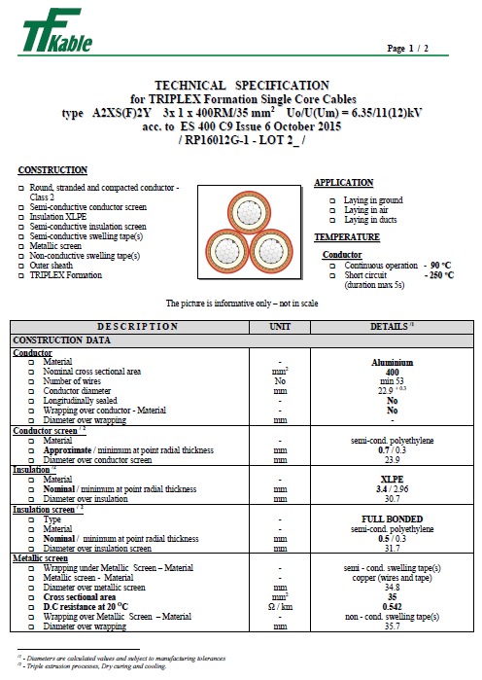

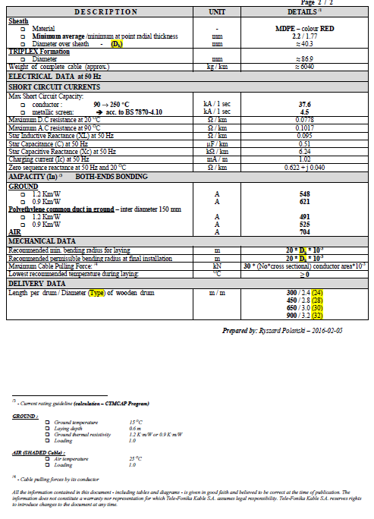

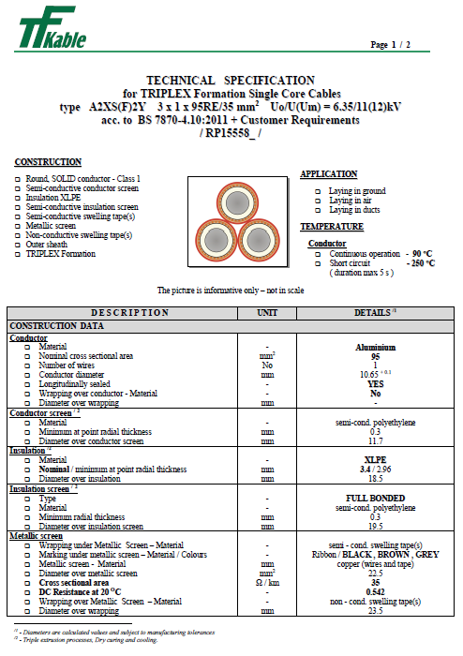

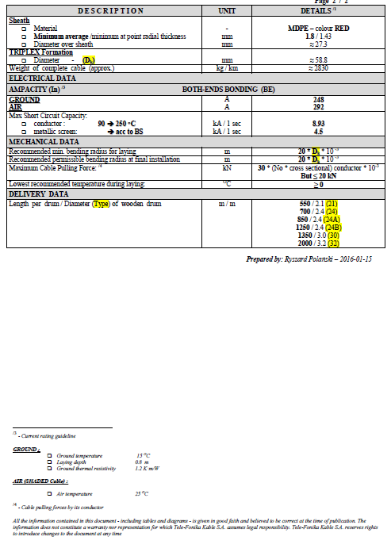

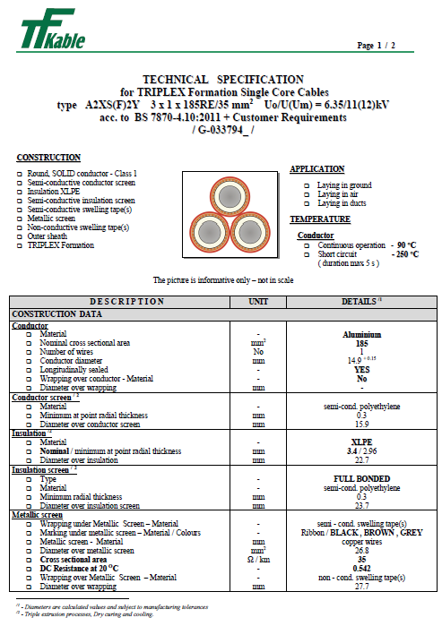

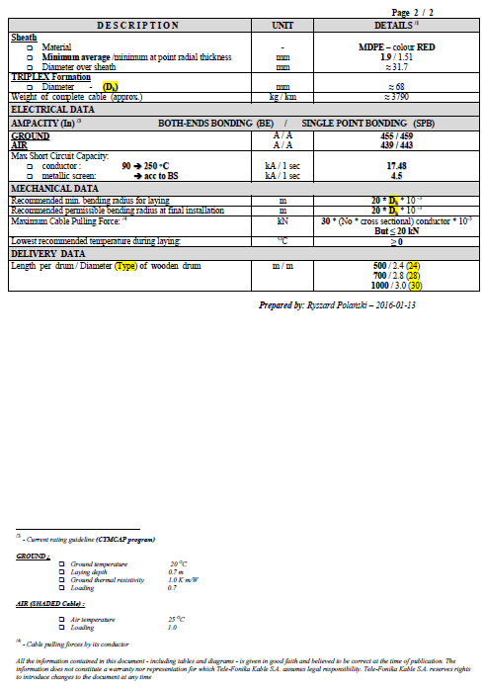

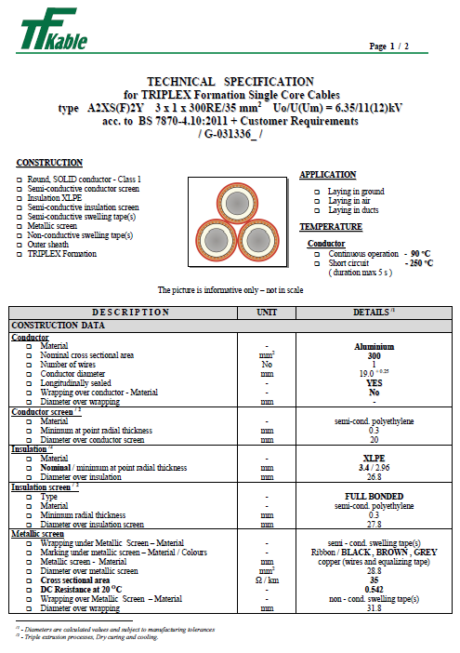

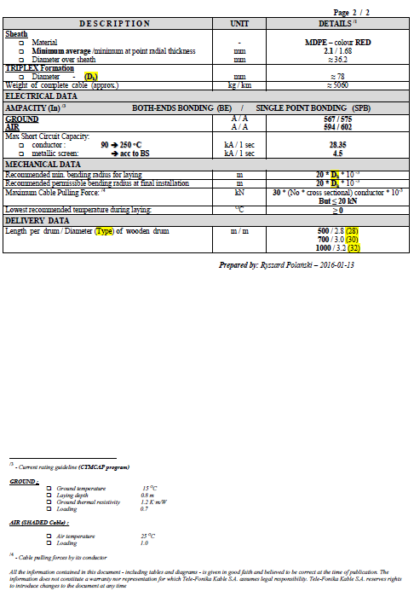

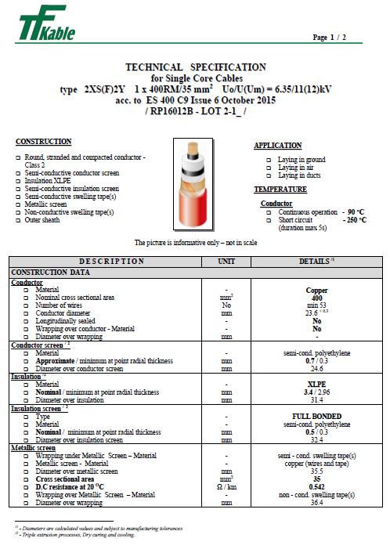

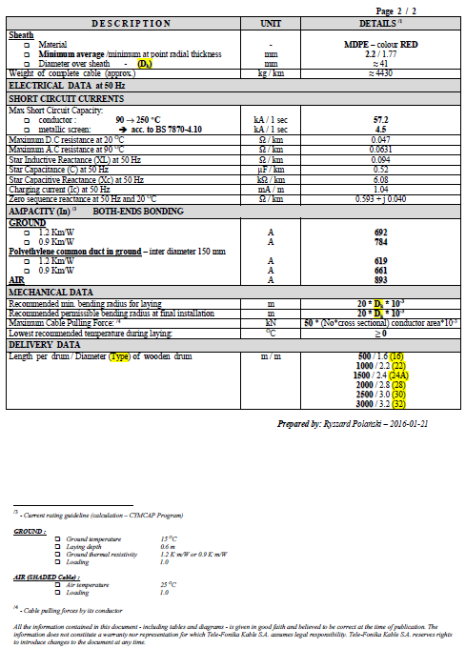

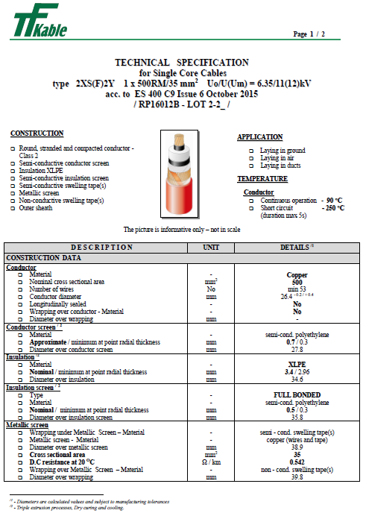

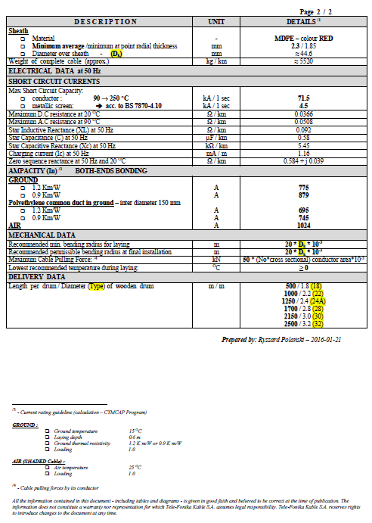

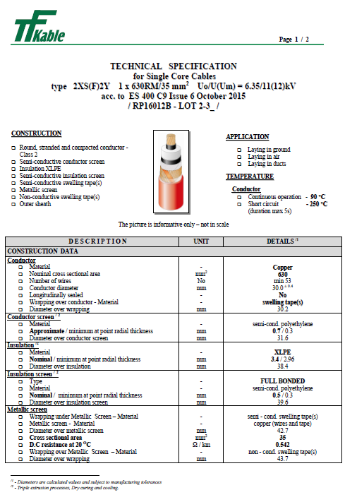

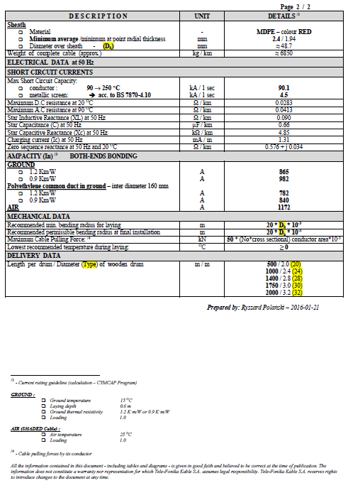

Approved for issue by the
Technical Policy Panel

© 2015 Electricity North West Limited.

All Rights Reserved
The copyright of this document, which contains information of a proprietary nature, is vested in Electricity North West Limited. The contents of this document may not be used for purposes other than that for which it has been supplied and may not be reproduced, either wholly or in part, in any way whatsoever. It may not be used by, or its contents divulged to, any other person whatsoever without the prior written permission of Electricity North West Limited.

Electricity Specification 400C11

Issue 6 October 2015

Low Voltage Mains Cables

Contents
- Scope
- Definitions
- General Requirements for Approvals and Assurance
- Conditions of Installation
- Conditions of Operation for Power Cables
- Cable Longevity
- Manufacturing
- Technical Support
- Requirements for Testing and Sampling
- Technical Particulars
- Documents Referenced
- Keywords
Appendices A to C

Issue and Amendment Summary
Amendment  No.  Date | Brief Description and Amending Action
0 | Issue 1  First Issue  Prepared by: Authorised by:
0  15/07/97 | Issue 2  Document updated in Word 6 with addition of 4 core polymeric waveform cable and inclusion of single phase 400mm² copper XLPE/PVC for use in substations.  Prepared by: DPH Authorised by:
0  05/01/01 | Issue 3  Document updated to BS 7870 and 400mm² singe core armoured cable added. 240mm² Waveform removed.  Prepared by: DSD Authorised by:
1  01/03/01 | Issue 3  Minor update for clarification purposes and current rating requirements added.  Prepared by: DSD Authorised by:
0  09/11/04 | Issue 4  Specification updated for new acceptance requirements.  Prepared by: D. P. Horsman.  Approved by the Standards Steering Group and signed  on its behalf by:
1  15/12/05 | Issue 4  Cable descriptions amended in Appendix A.  Prepared by: D. P. Horsman  Approved by the Technical Policy Panel and signed  on its behalf by:

Issue and Amendment Summary (Continued)
Amendment  No.  Date | Brief Description and Amending Action
0  06/03/12 | Issue 5  4 core LS0H cable added  Prepared by: John Scott  Approved by the Technical Policy Panel and signed  on its behalf by: Paul Whittaker
-  15/10/15 | Issue 6  Specification updated as marked. The latest template has been applied and the Specification has been updated to the latest editorial standard.  Prepared by: John Scott  Approved by the Technical Policy Panel and signed  on its behalf by: Steve Cox

Low Voltage Mains cables

Scope
This Specification covers the technical requirements for Low Voltage (LV) mains cables for use on the Electricity North West Limited (hereinafter referred to as Electricity North West) Distribution System.

Definitions
Approval: | Sanction by the Electricity North West Underground Circuits Manager that specified criteria have been satisfied.
Contract: | The agreement between Electricity North West and the Contractor for the execution of the Works including therein all documents to which reference may properly be made in order to ascertain the rights and obligations of the parties under the said agreement.
Contractor: | The person or person's firm or company, including personal representatives, successors and permitted assigns, whose Tender has been accepted by Electricity North West.
Specification: | The Specifications and schedules (if any) agreed by the parties for the purpose of the Contract.
SubContractor: | Any person (other than the Contractor) named in the Contract for any part of the Works or any person to whom any part of the Contract has been sub-let with the consent in writing of the Electricity North West Underground Circuits Manager, and the legal representatives, successors and assigns of such person.
Supplier: | Any person or person's firm or company who supplies goods to Electricity North West or to its Contractor.
Tender: | An offer in writing to execute work or supply goods at a fixed price.
Tenderer: | The person or person's firm or company, including personal representatives, successors and permitted assigns, invited by Electricity North West to submit a Tender.

GENERAL REQUIREMENTS FOR APPROVALS AND TESTING

Product not to be Changed
No change in the product, packaging or labelling shall be made after Approval has been granted without prior notice to the Electricity North West Underground Circuits Manager and receipt of a written agreement from the Electricity North West Underground Circuits Manager.

Electricity North West Technical Approval
The Tenderer shall submit, with this Tender, proposals for testing which will demonstrate, to the satisfaction of the Electricity North West Underground Circuits Manager, compliance with this Specification. Such tests shall be carried out without expense to Electricity North West.
Alternatively, the Tenderer may submit technical reports and other data that he considers will demonstrate, to the satisfaction of the Electricity North West Underground Circuits Manager, compliance with this Specification. Acceptance of this evidence shall be at the discretion of the Electricity North West Underground Circuits Manager but will not be unreasonably withheld.
15/10/15
Approval shall be ‘factory specific’ and is not transferable to another factory without the written Approval of the Electricity North West Underground Circuits Manager.
The Supplier and product shall comply with all the relevant requirements of Electricity North West documents EPD311 and CP311.

Quality Assurance
The Tenderer shall confirm whether or not Approval is held in accordance with a quality assurance scheme accredited under BS EN ISO 9000. If not, he shall submit a statement of the quality assurance procedures employed to control the quality of the product, including the performance of Suppliers and Sub-Contractors.
15/10/15
15/10/15
The right is reserved for the Electricity North West Underground Circuits Manager to require, from time to time, the repeat of such tests as he may deem to be reasonably necessary to demonstrate continued compliance with the Specification.
The Tenderer shall submit, with his Tender, a list of tests and inspections which are carried out on the product prior to despatch which shall demonstrate, to the satisfaction of the Electricity North West Underground Circuits Manager, fitness for installation and service.
The Tenderer shall provide free of charge to Electricity North West such samples as may, in the opinion of the Electricity North West Underground Circuits Manager, be reasonably required for inspection and/or retention as quality control samples. The Electricity North West Underground Circuits Manager will confirm the requirements for samples at the time of tendering.
The right is reserved for the Electricity North West Underground Circuits Manager to make, from time to time, such inspections of the Tenderer’s facilities as he may deem to be reasonably necessary to ensure compliance with this Specification and any Contract of which it forms a part.
The Tenderer shall submit, with his Tender, such details of product packaging disposal, as will enable Electricity North West to comply with the requirements of BS EN ISO 14001: 2004 – Environmental Management Systems.

Formulation
The Tenderer shall submit, with his Tender, such details of the formulation and use of the product and associated substances as will enable Electricity North West to comply with the obligations of the Health and Safety at Work Act 1974 and the Control of Substances Hazardous to Health Regulations 2002, in the use, storage and disposal of the product. The Tenderer may stipulate, prior to submission of such information, that he requires it to remain confidential and the Electricity North West Underground Circuits Manager will, if requested, confirm his agreement to this prior to receipt of the information.
15/10/15

Identification Markings
The Tenderer shall submit, with his Tender, details of markings which it is proposed to apply to the product or packaging to identify manufacturing batches or items. The forms and content of such markings shall be subject to the Approval of the Electricity North West Underground Circuits Manager, and shall in all cases include the Electricity North West Approved Description and Commodity Code Number.
The Tenderer shall submit, with his Tender, such details of marking gross weight on components, assemblies and packages, as will enable Electricity North West to comply with the Manual Handling Operations Regulation 1992, for components, assemblies and packages supplied with a gross weight over 1kg. The forms and content of such markings shall be subject to the Approval of the Electricity North West Underground Circuits Manager.

Minimum Life Expectancy
The minimum life expectancy of all products covered by this Specification is 30 years.

Product Conformity
Preference will be given to those Suppliers who can provide suitable product conformity certification to a recognised or specified standard, or an equivalent certification.
15/10/15

Confirmation of Conformance
The Tenderer shall complete the conformance declaration sheets in Appendix C. Failure to complete these declaration sheets may result in an unacceptable bid.

Conditions of installation
Cables specified in this Specification will be pulled or laid into open trenches, pulled into ducts or installed in air. Cables may also be installed directly by trenchless installation techniques.
During storage and after installation cables can be expected to be subjected to the full range of climatic conditions encountered in the UK.
Cables may be surrounded by ground water for most of their operating life. Where cables are installed in ducts, flooding of ducts can occur resulting in permanently wet sections along the cable route.
Cables installed above ground will be supported by means of cleats either vertically or horizontally and these cables may be exposed to direct sunlight for significant periods.
Cables may be installed on wood poles in contact with the pole and, therefore, in contact with a pole preservation medium such as creosote.
Accessories may be cold applied or require application of heat.

Conditions of operation for power cables
The following are the general conditions under which power cables purchased in accordance with this Specification are required to operate:
- Nominal system voltage 400/230.
- The working voltage of any part of the system does not normally exceed the normal system voltage by more than 10%.
- Nominal system frequency: 50Hz.
15/10/15
- The system operates with the neutral point earthed either directly or through a resistance or reactance at one or more points.

Cable longevity
Cables offered shall be designed and manufactured to operate satisfactorily under the installation and operating conditions detailed in Sections 4 and 5.

Manufacturing
At the time of Tender, the Tenderer shall provide details of manufacturing location(s) for each cable offered.
Any Approval granted will be site specific and will not be transferable to any other site without the prior written agreement of the Electricity North West Underground Circuits Manager.

Technical support
During the Contract period questions will arise regarding unusual or non-standard applications where advice will be required on matters such as cable ratings etc. The successful Tenderer(s) will be expected to support Electricity North West with technical advice on these matters.

Requirements for testing and Sampling
The Electricity North West Underground Circuits Manager shall set out the requirement of the following tests to be carried out by the Supplier at the Supplier’s cost.

Requirement for Type Tests at the Supplier’s Premises
These are a series of one-off type tests, which are carried out to ensure the satisfactory performance of the product design, under extremes of operating stresses, and of endurance, as may be appropriate, to be determined by the Electricity North West Underground Circuits Manager.
These may or may not be destructive tests.

Type Test Approval
All cables offered shall be fully Type Tested and Qualified according to the requirements of the Technical Specification and Standards detailed for each cable type. The Tenderer shall provide Type Test certificates and Type Test reports, including details of independent witnesses, at the time of Tender.
Where a Tenderer wishes to offer a cable which has been Type Tested to an alternative Standard(s), full details of the alternative Standard(s) and how it differs from the Specified Standard(s) shall be provide at the time of Tender along with Type Test certificates.
If, during the period of the Contract, the Contractor wishes to make any changes to the Approved product, packaging or labelling, proposals for such changes shall be notified in writing to the Electricity North West Underground Circuits Manager. No such changes shall be implemented without the prior written Approval of the Electricity North West Underground Circuits Manager. If the Electricity North West Underground Circuits Manager deems that the changes require Type Approval testing to be repeated, in full or in part, the cost of such testing shall be borne by the Contractor.

Requirement for Routine Tests at the Supplier’s Premises and Sampling
These tests may be required to be carried out on every individual unit or component, as specified, or at some regular frequency to be determined by the Electricity North West Underground Circuits Manager.
The results of these tests may be required to be supplied to Electricity North West with each unit purchased or retained for inspection, at a period to be determined by the Electricity North West Underground Circuits Manager.

Routine and Sample Testing
The Contractor shall carry out all routine and sample tests specified for each cable. Tenderers shall state at the time of Tender their proposals for sample test frequencies where such frequencies are not detailed specifically by this Specification or the relevant referenced Standards or Specifications. The Electricity North West Underground Circuits Manager reserves the right to be present and witness routine and sample tests. Where the Electricity North West Underground Circuits Manager wishes to witness any such tests, the date and time of testing shall be mutually agreed.

Samples
During the Tender period the Tenderer shall submit samples for Approval as required by the Electricity North West Underground Circuits Manager. Such samples shall remain the property of Electricity North West.

TECHNICAL PARTICULARS

Cable Design
This Specification covers the supply of the following types of LV distribution cables:
(a) Single phase; 400mm² XLPE insulated, unarmoured / PVC sheathed cable.
(b) Single phase; 400mm² XLPE insulated, aluminium armoured / PVC sheathed cable.
(c) Three core; 95, 185 and 300mm² polymeric insulated waveform cable.
(d) Four core; 95, 185, and 300mm² polymeric insulated waveform cable.
(e) Three core; 95, 185 and 300mm² polymeric insulated waveform cable with LS0H properties.
(f) Four core; 95, 185 and 300mm² polymeric insulated waveform cable with LS0H properties.

Technical Requirements
Where a requirement of this Specification differs from that of another quoted Specification or Standard, the requirements of this Specification shall apply.
If a Tenderer is unsure regarding any requirement of this Specification, clarification shall be sought in writing from Electricity North West.
Single phase cables referenced at 10.1(a) shall conform to BS 7889.
Single phase cables referenced at 10.1(b) shall conform to BS 5467.
Three core cables referenced at 10.1(c) shall conform to BS 7870 Part 3 Section 3.40.
Four core cables referenced at 10.1(d) shall conform to BS 7870 Part 3 Section 3.40.
Three core cables referenced at 10.1(e) shall conform to BS 7870 Part 3 Section 3.50.
Four core cables referenced at 10.1(f) shall conform to BS 7870 Part 3 Section 3.50.

Cable Data
The following additional cable data shall be provided with all cables supplied:

Impedance Data
- Maximum dc resistance of phase conductor at 20ºC in ohms/km.
- Maximum ac resistance of phase conductor at maximum conductor temperature in ohms/km.
- Maximum dc resistance of CNE conductor or armour at 20ºC in ohms/km.
- Equivalent star reactance at 50 Hz in ohms/km.
- Equivalent star capacitance in pF/km.
- Charge current per phase at normal voltage and frequency in mA/m.
- Zero sequence impedance R₀ + jK₀ in ohms/km.

Current Rating Data
The maximum continuous current carrying capacity per phase conductor for the following conditions:
- Laid direct with g = 1.2 ºC/W and Tg = 15 ºC (with the exception of cable in Schedule 5).
- Laid direct with g = 0.9 ºC/W and Tg = 15 ºC (with the exception of cable in Schedule 5).
- Drawn into a 150mm ID smooth wall plastic duct (one cable or triplex cable per duct) where g = 1.2 ºC/W and Tg = 15 ºC (with the exception of cable in Schedules 5 & 6).
- Drawn into a 150mm ID smooth wall plastic duct (one cable or triplex cable per duct) where g = 0.9 ºC/W and Tg = 15 ºC (with the exception of cable in Schedules 5 & 6).
- In Air where Tg = 25 ºC.
Tenderers shall also provide data to show the variation in rating with Ground TR and depth of cover.

Installation Parameters
For each power cable offered the Tenderer shall provide the following parameters:
- Minimum dynamic bending radius in mm.
- Minimum static bending radius in mm.
- Recommended pulling method and maximum pulling tension in kgF.
- Phase Core Insulation

- Phase core insulation shall be XLPE type DIX 3 complying with the requirements of BS 7870-1 Annex B for all Low Voltage Mains Cables.
- Three phase Low Voltage Mains Cables shall have the cores laid up with a right hand direction of lay in the sequence Brown, Black, Grey (and Blue neutral for four core cable).
15/10/15
- The oversheath of the cables referred to in sections 10.1.1 to 10.1.4 shall be black PVC DMV 23 complying to the requirements of BS 7870-1 Annex B.
- The oversheath of the cables referred to in sections 10.1.5 to 10.1.6 shall be orange compound DMZ 4 complying to the requirements of BS 7870-1 Annex B.10.5 Cable Identification
- Each delivery length of cable shall be allocated a unique reference number. This unique reference number shall be marked on the cable near to the metre mark. This unique reference number will be used to identify all materials used within the manufacturing process. This number shall appear on the factory test sheet covering the cable length and shall be clearly marked on the drum on which the length is delivered and shall be referred to on all invoices and advice notes.

Phase Core Insulation
15/10/15
Phase core insulation shall be XLPE type DIX 3 complying with the requirements of BS 7870-1 Annex B for all Low Voltage Mains Cables.
Three phase Low Voltage Mains Cables shall have the cores laid up with a right hand direction of lay in the sequence Brown, Black, Grey (and Blue neutral for four core cable).
The oversheath of the cables referred to in sections 10.1(a) to 10.1(d) shall be black PVC DMV 23 complying to the requirements of BS 7870-1 Annex B.
The oversheath of the cables referred to in sections 10.1(e) to 10.1(f) shall be orange compound DMZ 4 complying to the requirements of BS 7870-1 Annex B.

Cable Identification
Each delivery length of cable shall be allocated a unique reference number. This unique reference number shall be embossed on the cable near to the metre mark. This unique reference number will be used to identify all materials used within the manufacturing process. This number shall appear on the factory test sheet covering the cable length and shall be clearly marked on the drum on which the length is delivered and shall be referred to on all invoices and advice notes.
15/10/15
15/10/15

Oversheath Marking
In addition to the requirements detailed in the relevant specification for each cable supplied, the unique reference number shall be embossed in the cable oversheath.

Logistical Requirements
Each cable supplied shall meet the requirements of Appendix B.

Documents referenced
Health and Safety at Work Etc Act 1974.
15/10/15
Control of Substances Hazardous to Health Regulations 2002.
Manual Handling Operations Regulation 1992.
15/10/15
BS EN ISO 9000: | Quality management systems.
BS EN ISO 14001: 2004: | Environmental management systems. Requirements with guidance for use.
BS 5467: 1997: | Specification for 600/1000 V and 1900/3300 V Armoured Electric Cables having Thermosetting Insulation.  15/10/15
BS EN 60228: 2005: | Conductors of insulated cables.
BS 7655: | Insulation and sheathing materials for cables.  15/10/15
BS 7870 Part 1: | LV and MV polymeric insulated cables for use by distribution and generation utilities.
BS 7870 Part 3: | XLPE Insulated, Copper Wire Waveform Concentric Cables with Solid Aluminium Conductors.
BS 7889: 1997: | Specification for 600/1000 V Single-Core Unarmoured Electric Cables having Thermosetting Insulation.  15/10/15
EPD311: | Approval of Equipment.
CP311: | Equipment Approval Process.
ES400C7: | Returnable Cable Drums for Mains Cables Conforming to ECP 410 Chapter 1.

Keywords
Cable; Waveform; XLPE; PVC; Polymeric

appendix a
Schedule of cables

Item No. | Ordering Specification | Size (mm²) | CC No.
1 | Cable, LV, single core, XLPE insulated, unarmoured (for use in indoor substations) | 400 | TBA
2 | Cable, LV, single core; XLPE insulated, armoured (for use in outdoor substations) | 400 | TBA
3 | Cable, LV, 3 core, waveform | 95  185  300 | 003697  003700  003727
4 | Cable, LV, 4 core, waveform | 95  185  300 | 003735  000701  003759
5 | Cable, LV, 3 core, waveform (LS0H) | 95  185  300 | TBA  TBA  TBA
6 | Cable, LV, 4 core, waveform (LS0H) | 95  185  300 | TBA  TBA  TBA

A1. schedule one – SINGLE core: 400mm² XLPE INSULATED unarmoured CABLE (for use in indoor substations)

A1.1 Specification
Circular stranded copper conductor, XLPE insulation, unarmoured with Black PVC oversheath, 0.6/1.0kV cable and be in accordance with BS 7889: 1997, Table 3.
The phase colour shall be brown, the neutral colour shall be blue.

A2. schedule two – SINGLE core: 400mm² XLPE INSULATED armoured CABLE (for use in OUTDOOR substations)

A2.1 Specification
Circular copper conductor, XLPE insulation, 147 mm² of aluminium wire armour, Black PVC oversheath, 0.6/1.0kV cable and be in accordance with BS 5467: 1997, Table 4.
The phase colour shall be brown, the neutral colour shall be blue.

A3. schedule three – 3 CORE: 95, 185 and 300mm² POLYMERIC INSULATED WAVEFORM CABLE

A3.1 Specification
Three core, three phase sectoral solid aluminium conductor, XLPE insulation, CNE of copper wires applied in waveform embedded on synthetic rubber, Black PVC oversheath, 0.6/1.0kV cable.
15/10/15
Phase conductors shall be sectoral shaped solid aluminium and shall comply to the requirements for solid conductors (class 1) as specified in BS EN 60228. The conductors shall also conform to the dimensional requirements specified in BS EN 60228 or BS 3988. The Supplier shall confirm which shape of conductor is being offered and to what specification.
Phase core insulation shall be XLPE type DIX3 complying with the requirements of BS 7870-1 Annex B, however the maximum permissible shrinkage shall be 4%. The test shall be carried out at both 65ºC for 24 hours and 130ºC for 1 hour.
Cores shall be laid up with a right hand direction of lay in the sequence Brown, Black and Grey.
The CNE of copper wires shall not stick to the synthetic bedding layer.
The oversheath shall be black PVC type DMV 23 complying with the requirements of BS 7870-1 Annex B and applied so that there is no internal protrusion of the oversheath material around the CNE copper wires.
Cable to be in accordance with BS 7870 Part 3 Section 3.40.

A4. schedule four – 4 CORE: 95, 185 AND 300mm² POLYMERIC INSULATED WAVEFORM CABLE

A4.1 Specification
Four core, three phase and separate neutral sectoral solid aluminium conductor, XLPE insulation, SCNE of copper wires applied in waveform embedded on synthetic rubber, Black PVC oversheath, 0.6/1.0kV.
15/10/15
Phase conductors shall be sectoral shaped solid aluminium and shall comply to the requirements for solid conductors (class 1) as specified in BS EN 60228. The conductors shall also conform to the dimensional requirements specified in BS EN 60228 or BS 3988. The Supplier shall confirm which shape of conductor is being offered and to what specification.
Phase core insulation shall be XLPE type DIX3 complying with the requirements of BS 7870-1 Annex B, however the maximum permissible shrinkage shall be 4%.The test shall be carried out at both 65ºC for 24 hours and 130ºC for 1 hour. The neutral core shall be coloured blue and the cores shall be laid up with a right hand direction of lay in the sequence Brown, Black, Grey and Blue.
The CNE of copper wires shall not stick to the synthetic bedding layer.
The oversheath shall be black PVC type DMV 23 complying with the requirements of BS 7870-1 Annex B and applied so that there is no internal protrusion of the oversheath material around the CNE copper wires.
Cable to be in accordance with BS 7870 Part 3 Section 3.40.

A5. schedule five – 3 CORE: 95, 185 and 300mm² POLYMERIC INSULATED WAVEFORM CABLE (LS0H)

A5.1 Specification
Three core, three phase sectoral solid aluminium conductor, XLPE insulation, CNE of copper wires applied in waveform embedded on a LS0H bedding, LS0H oversheath, 0.6/1.0kV cable.
15/10/15
Phase conductors shall be sectoral shaped solid aluminium and shall comply to the requirements for solid conductors (class 1) as specified in BS EN 60228. The conductors shall also conform to the dimensional requirements specified in BS EN 60228 or BS 3988. The Supplier shall confirm which shape of conductor is being offered and to what specification.
Phase core insulation shall be XLPE type DIX3 complying with the requirements of BS 7870-1 Annex B, however the maximum permissible shrinkage shall be 4%.The test shall be carried out at both 65ºC for 24 hours and 130ºC for 1 hour.
The CNE of copper wires shall not stick to the synthetic bedding layer.
The oversheath shall be orange compound DMZ 23 complying with the requirements of BS 7870-1 Annex B and applied so that there is no internal protrusion of the oversheath material around the CNE copper wires.
Cable to be in accordance with BS 7870 Part 3 Section 3.50.

A6. schedule Six – 4 CORE: 95, 185 and 300mm² POLYMERIC INSULATED WAVEFORM CABLE (LS0H)

A6.1 Specification
Four core, three phase and a separate neutral sectoral solid aluminium conductor, XLPE insulation, CNE of copper wires applied in waveform embedded on a LS0H bedding, LS0H oversheath, 0.6/1.0kV cable.
Phase conductors shall be sectoral shaped solid aluminium and shall comply to the requirements for solid conductors (class 1) as specified in BS EN 60228. The conductors shall also conform to the dimensional requirements specified in BS EN 60228 or BS 3988. The Supplier shall confirm which shape of conductor is being offered and to what specification.
Phase core insulation shall be XLPE type DIX3 complying with the requirements of BS 7870-1 Annex B, however the maximum permissible shrinkage shall be 4%. The test shall be carried out at both 65ºC for 24 hours and 130ºC for 1 hour. The oversheath shall be orange compound DMZ 23 complying with the requirements of BS 7870-1 Annex B and applied so that there is no internal protrusion of the oversheath material around the Earth copper wires.
Cable to be in accordance with BS 7870 Part 3 Section 3.50.

Appendix B
15/10/15
Logistical Requirements

B1. Cable Drums and labelLing
Drums used for LV mains cables shall have a maximum width of 1200mm and a maximum weight of 2500kg.
Cable drums shall meet the requirements of ES400C7.
All cable drums shall be marked in accordance with the relevant cable specification or standard. The drum label shall also contain:
- Electricity North West commodity code
- Name of manufacturer
- Supplied length
- Rated voltage
- Number of cores
- Size of conductor
- Type of conductor material ("Cu" or "Al")
- Abbreviated description of cable construction
- Gross and nett weights
- Direction of rolling drum
- The metre marking start and end values
- The unique reference number

B2. general logistical requirements
Cable drums may be stored for long periods outdoors. All drum labels shall remain legible and durable under these conditions.
All cable drums shall be returnable and the Tenderer shall arrange to collect empty drums from the company's normal delivery locations. Tenderers shall state at the time of Tender their proposed cable drum sizes and weights for each cable type offered.
The ends of all cables shall be effectively sealed against the ingress of moisture by a method appropriate to the cable type. Tenderers shall detail at the time of Tender their proposed sealing arrangement for each cable type offered.
The cable end projecting from the drum shall be protected from damage during transit, storage and handling on site.
The cable on the drum shall not be susceptible to damage during transit, storage and handling on site.
15/10/15
Tenderers shall state at the time of Tender their proposed method of protection for each cable.

Appendix C
15/10/15
CONFORMANCE DECLARATION
SECTION-BY-SECTION CONFORMANCE WITH SPECIFICATION
The Tenderer shall declare conformance or otherwise for each product/service or range of products/services, section-by-section, using the following Conformance Declaration Codes.
Conformance Declaration Codes:
N/A = | Section is not applicable/appropriate to the product/service.
C1 = | The product/service conforms fully with the requirements of this section.
C2 = | The product/service conforms partially with the requirements of this section.
C3 = | The product/service does not conform to the requirements of this section.
C4 = | The product/service does not currently conform to the requirements of this section, but the manufacturer proposes to modify and test the product in order to conform.
Manufacturer:
Product/Service description:

Product/Service reference:

Assessor details
Name:
Company:
Signature:
Date:

SECTION-BY-SECTION CONFORMANCE
15/10/15
Section | Section Topic | Conformance  Declaration  Code | Remarks *  (must be completed if code is not C1)
3.1 | Product not to be Changed
3.2 | Electricity North West Technical Approval
3.3 | Quality Assurance
3.4 | Formulation
3.5 | Identification Markings
3.6 | Minimum Life Expectancy
3.7 | Product Conformity
3.8 | Confirmation of Conformance
4. | Conditions of Installation
5. | Conditions of Operation for Power Cables
6. | Cable Longevity
7. | Manufacturing
8. | Technical Support
9.1 | Requirement for Type Tests at the Supplier’s Premises
9.2 | Type Test Approval
9.3 | Requirement for Routine Tests at the Supplier’s Premises and Sampling
9.4 | Routine and Sample Testing
9.5 | Samples
10.2 | Technical Requirements
10.3.1 | Impedance Data
10.3.2 | Current Rating Data
10.3.3 | Installation Parameters
10.4 | Phase Core Insulation
10.5 | Cable Identification
10.5.1 | Oversheath Marking
10.6 | Logistical Requirements
App A | Schedule 1
App A | Schedule 2
App A | Schedule 3
App A | Schedule 4
App A | Schedule 5
App A | Schedule 6

Additional Notes:

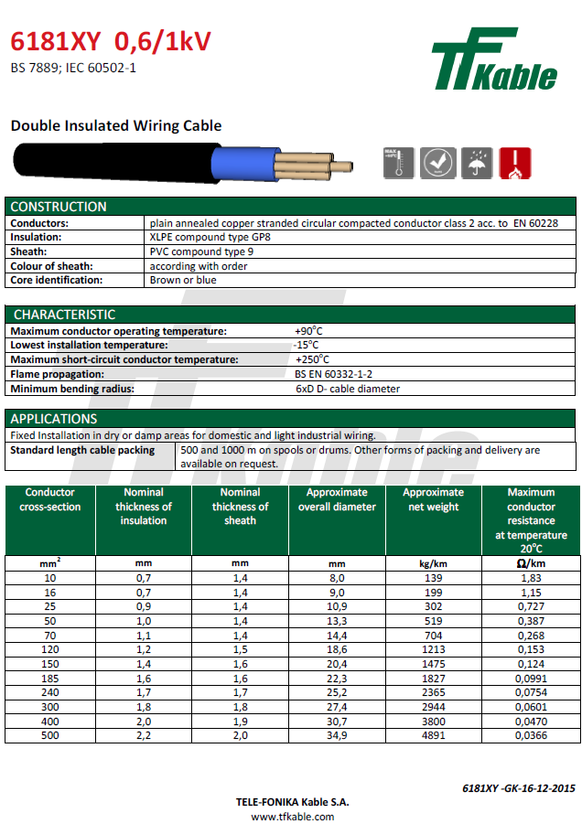

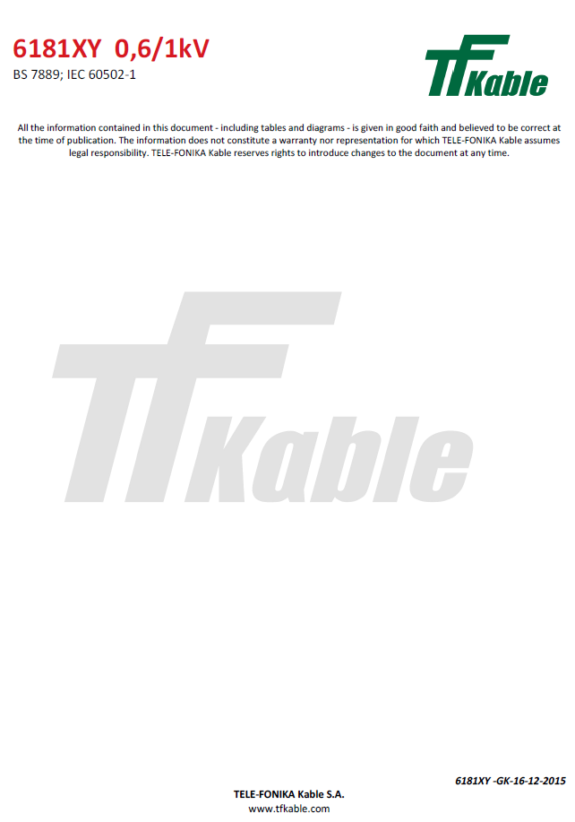

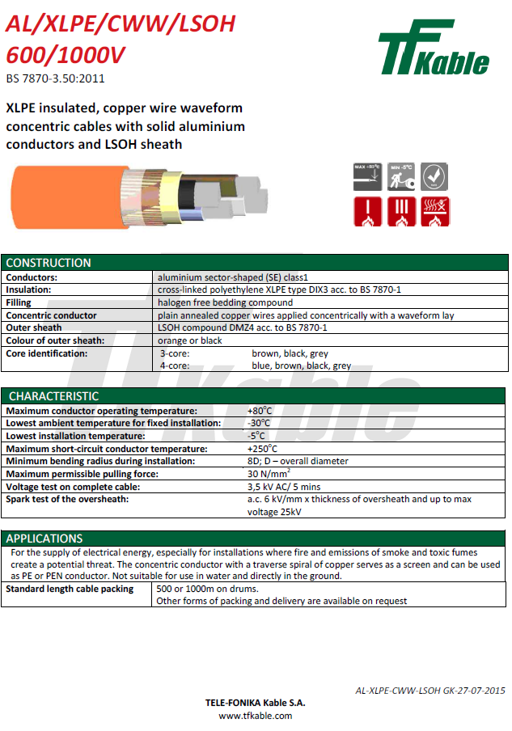

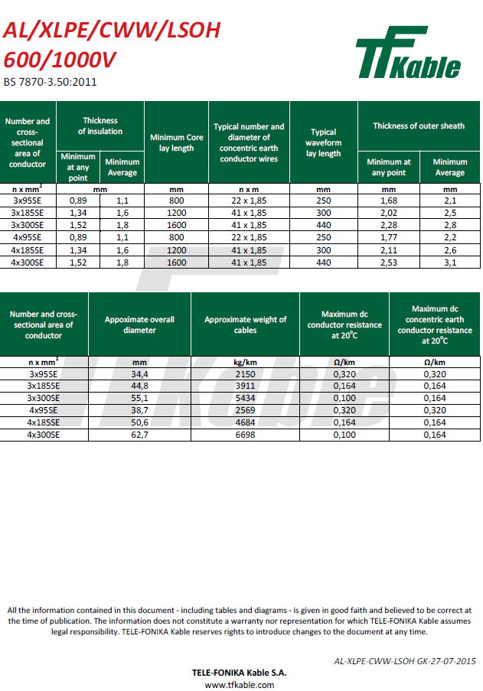

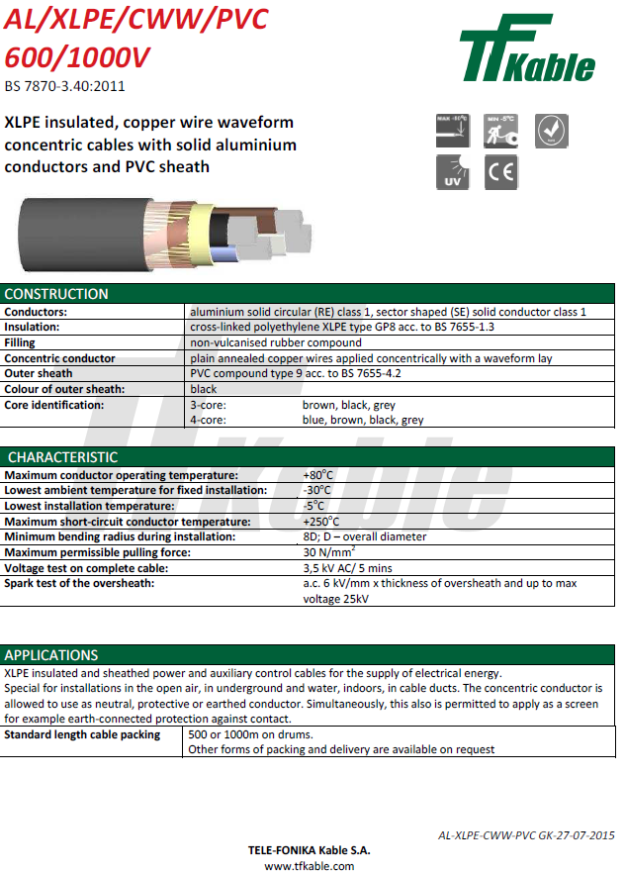

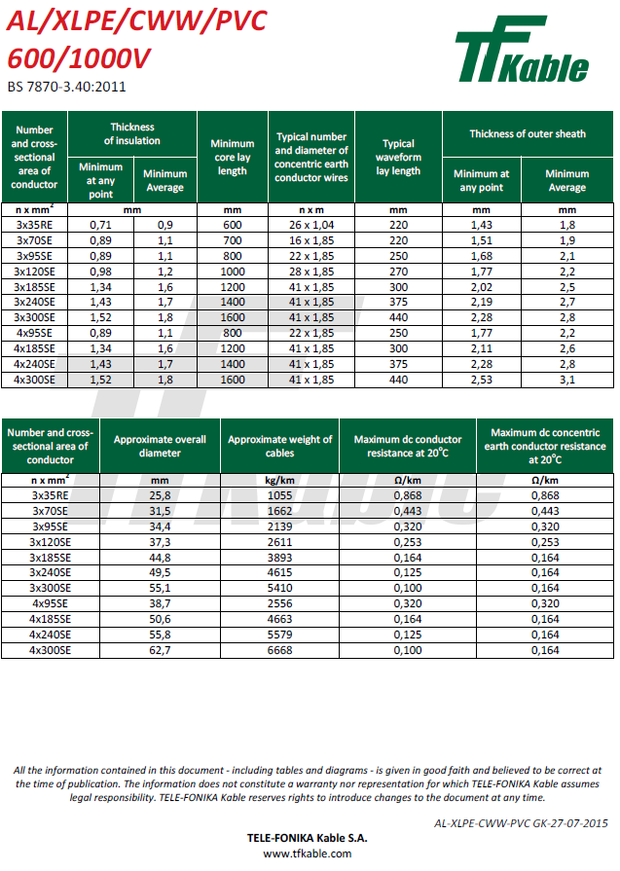

Approved for issue by the
Technical Policy Panel

© 2015 Electricity North West Limited.

All Rights Reserved
The copyright of this document, which contains information of a proprietary nature, is vested in Electricity North West Limited. The contents of this document may not be used for purposes other than that for which it has been supplied and may not be reproduced, either wholly or in part, in any way whatsoever. It may not be used by, or its contents divulged to, any other person whatsoever without the prior written permission of Electricity North West Limited.

Electricity Specification 400C13

Issue 4 October 2015

Multipair & Multicore Auxiliary Cables
Contents
- Scope
- Definitions
- General Requirements for Approvals and Assurance
- Conditions of Installation
- Conditions of Operation for Power Cables
- Cable Longevity
- Manufacturing
- Technical Support
- Testing and Approval
- Technical Particulars
- Schedule One
- Schedule Two
- Schedule Three
- Schedule Four
- Schedule Five
- Schedule Six
- Documents Referenced
- Keywords
Appendices A to C

Issue and Amendment Summary
Amendment  No.  Date | Brief Description and Amending Action
0  27/04/01 | Issue 1  First Issue  Prepared by: DSD Authorised by:
0  22/04/02 | Issue 2  Updated to latest Template. 0.8 mm diameter multipair cable added. New clauses for Type & Routine Testing added.  Prepared by: D. Horsman. Authorised by:
0  11/11/04 | Issue 3  Specification updated for new acceptance requirements.  Prepared by: D. P. Horsman.  Approved by the Standards Steering Group and signed  on its behalf by:
-  15/10/15 | Issue 4  Specification updated as marked. The latest template has been applied and the Specification has been updated to the latest editorial standard.  Prepared by: John Scott  Approved by the Technical Policy Panel and signed  on its behalf by: Steve Cox

Multipair & Multicore Auxiliary Cables

Scope
This Specification covers the technical requirements for multicore and multipair auxiliary cables for use on the Electricity North West Limited (hereinafter referred to as Electricity North West) Distribution System.

Definitions
Approval: | Sanction by the Electricity North West Underground Circuits Manager that specified criteria have been satisfied.
Contract: | The agreement between Electricity North West and the Contractor for the execution of the Works including therein all documents to which reference may properly be made in order to ascertain the rights and obligations of the parties under the said agreement.
Contractor: | The person or person's firm or company, including personal representatives, successors and permitted assigns, whose Tender has been accepted by Electricity North West.
Specification: | The Specifications and schedules (if any) agreed by the parties for the purpose of the Contract.
SubContractor: | Any person (other than the Contractor) named in the Contract for any part of the Works or any person to whom any part of the Contract has been sub-let with the consent in writing of the Electricity North West Underground Circuits Manager, and the legal representatives, successors and assigns of such person.
Supplier: | Any person or person's firm or company who supplies goods to Electricity North West or to its Contractor.
Tender: | An offer in writing to execute work or supply goods at a fixed price.
Tenderer: | The person or person's firm or company, including personal representatives, successors and permitted assigns, invited by Electricity North West to submit a Tender.

GENERAL REQUIREMENTS FOR APPROVALS AND TESTING

Product not to be Changed
No change in the product, packaging or labelling shall be made after Approval has been granted without prior notice to the Electricity North West Underground Circuits Manager and receipt of a written agreement from the Electricity North West Underground Circuits Manager.

Electricity North West Technical Approval
The Tenderer shall submit, with this Tender, proposals for testing which will demonstrate, to the satisfaction of the Electricity North West Underground Circuits Manager, compliance with this Specification. Such tests shall be carried out without expense to Electricity North West.
Alternatively, the Tenderer may submit technical reports and other data that he considers will demonstrate, to the satisfaction of the Electricity North West Underground Circuits Manager, compliance with this Specification. Acceptance of this evidence shall be at the discretion of the Electricity North West Underground Circuits Manager but will not be unreasonably withheld.
15/10/15
Approval shall be ‘factory specific’ and is not transferable to another factory without the written Approval of the Electricity North West Underground Circuits Manager.
The Supplier and product shall comply with all the relevant requirements of Electricity North West documents EPD311 and CP311.

Quality Assurance
The Tenderer shall confirm whether or not Approval is held in accordance with a quality assurance scheme accredited under BS EN ISO 9000. If not, he shall submit a statement of the quality assurance procedures employed to control the quality of the product, including the performance of Suppliers and Sub-Contractors.
15/10/15
15/10/15
The right is reserved for the Electricity North West Underground Circuits Manager to require, from time to time, the repeat of such tests as he may deem to be reasonably necessary to demonstrate continued compliance with the Specification.
The Tenderer shall submit, with his Tender, a list of tests and inspections which are carried out on the product prior to despatch which shall demonstrate, to the satisfaction of the Electricity North West Underground Circuits Manager, fitness for installation and service.
The Tenderer shall provide free of charge to Electricity North West such samples as may, in the opinion of the Electricity North West Underground Circuits Manager, be reasonably required for inspection and/or retention as quality control samples. The Electricity North West Underground Circuits Manager will confirm the requirements for samples at the time of tendering.
The right is reserved for the Electricity North West Underground Circuits Manager to make, from time to time, such inspections of the Tenderer’s facilities as he may deem to be reasonably necessary to ensure compliance with this Specification and any Contract of which it forms a part.
The Tenderer shall submit, with his Tender, such details of product packaging disposal, as will enable Electricity North West to comply with the requirements of BS EN ISO 14001: 2004 – Environmental Management Systems.

Formulation
The Tenderer shall submit, with his Tender, such details of the formulation and use of the product and associated substances as will enable Electricity North West to comply with the obligations of the Health and Safety at Work Act 1974 and the Control of Substances Hazardous to Health Regulations 2002, in the use, storage and disposal of the product. The Tenderer may stipulate, prior to submission of such information, that he requires it to remain confidential and the Electricity North West Underground Circuits Manager will, if requested, confirm his agreement to this prior to receipt of the information.
15/10/15

Identification Markings
The Tenderer shall submit, with his Tender, details of markings which it is proposed to apply to the product or packaging to identify manufacturing batches or items. The forms and content of such markings shall be subject to the Approval of the Electricity North West Underground Circuits Manager, and shall in all cases include the Electricity North West Approved Description and Commodity Code Number.
The Tenderer shall submit, with his Tender, such details of marking gross weight on components, assemblies and packages, as will enable Electricity North West to comply with the Manual Handling Operations Regulation 1992, for components, assemblies and packages supplied with a gross weight over 1kg. The forms and content of such markings shall be subject to the Approval of the Electricity North West Underground Circuits Manager.

Minimum Life Expectancy
The minimum life expectancy of all products covered by this Specification is 30 years.

Product Conformity
Preference will be given to those Suppliers who can provide suitable product conformity certification to a recognised or specified standard, or an equivalent certification.
15/10/15

Confirmation of Conformance
The Tenderer shall complete the conformance declaration sheets in Appendix C. Failure to complete these declaration sheets may result in an unacceptable bid.

Conditions of installation
Cables specified in this Specification will be pulled or laid into open trenches, pulled into ducts or installed in air. Cables may also be installed directly by trenchless installation techniques.
During storage and after installation cables can be expected to be subjected to the full range of climatic conditions encountered in the UK.
Cables may be surrounded by ground water for most of their operating life. Where cables are installed in ducts, flooding of ducts can occur resulting in permanently wet sections along the cable route.
Cables installed above ground will be supported by means of cleats either vertically or horizontally and these cables may be exposed to direct sunlight for significant periods.
Cables may be installed on wood poles in contact with the pole and, therefore, in contact with a pole preservation medium such as creosote.
Accessories may be cold applied or require application of heat.

Conditions of operation for power cables
The following are the general conditions under which power cables purchased in accordance with this Specification are required to operate:
15/10/15
- Nominal system voltage (V): 11 000/6 360; 33 000/19 000 and 132 000/76 000.
- The working voltage of any part of the system does not normally exceed the normal system voltage by more than 6%.
- Nominal system frequency: 50Hz.
- The system operates with the neutral point earthed either directly or through a resistance or reactance at one or more points.

Cable longevity
Cables offered shall be designed and manufactured to operate satisfactorily under the installation and operating conditions detailed in Sections 4 and 5.
15/10/15

Manufacturing
At the time of Tender, the Tenderer shall provide details of manufacturing location(s) for each cable offered. For cables with extruded insulation, the Tenderer shall also provide details of extrusion and curing technology for each cable offered. The cross linking process will be completely “Dry Cured” and no water will be used during this process.
15/10/15
Any Approval granted will be site specific and will not be transferable to any other site without the prior written agreement of the Electricity North West Underground Circuits Manager.

Technical support
During the Contract period questions will arise regarding unusual or non-standard applications where advice will be required on matters such as cable ratings etc. The successful Tenderer(s) will be expected to support Electricity North West with technical advice on these matters.

Testing and approval

Type Test Approval
All cables offered shall be fully Type Tested and Qualified according to the requirements of the Technical Specification and Standards detailed for each cable type. The Tenderer shall provide Type Test certificates and Type Test reports, including details of independent witnesses, at the time of Tender.
Where a Tenderer wishes to offer a cable which has been Type Tested to an alternative Standard(s), full details of the alternative Standard(s) and how it differs from the Specified Standard(s) shall be provided at the time of Tender along with Type Test certificates.
If, during the period of the Contract, the Contractor wishes to make any changes to the Approved product, packaging or labelling, proposals for such changes shall be notified in writing to the Electricity North West Underground Circuits Manager. No such changes shall be implemented without the prior written Approval of the Electricity North West Underground Circuits Manager. If the Electricity North West Underground Circuits Manager deems that the changes require Type Approval testing to be repeated, in full or in part, the cost of such testing shall be borne by the Contractor.
15/10/15

Requirement for Routine Tests at the Supplier’s Premises and Sampling
These tests may be required to be carried out on every individual unit or component, as specified, or at some regular frequency to be determined by the Electricity North West Underground Circuits Manager.
The results of these tests may be required to be supplied to Electricity North West with each unit purchased or retained for inspection, at a period to be determined by the Electricity North West Underground Circuits Manager.

Routine and Sample Testing
The Contractor shall carry out all routine and sample tests specified for each cable. Tenderers shall state at the time of Tender their proposals for sample test frequencies where such frequencies are not detailed specifically by this Specification or the relevant referenced Standards or Specifications. The Electricity North West Underground Circuits Manager reserves the right to be present and witness routine and sample tests. Where the Electricity North West Underground Circuits Manager wishes to witness any such tests, the date and time of testing shall be mutually agreed.

Samples
During the Tender period the Tenderer shall submit samples for Approval as required by the Electricity North West Underground Circuits Manager. Such samples shall remain the property of Electricity North West.

TECHNICAL PARTICULARS

Scope
This Specification covers the supply of the following types of auxiliary cables:

Multicore Cables
4, 7, 12 and 19 core PVC insulated, steel wire armoured multicore cable with PVC oversheath with a conductor size of 7/0.67mm diameter.

1/0.8mm Multipair Cables
15/10/15
7, 19, 37 and 61 pair polythene insulated multipair cable with PVC oversheath, with core diameter of 0.8mm.
Both filled and unfilled types are required (refer to Sections 39 to 42).

1/0.9mm Multipair Cables
7, 19, 37 and 61 pair unfilled polythene insulated multipair cable with PVC oversheath, with core diameter of 0.9mm.

Technical Requirements
Multicore cables referenced at 0 shall comply with BS7870 Part 8 Section 8.1.
Multipair cables referenced at 0 shall comply with BS7870 Part 8 Section 8.2.
15/10/15
Multipair cables referenced at 0 shall comply with ENA TS 09-6.

Cable Technical Characteristics
Cable technical characteristics shall be in accordance with ENA TS 09-6.

Cable Identification
15/10/15
Each delivery length of cable shall be allocated a unique reference number. This unique reference number shall be embossed on the cable near to the metre mark. This unique reference number will be used to identify all materials used within the manufacturing process. This number shall appear on the factory test sheet covering the cable length and shall be clearly marked on the drum on which the length is delivered and shall be referred to on all invoices and advice notes.

Oversheath Marking
In addition to the requirements detailed in the relevant specification for each cable supplied, the unique reference number shall be embossed in the cable oversheath.

Logistical Requirements
Each cable supplied shall meet the requirements of Appendix B.

Schedule One – Multicore: 4, 7, 12 & 19 core PVC insulated

Specification
The cable described in Section 0 shall have seven strand 0.67mm diameter, circular copper conductors complying with BS EN 60228 (class 2); PVC insulation with one layer of galvanized steel wire armourand black PVC oversheath.
15/10/15
Cable to be in accordance with BS 7870 Part 8 Section 8.1.
15/10/15

Schedule Two – Multipair: 7, 19, 37 & 61 pair polythene insulated with 1/0.8mm diameter conductor (Induced voltages not exceeding 5kV)

(Shall be used only for new work.)

Specification
The cable described in Section 0 shall have one 0.8mm diameter circular solid copper conductor complying with BS EN 60228 in so far as applicable, polythene insulation, unfilled with one layer of galvanized steel wire armour and black PVC oversheath.
Cable to be in accordance with BS 7870 Part 8 Section 8.2.
The cable sheath shall, in addition to the requirements of BS 7870 Part 8, be embossed with the conductor diameter and number of pairs, eg 0.8mm/37pr and indicate the cable is unfilled.
The cores shall be clearly identified by colours in accordance with the sequence detailed in ENA TS 09-6.
15/10/15

Schedule Three – multipair: 7, 19, 37 & 61 pair polythene insulated with 1/0.8mm diameter conductor (Induced Voltages not Exceeding 5kV)

(Shall be used only for new work.)

Specification
The cable described in Section 0 shall have one 0.8mm diameter circular solid copper conductor complying with BS EN 60228 in so far as applicable, polythene insulation, filled with one layer of galvanized steel wire armour and black PVC oversheath.
Filled cables shall be filled with a suitable medium which shall have no detrimental effect on the core insulation and insulation colours.
Cable to be in accordance with BS 7870 Part 8 Section 8.2.
The cable sheath shall, in addition to the requirements of BS 7870 Part 8, be embossed with the conductor diameter and number of pairs, eg 0.8mm/37pr and shall indicate the cable is filled.
The cores shall be clearly identified by colours in accordance with the sequence detailed in ENA TS 09-6.

Schedule Four – multipair: 7, 19, 37 & 61 pair polythene insulated with 1/0.8mm diameter conductor (Induced voltages May exceed 5kV but not exceed 15kV)

(Shall be used only for new work.)

Specification
The cable described in Section 0 shall have one 0.8mm diameter circular solid copper conductor complying with BS EN 60228 in so far as applicable, polythene insulation, unfilled with one layer of galvanized steel wire armour and black PVC oversheath.
Cable to be in accordance with BS 7870 Part 8 Section 8.2.
The cable sheath shall, in addition to the requirements of BS 7870 Part 8, be embossed with the conductor diameter and number of pairs, eg 0.8mm/37pr and indicate the cable is unfilled.
The cores shall be clearly identified by colours in accordance with the sequence detailed in ENA TS 09-6.

Schedule Five – multipair: 7, 19, 37 & 61 pair polythene insulated with 1/0.8mm diameter conductor (Induced voltages May exceed 5kV but not exceed 15kV)
15/10/15

(Shall be used only for new work.)

Specification
The cable described in Section 0 shall have one 0.8mm diameter circular solid copper conductor complying with BS EN 60228 in so far as applicable, polythene insulation, filled with one layer of galvanized steel wire armour and black PVC oversheath.
Filled cables shall be filled with a suitable medium which shall have no detrimental effect on the core insulation and insulation colours.
Cable to be in accordance with BS 7870 Part 8 Section 8.2.
The cable sheath shall, in addition to the requirements of BS 7870 Part 8, be embossed with the conductor diameter and number of pairs, eg 0.8mm/37pr and shall indicate the cable is filled.
The cores shall be clearly identified by colours in accordance with the sequence detailed in ENA TS 09-6.

Schedule Six – multipair: 7, 19, 37 & 61 pair polythene insulated with 1/0.9mm diameter conductor (Induced Voltages may exceed 5kV but not exceed 15kV)
15/10/15

(Shall be used only for repairs to the existing network.)

Specification
The cable described in Section 0 shall have one 0.9mm diameter circular solid copper conductor complying with BS EN 60228 in so far as applicable, polythene insulation, unfilled with one layer of galvanized steel wire armour and black PVC oversheath.
15/10/15
15/10/15
Cable to be in accordance ENA TS 09-6.
The cable sheath shall, in addition to the requirements of ENA TS 09-6, be embossed with the conductor diameter and number of pairs, eg 0.9mm/19pr.
15/10/15

Documents referenced
Health and Safety at Work Etc Act 1974.
15/10/15
Control of Substances Hazardous to Health Regulations 2002.
Manual Handling Operations Regulation 1992.
15/10/15
BS EN ISO 9000: | Quality management systems.
BS EN ISO 14001: 2004: | Environmental management systems. Requirements with guidance for use.
BS EN 60228: 2005: | Conductors of insulated cables.
BS7870 Part 8 Section 8.1: | LV and MV polymeric insulated cables for use by distribution and generation utilities.
BS7870 Part 8 Section 8.2: | LV and MV polymeric insulated cables for use by distribution and generation utilities.
ENA TS 09-06: | Auxiliary Multicore & Multipair Cables.  15/10/15
CENELEC HD 605 | Electrical Cables – Additional test Methods.
EPD311: | Approval of Equipment.
CP311: | Equipment Approval Process.
ES400C7: | Returnable Cable Drums for Mains Cables Conforming to ECP 410 Chapter 1.

Keywords
Cable; multicore; multipair

appendix a
Schedule of cables

Item  No. | Ordering Specification | No. of  cores/pairs | CC No.
1 | Multicore Cable  PVC insulated, steel wire armoured multicore cable with PVC oversheath with a conductor size of 7/0.67mm diameter | 4  7  12  19 | TBA  TBA  TBA  TBA  15/10/15
2 | Multipair Cable (Induced Voltages not exceeding 5kV)  Unfilled polythene insulated multipair cable with PVC oversheath, with core diameter of 1/0.8mm | 7  19  37  61 | TBA  TBA  TBA  TBA
3 | Multipair Cable (Induced Voltages not exceeding 5kV)  Filled polythene insulated multipair cable with PVC oversheath, with core diameter of 1/0.8mm | 7  19  37  61 | TBA  TBA  TBA  TBA
4 | Multipair Cable (Induced Voltages may exceed 5kV but not exceed 15kV)  Unfilled polythene insulated multipair cable with PVC oversheath, with core diameter of 1/0.8mm | 7  19  37  61 | TBA  TBA  TBA  TBA
5 | Multipair Cable (Induced Voltages may exceed 5kV but not exceed 15kV)  Filled polythene insulated multipair cable with PVC oversheath, with core diameter of 1/0.8mm | 7  19  37  61 | TBA  TBA  TBA  TBA
6 | Multipair Cable (Induced Voltages may exceed 5kV but not exceed 15kV)  Unfilled polythene insulated multipair cable with PVC oversheath, with core diameter of 1/0.9mm | 7  19  37  61 | TBA  TBA  TBA  TBA

Appendix B
15/10/15
Logistical Requirements

B1. Cable Drums and labelLing
Cable drums shall meet the requirements of ES400C7.
All cable drums shall be marked in accordance with the relevant cable specification or standard. The drum label shall also contain:
- Electricity North West commodity code
- Name of manufacturer
- Supplied length
- Rated voltage
- Cable type
- Number of cores/pairs
- Size of conductor
- Gross and nett weights
- Direction of rolling drum
- The metre marking start and end values
- The unique reference number

B2. general logistical requirements
Cable drums may be stored for long periods outdoors. All drum labels shall remain legible and durable under these conditions.
All cable drums shall be returnable and the Tenderer shall arrange to collect empty drums from the company's normal delivery locations. Tenderers shall state at the time of Tender their proposed cable drum sizes and weights for each cable type offered.
The ends of all cables shall be effectively sealed against the ingress of moisture by a method appropriate to the cable type. Tenderers shall detail at the time of Tender their proposed sealing arrangement for each cable type offered.
The cable end projecting from the drum shall be protected from damage during transit, storage and handling on site.
The cable on the drum shall not be susceptible to damage during transit, storage and handling on site.
15/10/15
Tenderers shall state at the time of Tender their proposed method of protection for each cable.

Appendix C
15/10/15
CONFORMANCE DECLARATION
SECTION-BY-SECTION CONFORMANCE WITH SPECIFICATION
The Tenderer shall declare conformance or otherwise for each product/service or range of products/services, section-by-section, using the following Conformance Declaration Codes.
Conformance Declaration Codes:
N/A = | Section is not applicable/appropriate to the product/service.
C1 = | The product/service conforms fully with the requirements of this section.
C2 = | The product/service conforms partially with the requirements of this section.
C3 = | The product/service does not conform to the requirements of this section.
C4 = | The product/service does not currently conform to the requirements of this section, but the manufacturer proposes to modify and test the product in order to conform.
Manufacturer:
Product/Service description:

Product/Service reference:

Assessor details
Name:
Company:
Signature:
Date:

SECTION-BY-SECTION CONFORMANCE
15/10/15
Section | Section Topic | Conformance  Declaration  Code | Remarks *  (must be completed if code is not C1)
3.1 | Product not to be Changed
3.2 | Electricity North West Technical Approval
3.3 | Quality Assurance
3.4 | Formulation
3.5 | Identification Markings
3.6 | Minimum Life Expectancy
3.7 | Product Conformity
3.8 | Confirmation of Conformance
4. | Conditions of Installation
5. | Conditions of Operation for Power Cables
6. | Cable Longevity
7. | Manufacturing
8. | Technical Support
9.1 | Type Test Approval
9.2 | Requirement for Routine Tests at the Supplier’s Premises and Sampling
9.3 | Routine and Sample Testing
9.4 | Samples
10.2 | Technical Requirements
10.4 | Cable Identification
10.4.1 | Oversheath Marking
10.5 | Logistical Requirements
11.1 | Specification
12.1 | Specification
13.1 | Specification
14.1 | Specification
15.1 | Specification
16.1 | Specification

Additional Notes:
15/10/15

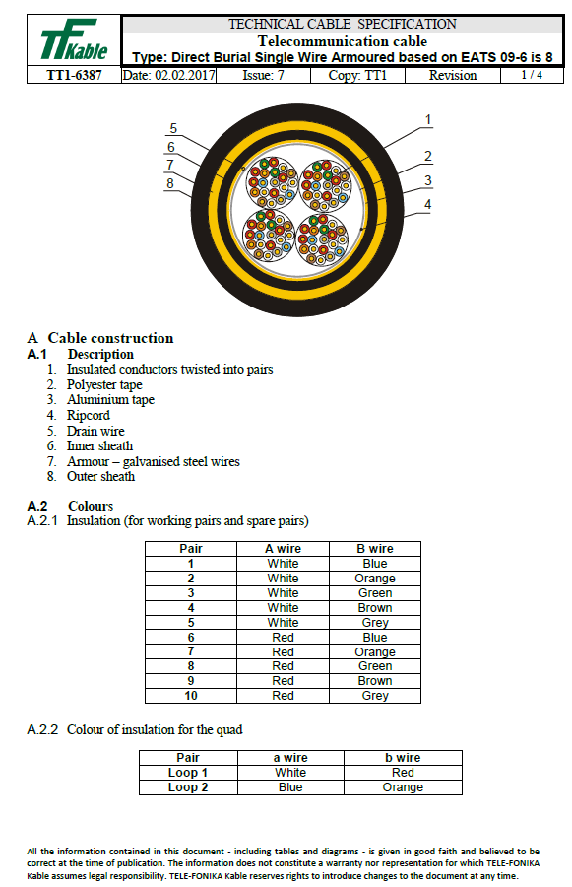

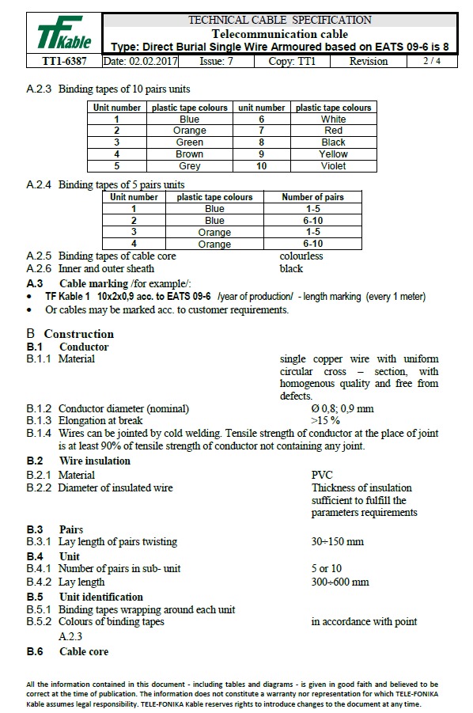

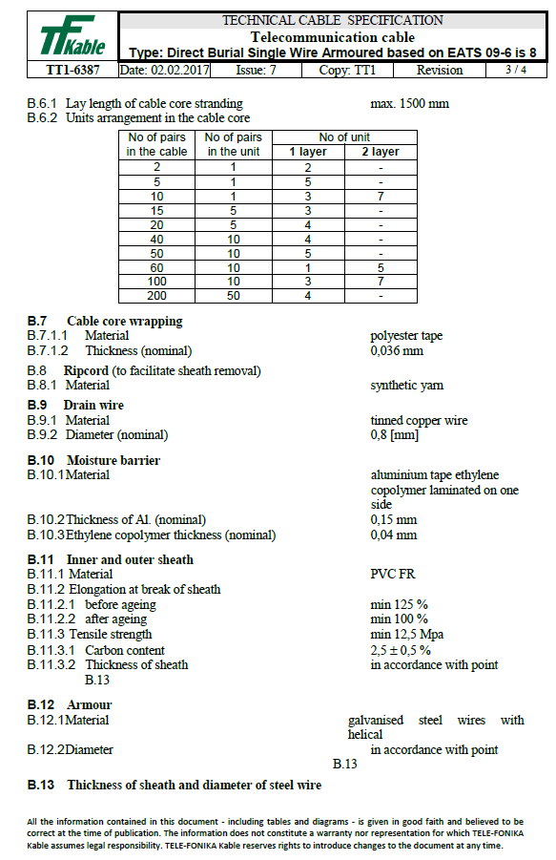

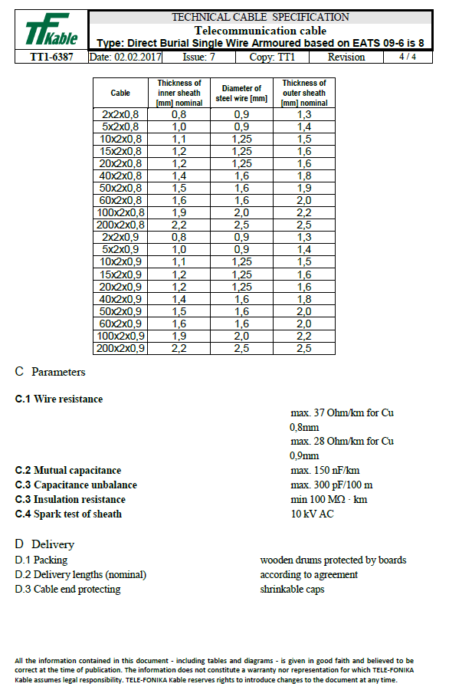

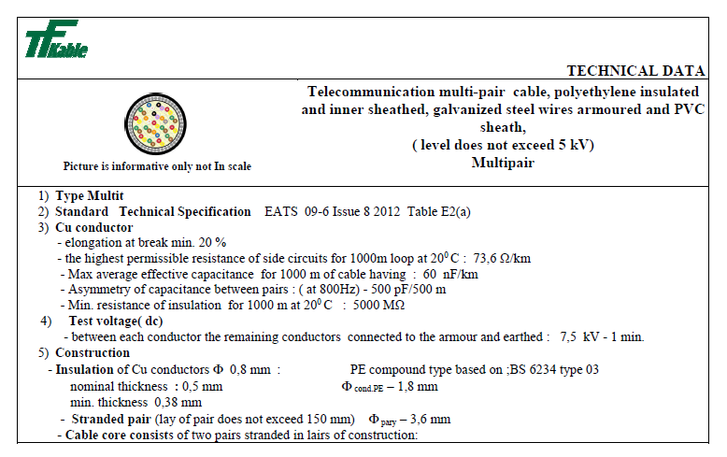
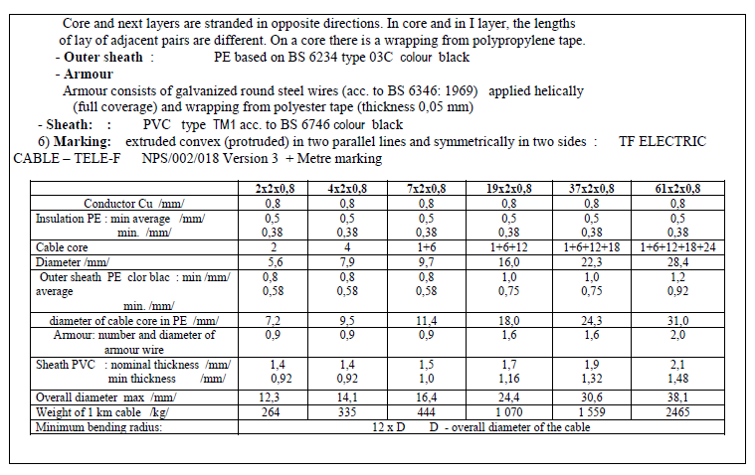
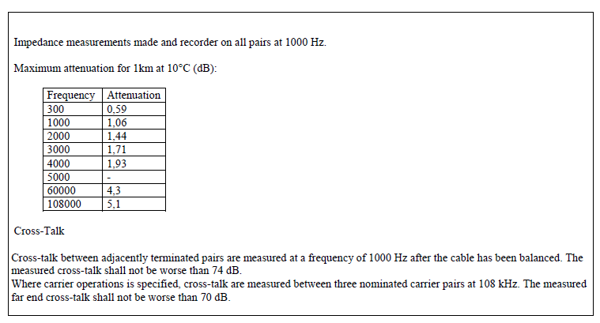
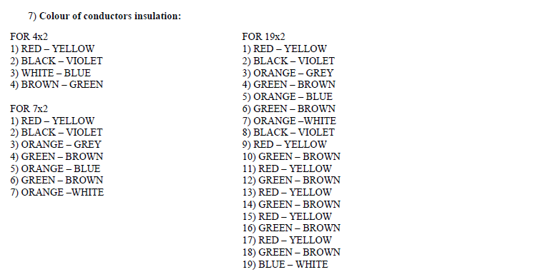
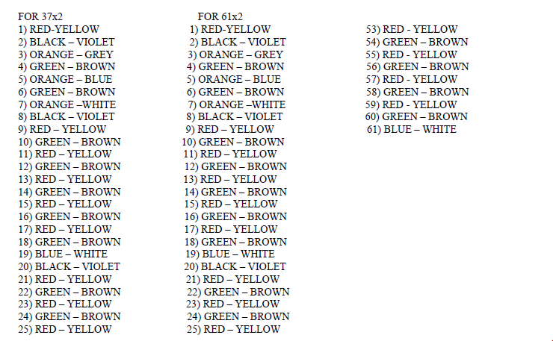
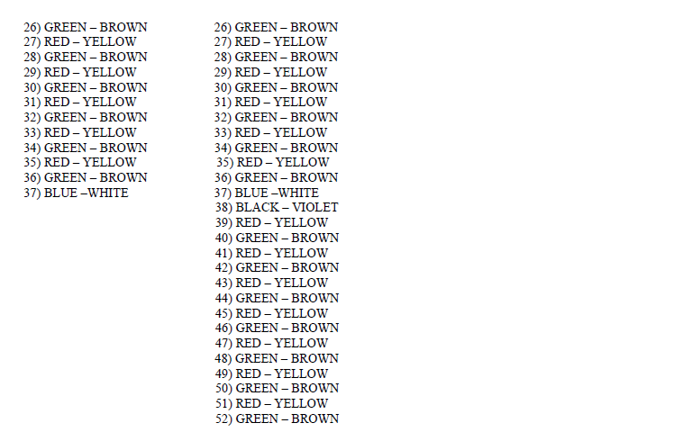

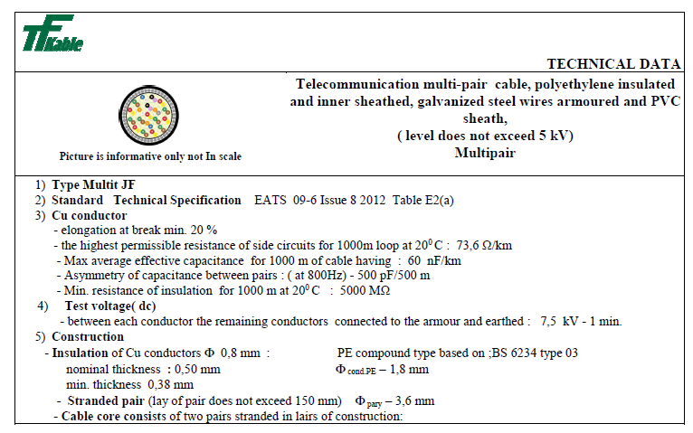
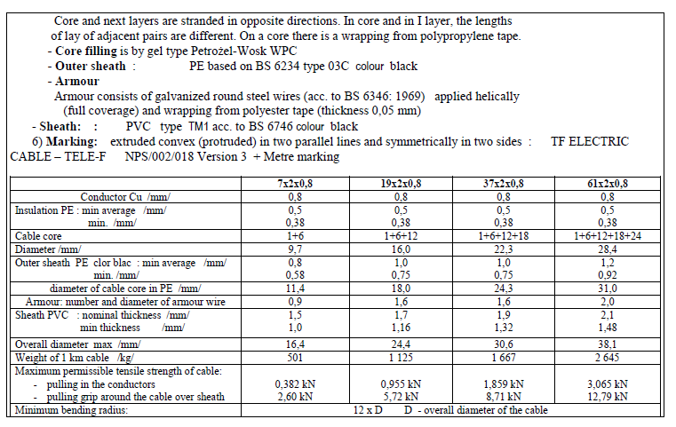
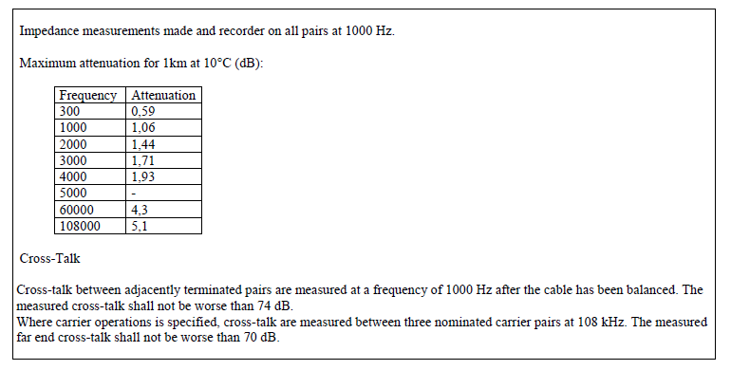

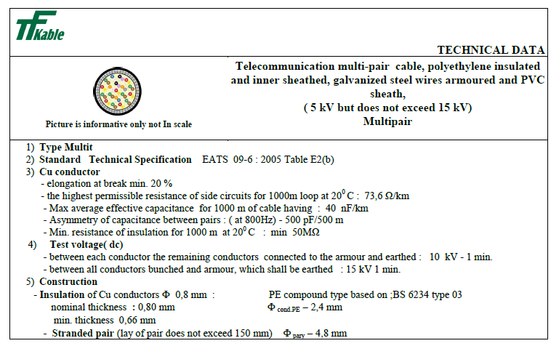
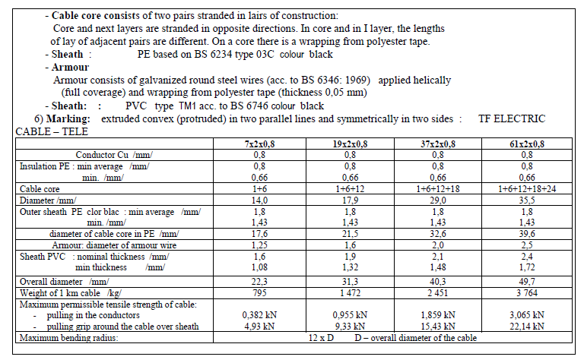
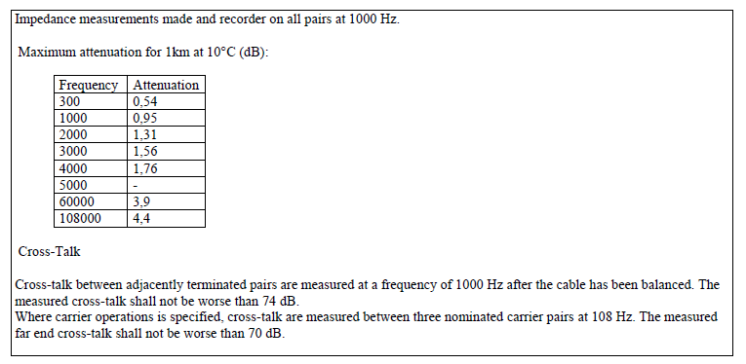

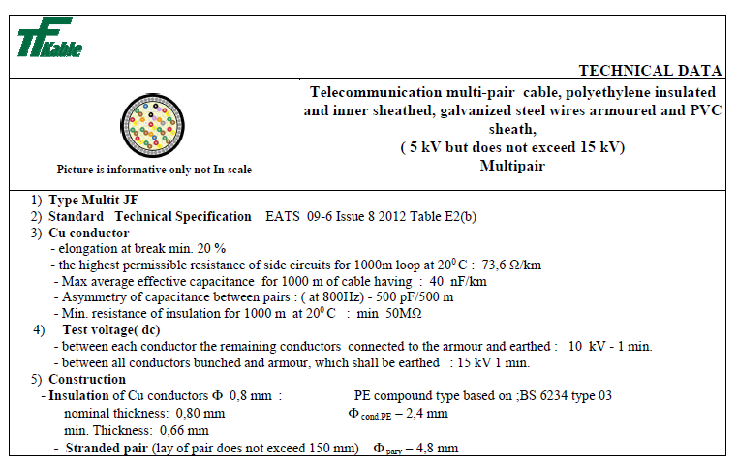
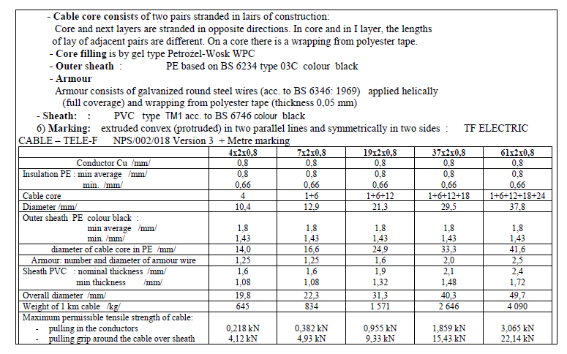
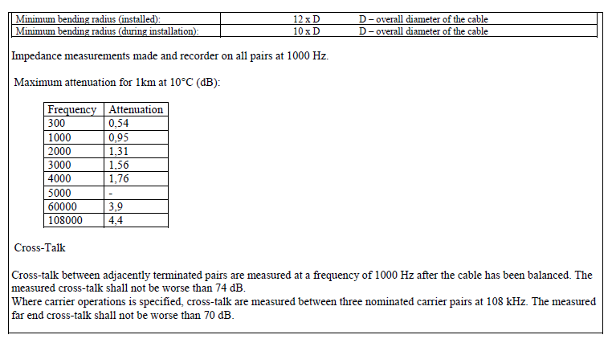

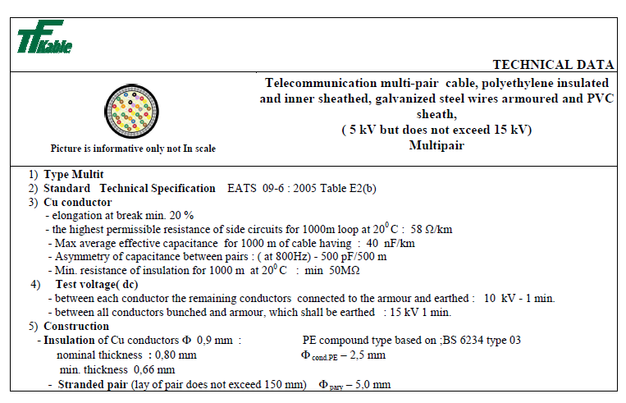
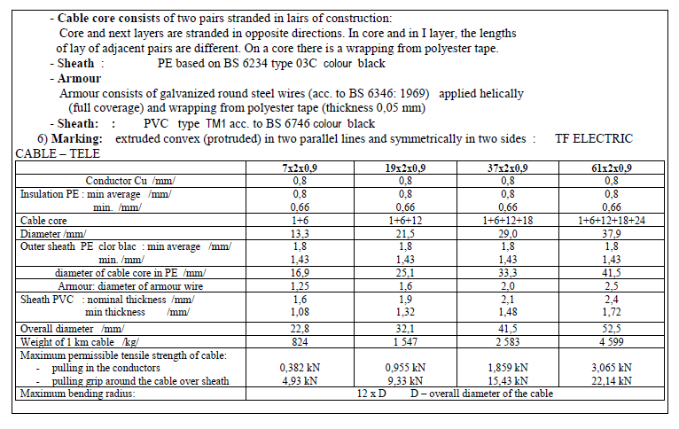
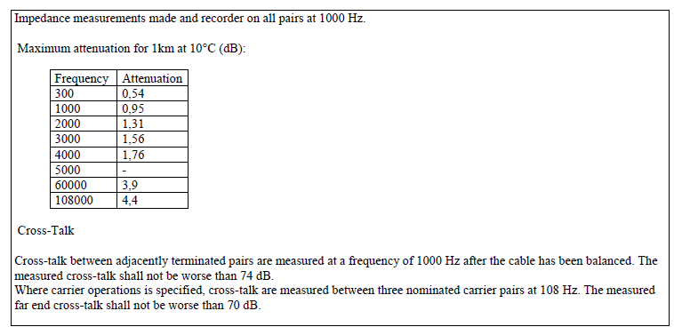

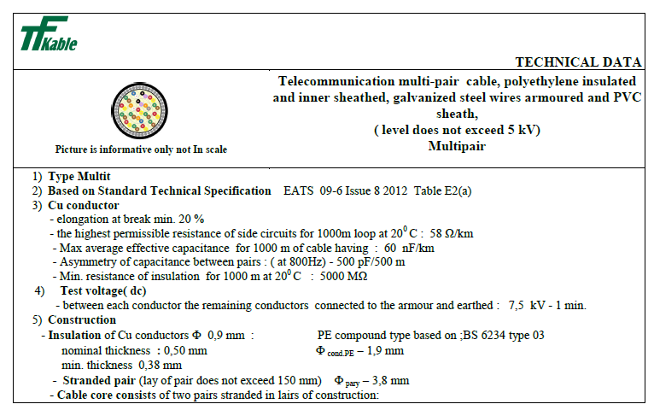

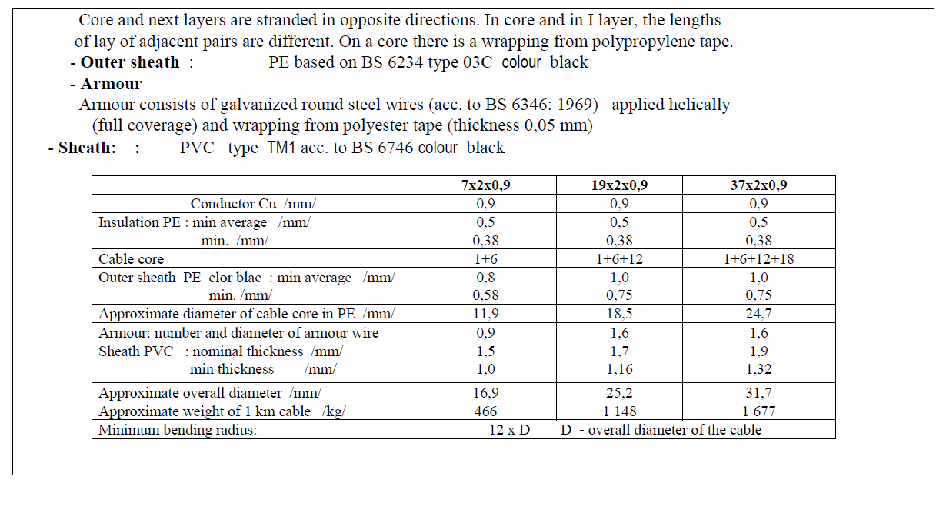

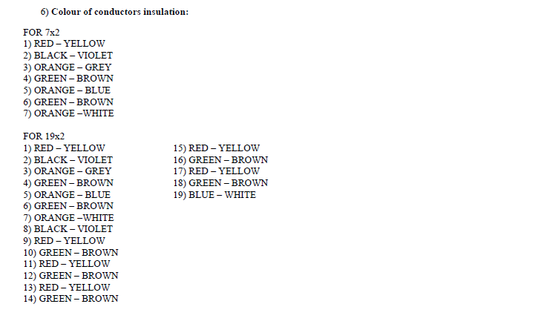

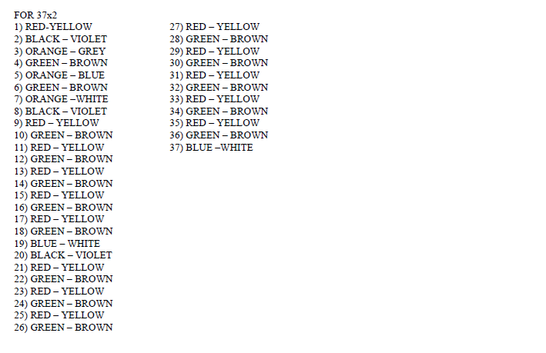

Electricity Specification 400C10

Issue 6 October 2015

33kV Distribution Cables

Contents
- Scope
- Definitions
- General Requirements for Approvals and Assurance
- Conditions of Installation
- Conditions of Operation for Power Cables
- Cable Longevity
- Manufacturing
- Technical Support
- Testing and Approval
- Technical Particulars
- Schedule One
- Schedule Two
- Documents Referenced
- Keywords
Appendices A to C

Issue and Amendment Summary
Amendment  No.  Date | Brief Description and Amending Action
0  15/07/97 | Issue 2  Prepared by: DPH Authorised by:
0  04/01/01 | Issue 3  Document updated to BS 7870 Part 4. ‘Wet’, ‘Quasi-dry’ and ‘Dry’ design polymeric cables added and Paper insulated designs removed.  Prepared by: DSD Authorised by:
1  26/02/01 | Issue 3  Minor update for clarification purposes and current rating requirements added.  Prepared by: DSD Authorised by:
0  02/01/02 | Issue 4  Removal of the following two cable types:  (i) Single Phase: 400mm² polymeric insulated ‘quasi dry’ design with copper screen wires, swellable water blocking tapes under and over the screen wires and copper phase conductors.  New document template applied.  Prepared by: DPH Authorised by:
0  11/11/04 | Issue 5  Specification updated for new acceptance requirements.  Prepared by: D. P. Horsman.  Approved by the Standards Steering Group and signed  on its behalf by:

Issue and Amendment Summary (Continued)
Amendment  No.  Date | Brief Description and Amending Action
1  04/05/05 | Issue 5  Amended to include an equalising tape over the copper screen wires.  Prepared by: D. P. Horsman.  Approved by the Standards Steering Group and signed  on its behalf by:
-  15/10/15 | Issue 6  Specification updated as marked. The latest template has been applied and the Specification has been updated to the latest editorial standard.  Prepared by: John Scott  Approved by the Technical Policy Panel and signed  on its behalf by: Steve Cox

33kV Distribution cables

Scope
This Specification covers the technical requirements for 33kV cables for use on the Electricity North West Limited (hereinafter referred to as Electricity North West) Distribution System.

Definitions
Approval: | Sanction by the Electricity North West Underground Circuits Manager that specified criteria have been satisfied.
Contract: | The agreement between Electricity North West and the Contractor for the execution of the Works including therein all documents to which reference may properly be made in order to ascertain the rights and obligations of the parties under the said agreement.
Contractor: | The person or person's firm or company, including personal representatives, successors and permitted assigns, whose Tender has been accepted by Electricity North West.
Specification: | The Specifications and schedules (if any) agreed by the parties for the purpose of the Contract.
SubContractor: | Any person (other than the Contractor) named in the Contract for any part of the Works or any person to whom any part of the Contract has been sub-let with the consent in writing of the Electricity North West Underground Circuits Manager, and the legal representatives, successors and assigns of such person.
Supplier: | Any person or person's firm or company who supplies goods to Electricity North West or to its Contractor.
Tender: | An offer in writing to execute work or supply goods at a fixed price.
Tenderer: | The person or person's firm or company, including personal representatives, successors and permitted assigns, invited by Electricity North West to submit a Tender.

General Requirements for Approvals and Testing

Product not to be Changed
No change in the product, packaging or labelling shall be made after Approval has been granted without prior notice to the Electricity North West Underground Circuits Manager and receipt of a written agreement from the Electricity North West Underground Circuits Manager.

Electricity North West Technical Approval
The Tenderer shall submit, with this Tender, proposals for testing which will demonstrate, to the satisfaction of the Electricity North West Underground Circuits Manager, compliance with this Specification. Such tests shall be carried out without expense to Electricity North West.
Alternatively, the Tenderer may submit technical reports and other data that he considers will demonstrate, to the satisfaction of the Electricity North West Underground Circuits Manager, compliance with this Specification. Acceptance of this evidence shall be at the discretion of the Electricity North West Underground Circuits Manager but will not be unreasonably withheld.
15/10/15
Approval shall be ‘factory specific’ and is not transferable to another factory without the written Approval of the Electricity North West Underground Circuits Manager.
The Supplier and product shall comply with all the relevant requirements of Electricity North West documents EPD311 and CP311.

Quality Assurance
The Tenderer shall confirm whether or not Approval is held in accordance with a quality assurance scheme accredited under BS EN ISO 9000. If not, he shall submit a statement of the quality assurance procedures employed to control the quality of the product, including the performance of Suppliers and Sub-Contractors.
15/10/15
15/10/15
The right is reserved for the Electricity North West Underground Circuits Manager to require, from time to time, the repeat of such tests as he may deem to be reasonably necessary to demonstrate continued compliance with the Specification.
The Tenderer shall submit, with his Tender, a list of tests and inspections which are carried out on the product prior to despatch which shall demonstrate, to the satisfaction of the Electricity North West Underground Circuits Manager, fitness for installation and service.
The Tenderer shall provide free of charge to Electricity North West such samples as may, in the opinion of the Electricity North West Underground Circuits Manager, be reasonably required for inspection and/or retention as quality control samples. The Electricity North West Underground Circuits Manager will confirm the requirements for samples at the time of tendering.
The right is reserved for the Electricity North West Underground Circuits Manager to make, from time to time, such inspections of the Tenderer’s facilities as he may deem to be reasonably necessary to ensure compliance with this Specification and any Contract of which it forms a part.
The Tenderer shall submit, with his Tender, such details of product packaging disposal, as will enable Electricity North West to comply with the requirements of BS EN ISO 14001: 2004 – Environmental Management Systems.

Formulation
The Tenderer shall submit, with his Tender, such details of the formulation and use of the product and associated substances as will enable Electricity North West to comply with the obligations of the Health and Safety at Work Act 1974 and the Control of Substances Hazardous to Health Regulations 2002, in the use, storage and disposal of the product. The Tenderer may stipulate, prior to submission of such information, that he requires it to remain confidential and the Electricity North West Underground Circuits Manager will, if requested, confirm his agreement to this prior to receipt of the information.
15/10/15

Identification Markings
The Tenderer shall submit, with his Tender, details of markings which it is proposed to apply to the product or packaging to identify manufacturing batches or items. The forms and content of such markings shall be subject to the Approval of the Electricity North West Underground Circuits Manager, and shall in all cases include the Electricity North West Approved Description and Commodity Code Number.
The Tenderer shall submit, with his Tender, such details of marking gross weight on components, assemblies and packages, as will enable Electricity North West to comply with the Manual Handling Operations Regulation 1992, for components, assemblies and packages supplied with a gross weight over 1kg. The forms and content of such markings shall be subject to the Approval of the Electricity North West Underground Circuits Manager.

Minimum Life Expectancy
The minimum life expectancy of all products covered by this Specification is 60 years.

Product Conformity
Preference will be given to those Suppliers who can provide suitable product conformity certification to a recognised or specified standard, or an equivalent certification.
15/10/15

Confirmation of Conformance
The Tenderer shall complete the conformance declaration sheets in Appendix C. Failure to complete these declaration sheets may result in an unacceptable bid.

Conditions of installation
Cables specified in this Specification will be pulled or laid into open trenches, pulled into ducts or installed in air. Cables may also be installed directly by trenchless installation techniques.
During storage and after installation cables can be expected to be subjected to the full range of climatic conditions encountered in the UK.
Cables may be surrounded by ground water for most of their operating life. Where cables are installed in ducts, flooding of ducts can occur resulting in permanently wet sections along the cable route.
Cables installed above ground will be supported by means of cleats either vertically or horizontally and these cables may be exposed to direct sunlight for significant periods.
Cables may be installed on wood poles in contact with the pole and, therefore, in contact with a pole preservation medium such as creosote.
Accessories may be cold applied or require application of heat.

Conditions of operation for power cables
The following are the general conditions under which power cables purchased in accordance with this Specification are required to operate:
15/10/15
- Nominal system voltage 19 000/33 000.
- The working voltage of any part of the system does not normally exceed the normal system voltage by more than 6%.
- Nominal system frequency: 50Hz.
- The system operates with the neutral point earthed either directly or through a resistance or reactance at one or more points.

Cable longevity
Cables offered shall be designed and manufactured to operate satisfactorily under the installation and operating conditions detailed in Sections 4 and 5. Cables with extruded insulation shall have passed the CIGRE 2 year long term ageing test specified as per proposed amendment 3, clause 5.4.15 to CENELEC HD 605. Preference will be for manufacturers that carry out the CIGRE 2 year test on a continual 1 year cycle.
15/10/15

Manufacturing
At the time of Tender, the Tenderer shall provide details of manufacturing location(s) for each cable offered. For cables with extruded insulation, the Tenderer shall also provide details of extrusion and curing technology for each cable offered. The cross linking process will be completely “Dry Cured” and no water will be used during this process.
15/10/15
Any Approval granted will be site specific and will not be transferable to any other site without the prior written agreement of the Electricity North West Underground Circuits Manager.

Technical support
During the Contract period questions will arise regarding unusual or non-standard applications where advice will be required on matters such as cable ratings etc. The successful Tenderer(s) will be expected to support Electricity North West with technical advice on these matters.

Testing and approval

Type Test Approval
All cables offered shall be fully Type Tested and Qualified according to the requirements of the Technical Specification and Standards detailed for each cable type. The Tenderer shall provide Type Test certificates and Type Test reports, including details of independent witnesses, at the time of Tender.
Where a Tenderer wishes to offer a cable which has been Type Tested to an alternative Standard(s), full details of the alternative Standard(s) and how it differs from the Specified Standard(s) shall be provided at the time of Tender along with Type Test certificates.
If, during the period of the Contract, the Contractor wishes to make any changes to the Approved product, packaging or labelling, proposals for such changes shall be notified in writing to the Electricity North West Underground Circuits Manager. No such changes shall be implemented without the prior written Approval of the Electricity North West Underground Circuits Manager. If the Electricity North West Underground Circuits Manager deems that the changes require Type Approval testing to be repeated, in full or in part, the cost of such testing shall be borne by the Contractor.
15/10/15

Requirement for Routine Tests at the Supplier’s Premises and Sampling
These tests may be required to be carried out on every individual unit or component, as specified, or at some regular frequency to be determined by the Electricity North West Underground Circuits Manager.
The results of these tests may be required to be supplied to Electricity North West with each unit purchased or retained for inspection, at a period to be determined by the Electricity North West Underground Circuits Manager.

Routine and Sample Testing
The Contractor shall carry out all routine and sample tests specified for each cable. Tenderers shall state at the time of Tender their proposals for sample test frequencies where such frequencies are not detailed specifically by this Specification or the relevant referenced Standards or Specifications. The Electricity North West Underground Circuits Manager reserves the right to be present and witness routine and sample tests. Where the Electricity North West Underground Circuits Manager wishes to witness any such tests, the date and time of testing shall be mutually agreed.

Samples
During the Tender period the Tenderer shall submit samples for Approval as required by the Electricity North West Underground Circuits Manager. Such samples shall remain the property of Electricity North West.

TECHNICAL PARTICULARS

Cable Design
This Specification covers the supply of the following types of polymeric 33kV single core distribution cables:
(a) Single phase: 185, 240, 300, 400, 500mm² polymeric insulated ‘quasi-dry design’ with copper screen wires and swellable water blocking tapes under and over the screen wires. Copper stranded phase conductors. Both single core and triplex.
15/10/15
(b) Single phase: 300, 400, 500, 630, 800, 1000 mm² polymeric insulated ‘quasi-dry design’ with copper screen wires and swellable water blocking tapes under and over the screen wires. Aluminium stranded phase conductors. Both single core and triplex up to and including 500mm².

Technical Requirements
Where a requirement of this Specification differs from that of another quoted Specification or Standard, the requirements of this Specification shall apply.
If a Tenderer is unsure regarding any requirement of this Specification, clarification shall be sought in writing from Electricity North West.
33kV cables referenced at 10.1(a) shall comply with BS 7870 Part 4 Section 4.10.
15/10/15
33kV cables referenced at 10.1(b) shall comply with BS 7870 Part 4 Section 4.10.

Cable Data
The following additional cable data shall be provided with all cables supplied:

Impedance Data
- Maximum dc resistance of phase conductor at 20ºC in ohm/km.
- Maximum ac resistance of phase conductor at maximum conductor temperature in ohm/km.
- Equivalent star reactance at 50 Hz in ohm/km.
- Equivalent star capacitance in pF/km.
- Charge current per phase at normal voltage and frequency in mA/m.
- Zero sequence impedance R_{o} + jX_{o} in ohms/km.

Current Rating Data
The maximum continuous current carrying capacity per phase conductor for the following conditions:
- Laid direct with g = 1.2 ºC/W and Tg = 15 ºC.
- Laid direct with g = 0.9 ºC/W and Tg = 15 ºC.
- Drawn into a 150mm ID smooth wall plastic duct (one cable or triplex cable per duct) where g = 1.2 ºC/W and Tg = 15 ºC.
- Drawn into a 150mm ID smooth wall plastic duct (one cable or triplex cable per duct) where g = 0.9 ºC/W and Tg = 15 ºC.
- In Air where Tg = 25 ºC.
The following assumptions shall be made when quoting ratings:
- Single core cables are laid in touching trefoil.
- Cover to top of 33kV cables is 900mm.
- Ground thermal resistivity = 1.2Km/W.
- Ground temperature = 15 ºC.
- Air temperature = 25 ºC.
Tenderers shall also provide data to show the variation in rating with Ground TR and depth of cover.

Installation Parameters
For each power cable offered the Tenderer shall provide the following parameters:
- Minimum dynamic bending radius in mm.
- Minimum static bending radius in mm.
- Recommended pulling method and maximum pulling tension in kgF.

Shrinkage
15/10/15
Insulation shrinkage shall be performed at 130ºC for 6 hours and limited to 2%, in addition a test at 65ºC for 24 hours shall be performed.

Cable Identification
Each delivery length of cable shall be allocated a unique reference number. This unique reference number shall be embossed on the cable near to the metre mark. This unique reference number will be used to identify all materials used within the manufacturing process. This number shall appear on the factory test sheet covering the cable length and shall be clearly marked on the drum on which the length is delivered and shall be referred to on all invoices and advice notes.
15/10/15
15/10/15
Additional costs should be included if applicable for the option of providing a unique identifier / batch number or having Electricity North West printed on to the conductor to enable positive identification of ownership in event of theft.

Oversheath Marking
In addition to the requirements detailed in the relevant specification for each cable supplied, the unique reference number shall be embossed in the cable oversheath.

Logistical Requirements
Each cable supplied shall meet the requirements of Appendix B.

Schedule one – single phase, Stranded Copper conductor: 185, 240, 300, 400mm² ‘QUASI-DRY design’ polymeric insulated

Specification
The cable described in Section 10.1(a) shall have circular compacted stranded copper conductors complying with BS EN 60228 (class 2); ‘tree retardant’ cross linked polyethylene (XLPE) extruded insulation with bonded screen or ethylene propylene rubber (EPR) extruded insulation with strippable screen, 50mm² copper screen wires, equalising tape, swellable water blocking tapes under and over the screen wires and black medium density polyethylene (MDPE) oversheath.
The tapes under the wires shall be semi-conducting.
Insulation screens that are strippable shall have a strippable force in the range of 12Nm to 20Nm.
Concentricity and circularity of the XLPE extruded insulation shall comply with the requirements of BS 7870 Part 4 Section 4.10. Moisture content of water blocking tape will be less than 50 000 ppm.
The oversheath shall consist of an extruded layer of black MDPE complying with the requirements of BS 6234 and the relevant sections of BS 7870 Part 4. Maximum permissible shrinkage shall be 2%. The compound shall have a density within the range quoted in ENA TS 09-17. An outer graphite coating is not required.
The cable shall be available as single core and in a laid up triplex formation.
Written evidence shall be provided to show that the cable has undergone CIGRE ‘long term’ tests.
Cable to be in accordance with BS 7870 Part 4 Section 4.10.

Schedule Two – single phase Stranded Aluminium conductor: 300, 400, 500, 630, 800, 1000mm² ‘QUASI-DRY design’ polymeric insulated
15/10/15

Specification
The cable described in Section 10.1(b) shall have circular compacted stranded aluminium conductors complying with BS EN 60228 (class 2); ‘tree retardant’ cross linked polyethylene (XLPE) extruded insulation with bonded screen or ethylene propylene rubber (EPR) extruded insulation with strippable screen, 50mm² copper screen wires, equalising tape, swellable water blocking tapes under and over the screen wires and black medium density polyethylene (MDPE) oversheath.
The tapes under the wires shall be semi-conducting.
Insulation screens that are strippable shall have a strippable force in the range of 12Nm to 20Nm.
Concentricity and circularity of the XLPE extruded insulation shall comply with the requirements of BS 7870 Part 4 Section 4.10. Moisture content of water blocking tape will be less than 50 000 ppm.
The oversheath shall consist of an extruded layer of black MDPE complying with the requirements of BS 6234 and the relevant sections of BS 7870 Part 4. Maximum permissible shrinkage shall be 2%. The compound shall have a density within the range quoted in ENA TS 09-17. An outer graphite coating is not required.
The cable shall be available as single core and in a laid up triplex formation.
Written evidence shall be provided to show that the cable has undergone CIGRE ‘long term’ tests.
Cable to be in accordance with BS 7870 Part 4 Section 4.10.

Documents referenced
Health and Safety at Work Etc Act 1974.
15/10/15
Control of Substances Hazardous to Health Regulations 2002.
Manual Handling Operations Regulation 1992.
15/10/15
BS EN ISO 9000: | Quality management systems.
BS EN ISO 14001: 2004: | Environmental management systems. Requirements with guidance for use.
BS EN 60228: 2005: | Conductors of insulated cables.
BS 6234: | Specification for polyethylene insulation and sheath of electric cables.
BS 7655: | Insulation and sheathing materials for cables.  15/10/15
BS 7870 Part 4: | Single Core 33kV Design Cables.
ENA TS 09-17: | Single core cables for use in substations having extruded insulation and rated voltages of 6350/11 000 volts, and 19 000/33 000 volts.  15/10/15
CENELEC HD 605 | Electrical Cables – Additional test Methods.
EPD311: | Approval of Equipment.
CP311: | Equipment Approval Process.
ES400C7: | Returnable Cable Drums for Mains Cables Conforming to ECP 410 Chapter 1.

Keywords
11kV; Cable; EPR; MDPE; XLPE;

appendix a
Schedule of cables

Item No. | Ordering Specification | Size (mm²) | CC No.
1 | Single phase, stranded copper conductor: polymeric insulated ‘quasi-dry design’ with copper screen wires and swellable water blocking tapes under and over the screen wires. | Single core
 |  | 185  240  300  400  500  630 | 46100  46101  46102  46103  46104  TBA
 |  | Triplexed single core
 |  | 185  240  300  400  500 | 004695  004696  004697  004698  004700  15/10/15
2 | Single phase, stranded aluminium conductor: polymeric insulated ‘quasi-dry design’ with copper screen wires and swellable water blocking tapes under and over the screen wires. | Single core
 |  | 300  400  500  630  800  1000 | TBA  TBA  TBA  TBA  TBA  TBA
 |  | Triplexed single core
 |  | 300  400  500 | TBA  TBA  TBA

Appendix B
15/10/15
Logistical Requirements

B1. Cable Drums and labelLing
Drums used for 11 and 33kV cables shall have a maximum width of 1200mm and a maximum weight of 2500kg.
Cable drums shall meet the requirements of ES400C7.
All cable drums shall be marked in accordance with the relevant cable specification or standard. The drum label shall also contain:
- Electricity North West commodity code
- Name of manufacturer
- Supplied length
- Rated voltage
- Number of cores
- Size of conductor
- Type of conductor material ("Cu" or "Al")
- Abbreviated description of cable construction
- Gross and nett weights
- Direction of rolling drum
- The metre marking start and end values
- The unique reference number

B2. general logistical requirements
Cable drums may be stored for long periods outdoors. All drum labels shall remain legible and durable under these conditions.
All cable drums shall be returnable and the Tenderer shall arrange to collect empty drums from the company's normal delivery locations. Tenderers shall state at the time of Tender their proposed cable drum sizes and weights for each cable type offered.
The ends of all cables shall be effectively sealed against the ingress of moisture by a method appropriate to the cable type. Tenderers shall detail at the time of Tender their proposed sealing arrangement for each cable type offered.
The cable end projecting from the drum shall be protected from damage during transit, storage and handling on site.
The cable on the drum shall not be susceptible to damage during transit, storage and handling on site.
15/10/15
Tenderers shall state at the time of Tender their proposed method of protection for each cable.

Appendix C
15/10/15
CONFORMANCE DECLARATION
SECTION-BY-SECTION CONFORMANCE WITH SPECIFICATION
The Tenderer shall declare conformance or otherwise for each product/service or range of products/services, section-by-section, using the following Conformance Declaration Codes.
Conformance Declaration Codes:
N/A = | Section is not applicable/appropriate to the product/service.
C1 = | The product/service conforms fully with the requirements of this section.
C2 = | The product/service conforms partially with the requirements of this section.
C3 = | The product/service does not conform to the requirements of this section.
C4 = | The product/service does not currently conform to the requirements of this section, but the manufacturer proposes to modify and test the product in order to conform.
Manufacturer:
Product/Service description:

Product/Service reference:

Assessor details
Name:
Company:
Signature:
Date:

SECTION-BY-SECTION CONFORMANCE
15/10/15
Section | Section Topic | Conformance  Declaration  Code | Remarks *  (must be completed if code is not C1)
3.1 | Product not to be Changed
3.2 | Electricity North West Technical Approval
3.3 | Quality Assurance
3.4 | Formulation
3.5 | Identification Markings
3.6 | Minimum Life Expectancy
3.7 | Product Conformity
3.8 | Confirmation of Conformance
4. | Conditions of Installation
5. | Conditions of Operation for Power Cables
6. | Cable Longevity
7. | Manufacturing
8. | Technical Support
9.1 | Type Test Approval
9.2 | Requirement for Routine Tests at the Supplier’s Premises and Sampling
9.3 | Routine and Sample Testing
9.4 | Samples
10.2 | Technical Requirements
10.3.1 | Impedance Data
10.3.2 | Current Rating Data
10.3.3 | Installation Parameters
10.4 | Shrinkage
10.5 | Cable Identification
10.5.1 | Oversheath Marking
10.6 | Logistical Requirements
11.1 | Specification
12.1 | Specification

Additional Notes:
15/10/15

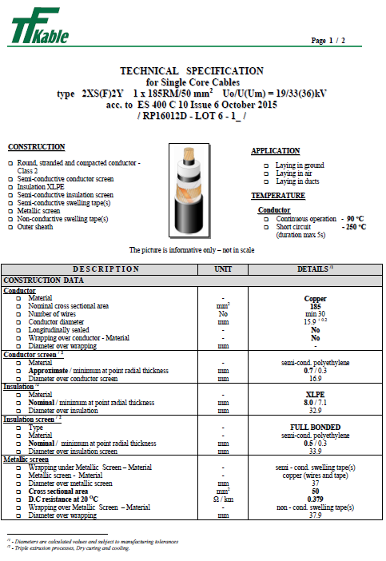

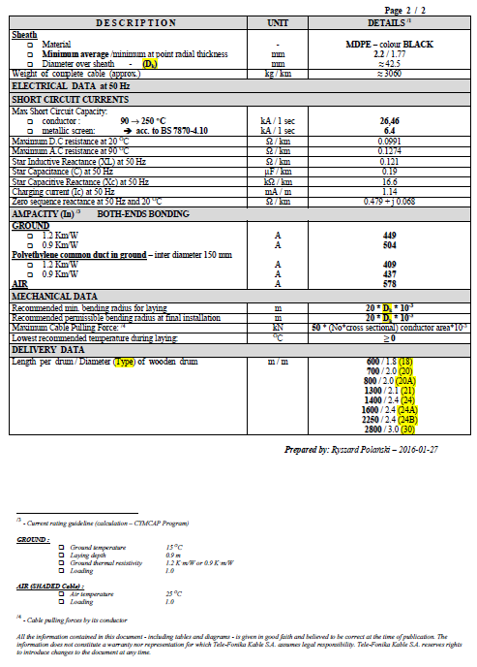

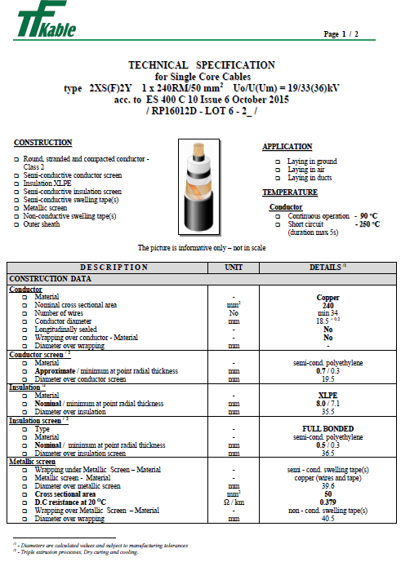

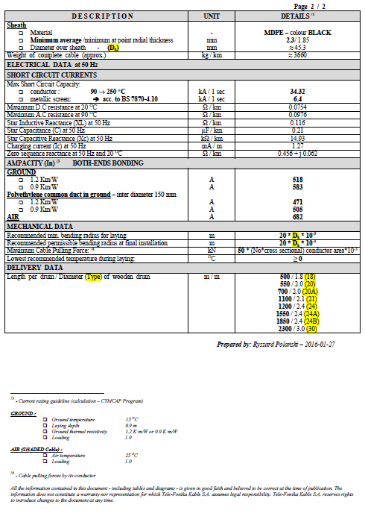

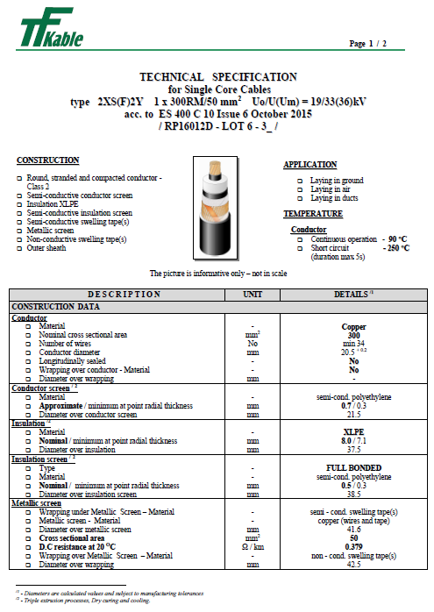

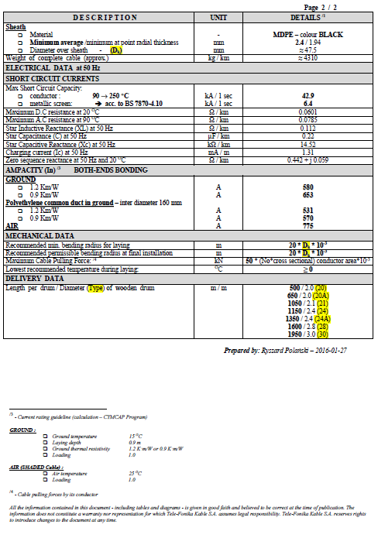

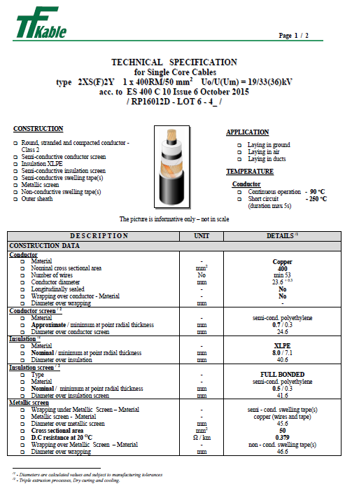

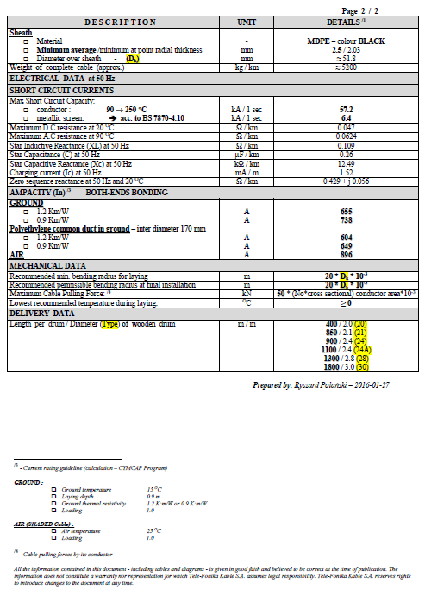

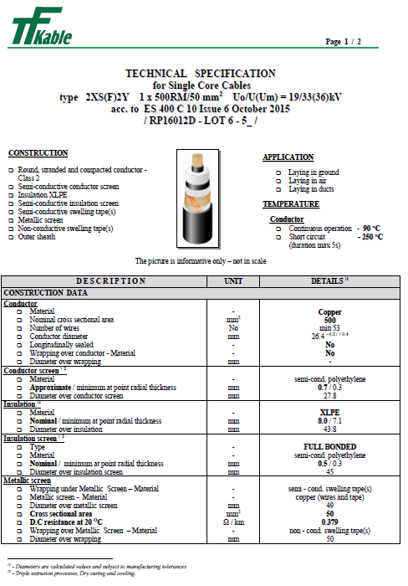

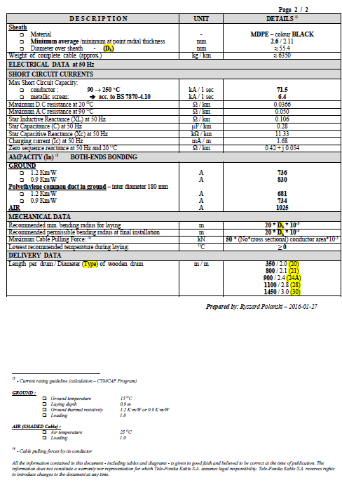

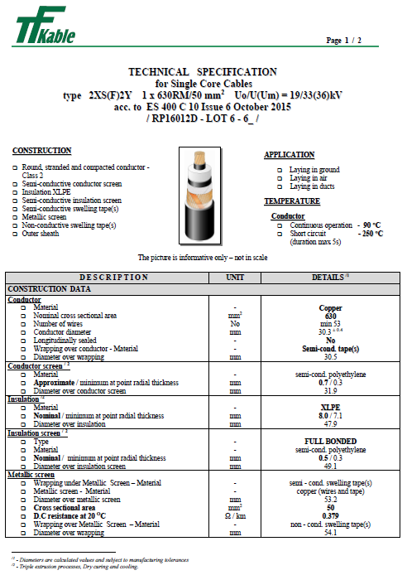

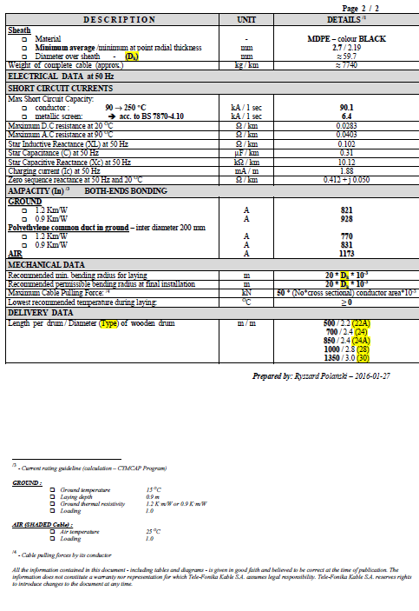

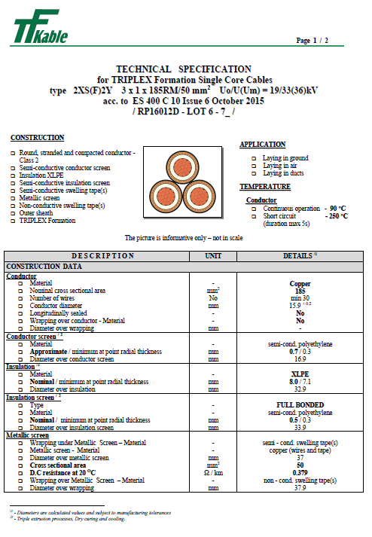

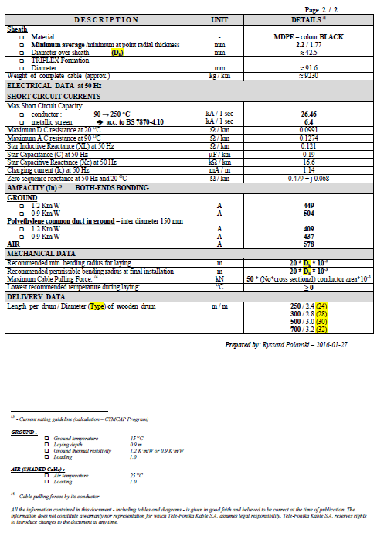

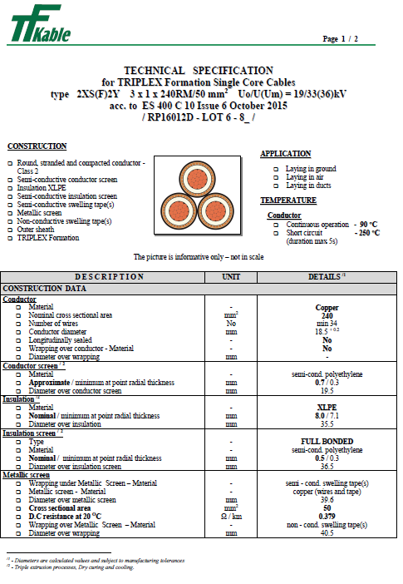

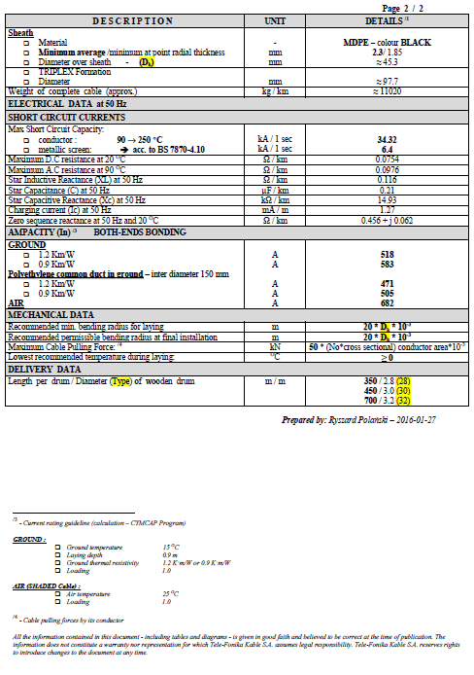

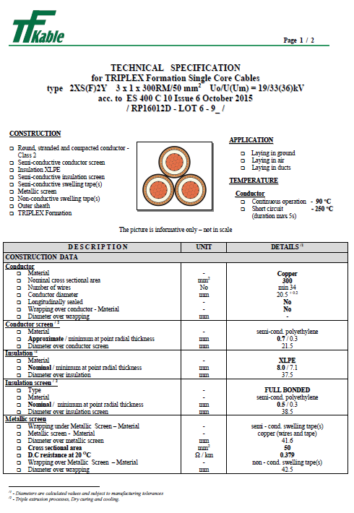

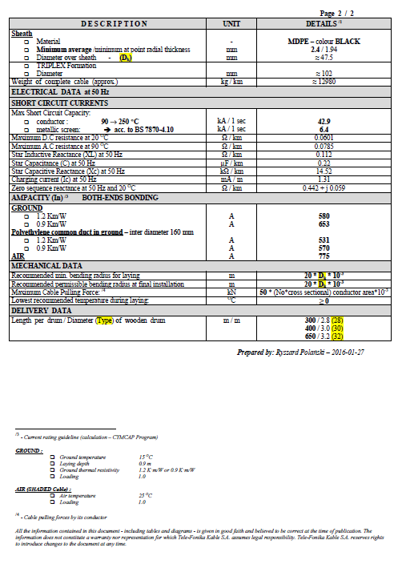

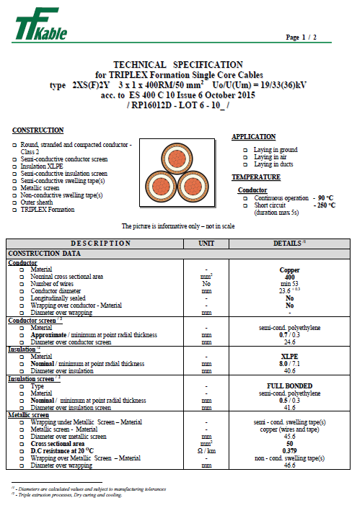

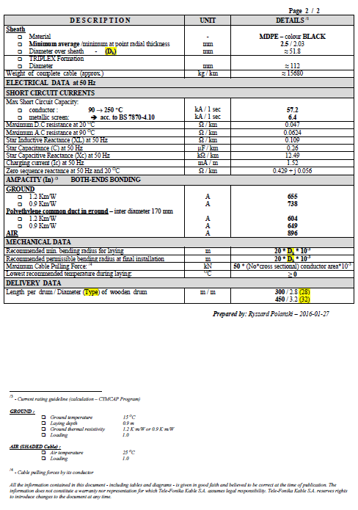

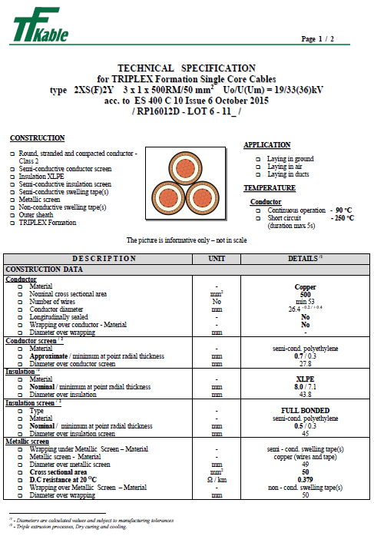

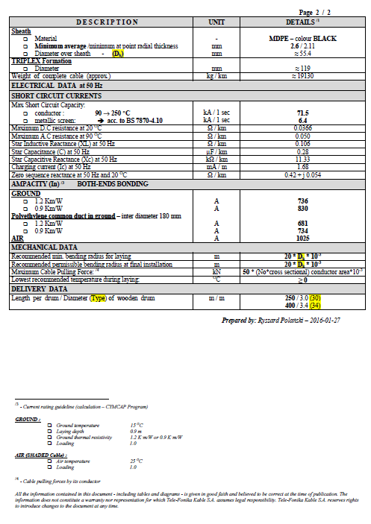

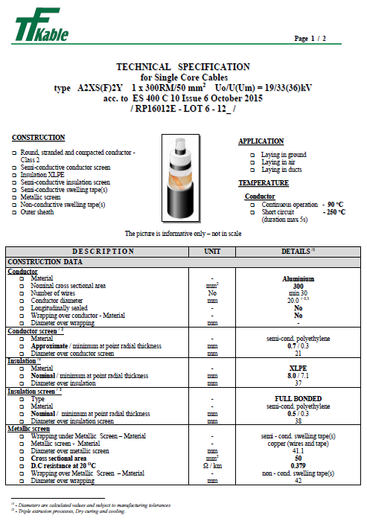

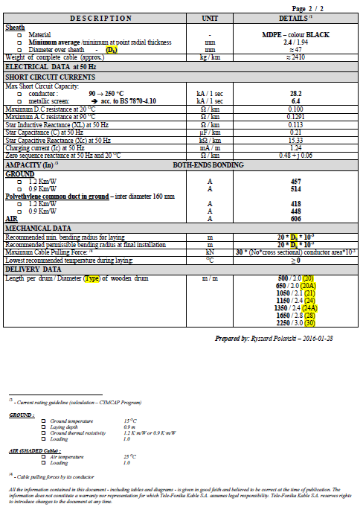

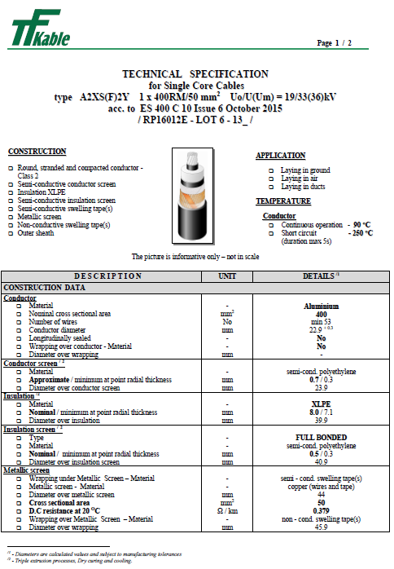

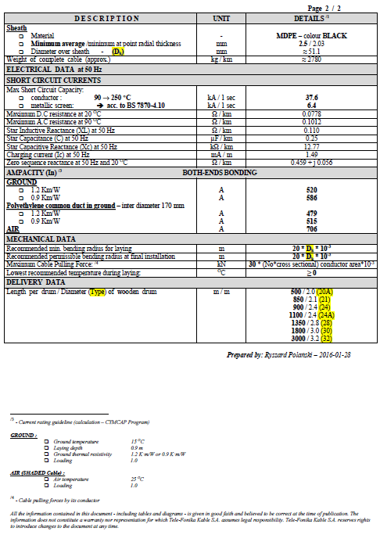

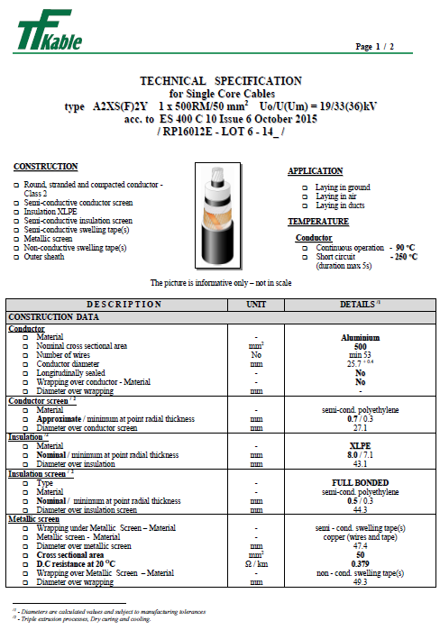

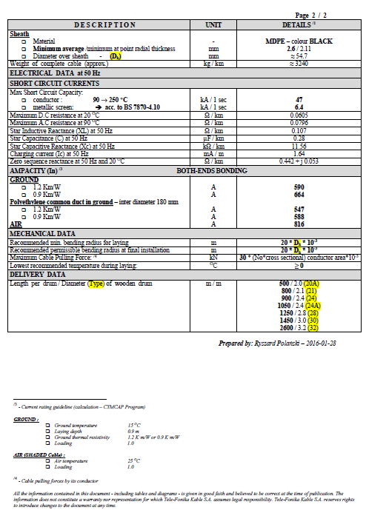

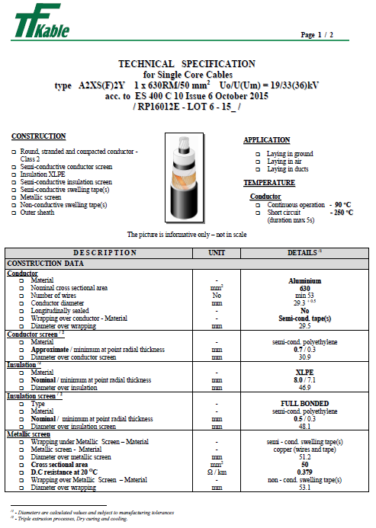

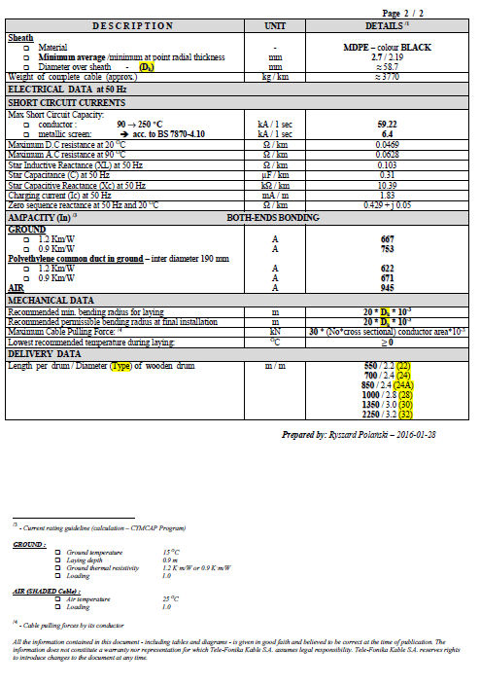

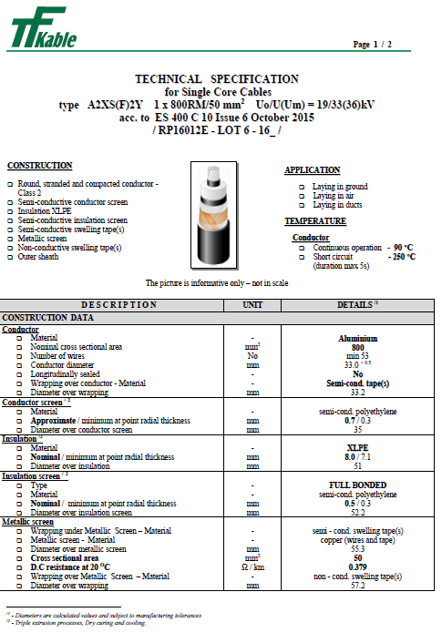

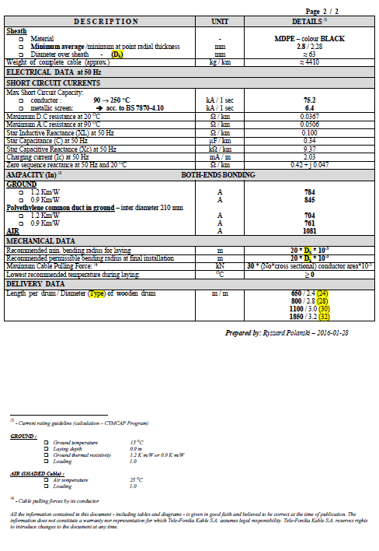

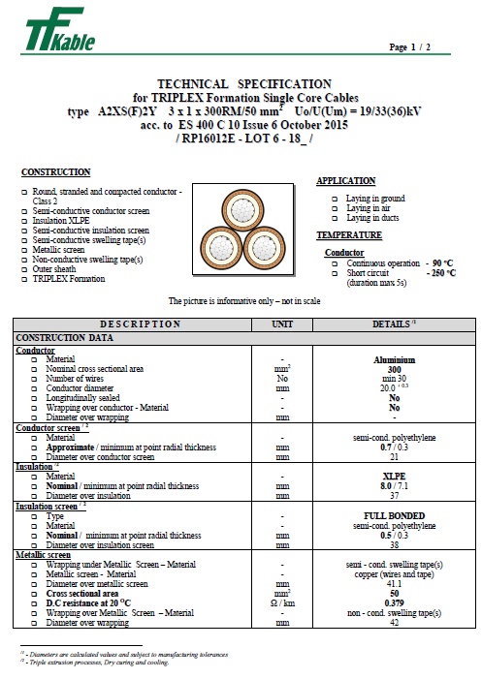

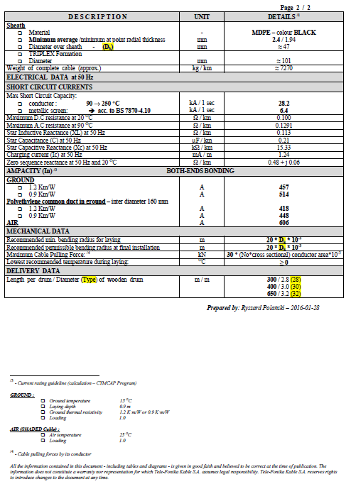

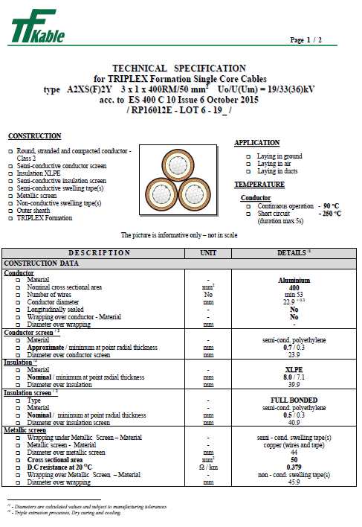

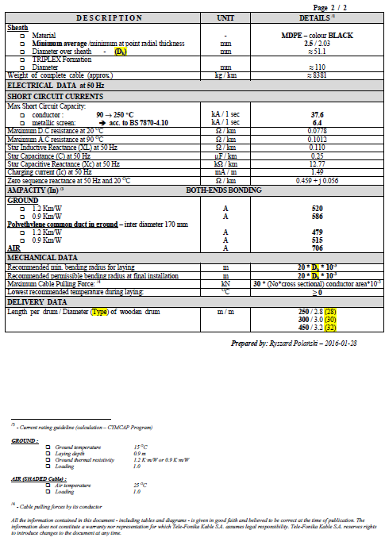

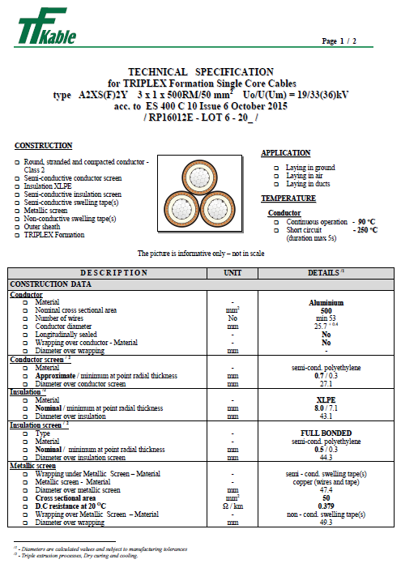

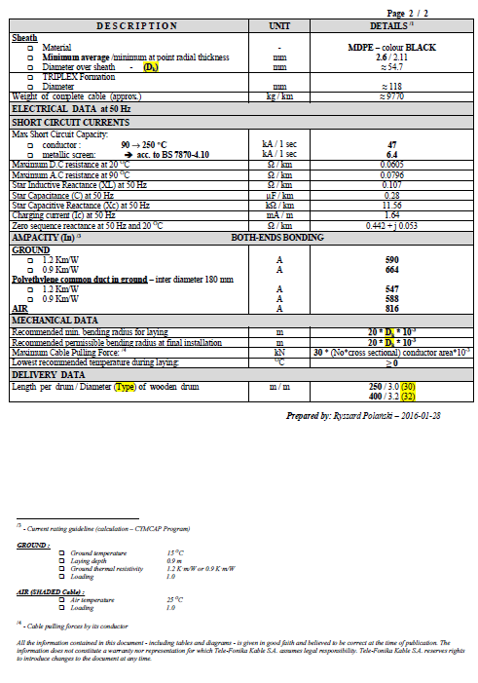

Schedule 2
Prices
- Pricing Preambles
- Attention is directed to Terms and Conditions, Specifications and any relevant Appendices/Annexes, which are to be read in conjunction with this document.
- All prices shall be submitted in line with the information detailed within this section of the ITT Document.
- Prices shall include for the whole of the Supplier’s obligations under the Framework Agreement whether expressly stated or reasonably implied.
- Where quantities are stated in the Pricing Schedule the Supplier should note that they may vary and there is no guarantee of quantity. The prices quoted in the Pricing Schedule shall apply regardless of the actual quantity of goods or services subsequently ordered.
- No quantity or continuity of supply is guaranteed to the Supplier and this has been taken into account when completing the Pricing Schedule.
- Each item in the Pricing Schedule is fully priced, with insertions for each item. If any item is unpriced (whether by leaving the rate and/or amount space blank or by entering “included” or otherwise), that item shall be deemed to be priced at “nil”. Because an item is priced at “nil” the Quotation Price will be unaffected by any difference between the final measurement quantity of that item and any estimated quantity which may be supplied to the supplier prior to commencement of supply.
- Any additional supply or services will be provided at the rates detailed in the Pricing Schedule, and such additional requirements are to be agreed on a case by case basis. No supply or services or are to be provided without first obtaining an official purchase order from the Company.
- Unless otherwise agreed in writing by the Company, the Supplier shall not be entitled to invoice the Company for the goods or services (or any part of them) prior to satisfactory Delivery of such goods or services in accordance with this Agreement.
- On or before the issue of an invoice, the Supplier shall submit to the Company Representative a priced advice note containing the same information as that set out in the Supplier’s invoice. However, a copy of the Supplier’s invoice will not constitute an advice note for the purposes of this paragraph.
- Subject to compliance by the Supplier with paragraph 10.0 and 11.0, the Company will pay each valid invoice by the end of the Month following the Month in which the Company receives such invoice. If the Construction Act applies to this Agreement, a validly rendered invoice becomes due for payment twenty (20) Business Days after the date of receipt by the Company and the final date for payment shall be the last day of the Month after the Month of receipt by the Company of the invoice.
- The Company shall, not later than five (5) Business Days after the due date for payment of any amount due under this Agreement specify the amount of the payment proposed to be made, to what the amount of the payment relates and the basis on which that amount was calculated.
- Prices submitted must allow for a possible partial award resulting from this Tender to the extent that a partial award can be made by the Company.
- Prices shall include all discounts.
- Prices shall exclude VAT (and the carriage paid including packing and labelling).
- Prices shall not exceed two decimal places of a pound (£ GBP).
- Prices shall include for the cable drum, full battening, delivery to site.

- Pricing Schedule

Pricing & VAT
All rates exclude Value Added Tax, which would be charged at the appropriate rate.
All prices have been calculated on the metal basis as noted below;
        - Copper - £3400 per tonne
        - Aluminium - £1000 per tonne

Based our submission on the following options:

- The British Cable Association (BCA) Cable Contract Price Adjustment (CPA Formula) to apply and the ‘Schedule of Prices, Index Figures and Labour Rates’ published by BCA (dated 18th January 2016 attached in Pricing) will contain ‘Schedule A Prices for Aluminium’ and ‘Schedule B of Index Figures’ for ‘Labour Index Rates BEAMA – 1980=100 - February 2015 indices 875.6’ and ‘Synthetic Resins & Plastic Materials – Table 4 (2514) 2000=100 – February 2015 indices 165.5’, ‘Premium Index for Aluminium Rod’ with monthly adjustments.

- Metal Price Adjustments for aluminium and copper only. However, to allow this contract to be considered sustainable over a 3 year period, we would ask for a yearly review. Should the price index of raw materials (based on February 2016 BCA Cable CPA indices) change by +/- 2% the base index would be changed accordingly, however, if the raw materials stay within the +/-2% range, prices will remain in place for the following year. We are willing to negotiate this point.
Cable CPA prices and indices for the month of April 2015
Copper Premium – 139.14
Aluminium Premium – 240.03
Labour Index – 875.6
Synthetic, Resins and Plastics Index – 165.5
All cables prices are inclusive of delivery to ENWL or sites of associated Contractors managing the installation of Mains Cable and managed by your Logistics Supply Chain.
However, prices quoted are based on:

- ENWL or their nominated Contractors, offloading drums from curtain sided vehicles and uploading empty drums – as is currently the practice.
- Full load deliveries (where possible)
- Standard lengths are subject to a tolerance of ±2.5%
Note: Any special off-loading requirements e.g. crane etc. can be provided at additional cost which would be confirmed on a case by case basis once requirements are known.

Supplier |  |  | TFK
Vendor Number |  |  | 21001439
Framework Agreement Number |  |  | 4600000930
 |  |  |  | Base Al | Base Cu | Base Synth Resin |  | Base Al Premium | Base Cu Premium | Base Labour
 |  |  |  | 1000 | 3400 | 165.5 |  | 240.03 | 139.14 | 875.6
 |  |  |  | Dec 16 Al | Dec 16 Cu |  |  | Al Prem | Cu Prem
 |  |  |  | 1621 | 5248 | 188.2 |  | 154.24 | 149.85 | 918.3
 |  |  |  | p | q | r |  | s | t | u
 |  |  |  | 621 | 1848 | 22.7 |  | -85.79 | 10.71 | 42.7
 |  |  |  | v | w | x |  | y | z | aa
 |  |  |  |  |  | 0.1372 |  | 2.47 | 1.435 | 0.0488 | 2006 base
 |  |  |  |  |  | ab |  | ac | ad | ae
 |  |  |  |  |  |  |  | -211.90 | 15.3689
 |  |  |  |  |  |  |  | af | ag

Lot Number | Line Number | Commodity  Code | Contract Description | SAP Line Item Description | Supplier Description | Lead Time | Contract Prices / km | Hollow | Metal | Variation Factor Al | Variation Factor Cu | Metals | Premium | Metals | Premium | SR & Plastics | Variation | Labour | Variation | This Months Price / km | This months Price / m
 |  |  |  |  |  |  | a | b | c | d | e | f | g | h | i | j | k | l | m | n | o
2 | 10 | 5702 | 400mm2 Single Phase: polymeric insulated ‘quasi-dry’ design with copper screen wires, swellable water blocking tapes under and over the screen wires and stranded aluminium phase conductors.35mm Copper Earth Screen wires, Red oversheath, Triplex formation | 3 x 1 x 400mm2 Al 11kV Triplex | 3 x 1 X 400 Str Ali 35mm Cu Scr Red OSH 11KV | 4-7 days | b + c | £9,641.20 | £7,498.80 | 3.480 | 1.182 | w X e | ag X e | v X e | af X d | af X d | i X b X ab | 0.2925 | l X b X ae | a+f+g+h+i+k+m | n/1000
2 | 20 | 4691 | 95mm2:Single Core Solid Aluminium: polymeric insulated ‘quasi-dry’ design with copper screen wires, swellable water blocking tapes under and over the screen wires and solid aluminium phase conductors.  35mm Copper Earth Screens  RED Oversheath  Triplex Formation | 3 x 1 x 95mm2 SAC 11kV Triplex | 3X1X95 SAC 35mm Cu Scr Red OSH 11KV | 4-7 days | b + c | £5,614.20 | £4,845.80 | 0.827 | 1.182 | w X e | ag X e | v X e | af X d | af X d | i X b X ab | 0.2925 | l X b X ae | a+f+g+h+i+k+m | n/1000
2 | 30 | 4692 | 185mm2 Single Core Solid Aluminium: polymeric insulated ‘quasi-dry’ design with copper screen wires, swellable water blocking tapes under and over the screen wires and solid aluminium phase conductors.  35mm Copper Earth Screens  RED Oversheath  Triplex Formation. | 3 x 1 x 185mm2 SAC 11kV Triplex | 3X1X185 SAC 35mm Cu Scr Red OSH 11KV | 4-7 days | b + c | £6,611.20 | £5,628.80 | 1.610 | 1.182 | w X e | ag X e | v X e | af X d | af X d | i X b X ab | 0.2925 | l X b X ae | a+f+g+h+i+k+m | n/1000
2 | 40 | 4693 | 300mm2 Single Core Solid Aluminium: polymeric insulated ‘quasi-dry’ design with copper screen wires, swellable water blocking tapes under and over the screen wires and solid aluminium phase conductors.  35mm Copper Earth Screens  RED Oversheath  Triplex Formation. | 3 x 1 x 300mm2 SAC 11kV Triplex | 3X1X300 SAC 35mm Cu Scr Red OSH 11KV | 4-7 days | b + c | £8,131.20 | £6,628.80 | 2.610 | 1.182 | w X e | ag X e | v X e | af X d | af X d | i X b X ab | 0.2925 | l X b X ae | a+f+g+h+i+k+m | n/1000
2 | 50 | 4701 | 400mm2 Single Core Stranded Copper: polymeric insulated ‘quasi-dry’ design with copper screen wires, swellable water blocking tapes under and over the screen wires and solid aluminium phase conductors.35mm Copper Earth Screens  RED Oversheath  Single cable | 1 x 400mm2 Cu 11kV | 1 X 400 Str Cu 35mm Cu Scr Red OSH 11KV | 4-7 days | b + c | £4,674.40 | £14,395.60 | 0.000 | 4.234 | w X e | ag X e | v X e | af X d | af X d | i X b X ab | 0.2925 | l X b X ae | a+f+g+h+i+k+m | n/1000
2 | 60 | 4702 | 500mm2 Single Core Stranded Copper: polymeric insulated ‘quasi-dry’ design with copper screen wires, swellable water blocking tapes under and over the screen wires and solid aluminium phase conductors.35mm Copper Earth Screens  RED Oversheath  Single cable | 500mm Single Strd Cu 35mm | 1 X 500 Str Cu 35mm Cu Scr Red OSH 11KV | 4-7 days | b + c | £6,260.40 | £17,659.60 | 0.000 | 5.194 | w X e | ag X e | v X e | af X d | af X d | i X b X ab | 0.2925 | l X b X ae | a+f+g+h+i+k+m | n/1000
2 | 70 | 4703 | 630mm2 Single Core Stranded Copper: polymeric insulated ‘quasi-dry’ design with copper screen wires, swellable water blocking tapes under and over the screen wires and solid aluminium phase conductors.35mm Copper Earth Screens  RED Oversheath  Single cable | 630mm Single Strd Cu 35mm | 1 X 630 Str Cu 35mm Cu Scr Red OSH 11KV | 4-7 days | b + c | £8,017.20 | £21,902.80 | 0.000 | 6.442 | w X e | ag X e | v X e | af X d | af X d | i X b X ab | 0.2925 | l X b X ae | a+f+g+h+i+k+m | n/1000
3 | 80 | 995246 | 400mm stranded copper Cable, single core, XLPE insulated, pvc sheath, (unarmoured) | 400mm 1C stranded Cu XLPE PVC unarmoured | 1c x 400 Str Cu, XLPE ins., PVC Sheath (Un-Aromoured) | 4-7 days | b + c | £3,474.00 | £13,056.00 | 0.000 | 3.840 | w X e | ag X e | v X e | af X d | af X d | i X b X ab | 0.2925 | l X b X ae | a+f+g+h+i+k+m | n/1000
3 | 90 | 995247 | 400mm stranded copper Cable, single core; XLPE insulated, armoured, pvc sheath | 400mm 1C stranded Cu XLPE PVC armoured | 1c x 400 Str Cu, XLPE ins., PVC Sheath (Aromoured) | 4-7 days | b + c | £5,638.00 | £13,462.00 | 0.406 | 3.840 | w X e | ag X e | v X e | af X d | af X d | i X b X ab | 0.2925 | l X b X ae | a+f+g+h+i+k+m | n/1000
3 | 100 | 3697 | 95mm Cable, 3 core, waveform | 95mm² 3 core Waveform | 3 X 95 Waveform PVC | 4-7 days | b + c | £3,148.00 | £2,812.00 | 0.772 | 0.600 | w X e | ag X e | v X e | af X d | af X d | i X b X ab | 0.2925 | l X b X ae | a+f+g+h+i+k+m | n/1000
3 | 110 | 3700 | 185mm Cable, 3 core, waveform | 185mm² 3 core Waveform | 3 X 185 Waveform PVC | 4-7 days | b + c | £5,366.20 | £5,653.80 | 1.516 | 1.217 | w X e | ag X e | v X e | af X d | af X d | i X b X ab | 0.2925 | l X b X ae | a+f+g+h+i+k+m | n/1000
3 | 120 | 3727 | 300mm Cable, 3 core, waveform | 300mm² 3 core Waveform | 3 X 300 Waveform PVC | 4-7 days | b + c | £7,066.20 | £6,603.80 | 2.466 | 1.217 | w X e | ag X e | v X e | af X d | af X d | i X b X ab | 0.2925 | l X b X ae | a+f+g+h+i+k+m | n/1000
3 | 130 | 3735 | 95mm Cable, 4 core, waveform | 95mm² 4 core Waveform | 4 X 95 Waveform PVC | 4-7 days | b + c | £3,727.60 | £2,942.40 | 1.018 | 0.566 | w X e | ag X e | v X e | af X d | af X d | i X b X ab | 0.2925 | l X b X ae | a+f+g+h+i+k+m | n/1000
3 | 140 | 701 | 185mm Cable, 4 core, waveform | 185mm² 4 core Waveform | 4 x 185 Waveform PVC | 4-7 days | b + c | £6,776.60 | £6,113.40 | 1.962 | 1.221 | w X e | ag X e | v X e | af X d | af X d | i X b X ab | 0.2925 | l X b X ae | a+f+g+h+i+k+m | n/1000
3 | 150 | 3759 | 300mm Cable, 4 core, waveform | 300mm² 4 core Waveform | 4 x 300 Waveform PVC | 4-7 days | b + c | £9,876.20 | £7,423.80 | 3.303 | 1.212 | w X e | ag X e | v X e | af X d | af X d | i X b X ab | 0.2925 | l X b X ae | a+f+g+h+i+k+m | n/1000
3 | 160 | 329253 | 95mm Cable, 3 core, waveform, LSZH | 95mm² 3 core Waveform LSOH | 3 X 95 Waveform LSOH Orange | 4-7 days | b + c | £4,278.00 | £2,812.00 | 0.772 | 0.600 | w X e | ag X e | v X e | af X d | af X d | i X b X ab | 0.2925 | l X b X ae | a+f+g+h+i+k+m | n/1000
3 | 170 | 995255 | 185mm Cable, 3 core, waveform, LSZH | 185mm² 3 core Waveform LSOH | 3 X 185 Waveform LSOH Orange | 4-7 days | b + c | £7,596.20 | £5,653.80 | 1.516 | 1.217 | w X e | ag X e | v X e | af X d | af X d | i X b X ab | 0.2925 | l X b X ae | a+f+g+h+i+k+m | n/1000
3 | 180 | 995256 | 300mm Cable, 3 core, waveform, LSZH | 300mm² 3 core Waveform LSOH | 3 X 300 Waveform LSOH Orange | 4-7 days | b + c | £11,396.20 | £6,603.80 | 2.466 | 1.217 | w X e | ag X e | v X e | af X d | af X d | i X b X ab | 0.2925 | l X b X ae | a+f+g+h+i+k+m | n/1000
3 | 190 | 3760 | 95mm Cable, 4 core, waveform, LSZH | 95mm² 4 core Waveform LSOH | 4 x 95 Waveform LSOH Orange | 4-7 days | b + c | £4,847.60 | £2,942.40 | 1.018 | 0.566 | w X e | ag X e | v X e | af X d | af X d | i X b X ab | 0.2925 | l X b X ae | a+f+g+h+i+k+m | n/1000
3 | 200 | 3761 | 185mm Cable, 4 core, waveform, LSZH | 185mm² 4 core Waveform LSOH | 4 X 185 Waveform LSOH Orange | 4-7 days | b + c | £8,806.60 | £6,113.40 | 1.962 | 1.221 | w X e | ag X e | v X e | af X d | af X d | i X b X ab | 0.2925 | l X b X ae | a+f+g+h+i+k+m | n/1000
3 | 210 | 3762 | 300mm Cable, 4 core, waveform, LSZH | 300mm² 4 core Waveform LSOH | 4 X 300 Waveform LSOH Orange | 4-7 days | b + c | £10,097.60 | £7,392.40 | 3.241 | 1.221 | w X e | ag X e | v X e | af X d | af X d | i X b X ab | 0.2925 | l X b X ae | a+f+g+h+i+k+m | n/1000
5 | 220 | 370 | 4 Core, Multicore Cable, PVC insulated, steel wire armoured multicore cable with PVC oversheath with a conductor size of 7/0.67mm diameter | 4C Multicore PVC SWA PVC 7/0.67mm dia | 4 Core Multicore, PVC SWA PVC 7/0.67 (2.5mm) | 4-7 days | b + c | £703.60 | £326.40 | 0.000 | 0.096 | w X e | ag X e | v X e | af X d | af X d | i X b X ab | 0.2925 | l X b X ae | a+f+g+h+i+k+m | n/1000
5 | 230 | 380 | 7 Core, Multicore Cable, PVC insulated, steel wire armoured multicore cable with PVC oversheath with a conductor size of 7/0.67mm diameter | 7C Multicore PVC SWA PVC 7/0.67mm dia | 7 Core Multicore, PVC SWA PVC 7/0.67 (2.5mm) | 4-7 days | b + c | £1,048.80 | £571.20 | 0.000 | 0.168 | w X e | ag X e | v X e | af X d | af X d | i X b X ab | 0.2925 | l X b X ae | a+f+g+h+i+k+m | n/1000
5 | 240 | 390 | 12 Core, Multicore Cable, PVC insulated, steel wire armoured multicore cable with PVC oversheath with a conductor size of 7/0.67mm diameter | 12C Multicore PVC SWA PVC 7/0.67mm dia | 12 Core Multicore, PVC SWA PVC7/0.67 (2.5mm) | 4-7 days | b + c | £1,500.80 | £979.20 | 0.000 | 0.288 | w X e | ag X e | v X e | af X d | af X d | i X b X ab | 0.2925 | l X b X ae | a+f+g+h+i+k+m | n/1000
5 | 250 | 400 | 19, Core, Multicore Cable, PVC insulated, steel wire armoured multicore cable with PVC oversheath with a conductor size of 7/0.67mm diameter | 19C Multicore PVC SWA PVC 7/0.67mm dia | 19 Core Multicore, PVC SWA PVC 7/0.67 (2.5mm) | 4-7 days | b + c | £2,199.60 | £1,550.40 | 0.000 | 0.456 | w X e | ag X e | v X e | af X d | af X d | i X b X ab | 0.2925 | l X b X ae | a+f+g+h+i+k+m | n/1000
5 | 260 | 480 | 7 Pair, Multipair Cable (Induced Voltages not exceeding 5kV) Unfilled polythene insulated multipair cable with PVC oversheath, with core diameter of 1/0.8mm | 7 M/Pr <5kV Unfill Poly PVC 1/0.8mm dia | 7-Pair: Multipair Cable Unfilled; up to 5kV withstand voltage 1/0.8 | 4-7 days | b + c | £942.40 | £217.60 | 0.000 | 0.064 | w X e | ag X e | v X e | af X d | af X d | i X b X ab | 0.2925 | l X b X ae | a+f+g+h+i+k+m | n/1000
5 | 270 | 340 | 19 Pair, Multipair Cable (Induced Voltages not exceeding 5kV) Unfilled polythene insulated multipair cable with PVC oversheath, with core diameter of 1/0.8mm | 19 M/Pr <5kV Unfill Poly PVC 1/0.8mm dia | 19-Pair: Multipair Cable Unfilled; up to 5kV withstand voltage 1/0.8 | 4-7 days | b + c | £1,721.80 | £588.20 | 0.000 | 0.173 | w X e | ag X e | v X e | af X d | af X d | i X b X ab | 0.2925 | l X b X ae | a+f+g+h+i+k+m | n/1000
5 | 280 | 350 | 37 Pair, Multipair Cable (Induced Voltages not exceeding 5kV) Unfilled polythene insulated multipair cable with PVC oversheath, with core diameter of 1/0.8mm | 37 M/Pr <5kV Unfill Poly PVC 1/0.8mm dia | 37-Pair: Multipair Cable Unfilled; up to 5kV withstand voltage 1/0.8 | 4-7 days | b + c | £2,984.20 | £1,145.80 | 0.000 | 0.337 | w X e | ag X e | v X e | af X d | af X d | i X b X ab | 0.2925 | l X b X ae | a+f+g+h+i+k+m | n/1000
5 | 290 | 360 | 61 Pair, Multipair Cable (Induced Voltages not exceeding 5kV) Unfilled polythene insulated multipair cable with PVC oversheath, with core diameter of 1/0.8mm | 61 M/Pr <5kV Unfill Poly PVC 1/0.8mm dia | 61-Pair: Multipair Cable Unfilled; up to 5kV withstand voltage 1/0.8 | 4-7 days | b + c | £4,293.00 | £1,887.00 | 0.000 | 0.555 | w X e | ag X e | v X e | af X d | af X d | i X b X ab | 0.2925 | l X b X ae | a+f+g+h+i+k+m | n/1000
5 | 300 | 381 | 7 Pair, Multipair Cable (Induced Voltages not exceeding 5kV) Filled polythene insulated multipair cable with PVC oversheath, with core diameter of 1/0.8mm | 7 M/Pr <5kV Unfill Poly PVC 1/0.8mm dia | 7-Pair: Multipair Cable Jelly Filled; up to 5kV withstand induced voltage 1/0.8 | 4-7 days | b + c | £1,042.40 | £217.60 | 0.000 | 0.064 | w X e | ag X e | v X e | af X d | af X d | i X b X ab | 0.2925 | l X b X ae | a+f+g+h+i+k+m | n/1000
5 | 310 | 382 | 19 Pair, Multipair Cable (Induced Voltages not exceeding 5kV) Filled polythene insulated multipair cable with PVC oversheath, with core diameter of 1/0.8mm | 19 M/Pr <5kV Unfill Poly PVC 1/0.8mm dia | 19-PairMultipair Cable Jelly Filled; up to 5kV withstand induced voltage 1/0.8 | 4-7 days | b + c | £1,731.80 | £588.20 | 0.000 | 0.173 | w X e | ag X e | v X e | af X d | af X d | i X b X ab | 0.2925 | l X b X ae | a+f+g+h+i+k+m | n/1000
5 | 320 | 383 | 37 Pair, Multipair Cable (Induced Voltages not exceeding 5kV) Filled polythene insulated multipair cable with PVC oversheath, with core diameter of 1/0.8mm | 37 M/Pr <5kV Unfill Poly PVC 1/0.8mm dia | 37-PairMultipair Cable Jelly Filled; up to 5kV withstand induced voltage 1/0.8 | 4-7 days | b + c | £2,961.00 | £1,139.00 | 0.000 | 0.335 | w X e | ag X e | v X e | af X d | af X d | i X b X ab | 0.2925 | l X b X ae | a+f+g+h+i+k+m | n/1000
5 | 330 | 384 | 61 Pair, Multipair Cable (Induced Voltages not exceeding 5kV) Filled polythene insulated multipair cable with PVC oversheath, with core diameter of 1/0.8mm | 61 M/Pr <5kV Unfill Poly PVC 1/0.8mm dia | 61-PairMultipair Cable Jelly Filled; up to 5kV withstand induced voltage 1/0.8 | 4-7 days | b + c | £4,523.00 | £1,887.00 | 0.000 | 0.555 | w X e | ag X e | v X e | af X d | af X d | i X b X ab | 0.2925 | l X b X ae | a+f+g+h+i+k+m | n/1000
5 | 340 | 385 | 7 Pair, Multipair Cable (Induced Voltages may exceed 5kV but not exceed 15kV) Unfilled polythene insulated multipair cable with PVC oversheath, with core diameter of 1/0.8mm | 7 M/Pr 5kV<15kV Unf PolyPVC 1/0.8mm dia | 7-PairMultipair Cable UNFilled; 5kV - 15kV withstand induced voltage 1/0.8 | 4-7 days | b + c | £1,622.40 | £217.60 | 0.000 | 0.064 | w X e | ag X e | v X e | af X d | af X d | i X b X ab | 0.2925 | l X b X ae | a+f+g+h+i+k+m | n/1000
5 | 350 | 386 | 19 Pair, Multipair Cable (Induced Voltages may exceed 5kV but not exceed 15kV) Unfilled polythene insulated multipair cable with PVC oversheath, with core diameter of 1/0.8mm | 19 M/Pr 5kV<15kV Unf PolyPVC 1/0.8mm dia | 19 Pair Multipair Cable UNFilled; 5kV - 15kV withstand induced voltage 1/0.8 | 4-7 days | b + c | £2,288.40 | £591.60 | 0.000 | 0.174 | w X e | ag X e | v X e | af X d | af X d | i X b X ab | 0.2925 | l X b X ae | a+f+g+h+i+k+m | n/1000
5 | 360 | 387 | 37 Pair, Multipair Cable (Induced Voltages may exceed 5kV but not exceed 15kV) Unfilled polythene insulated multipair cable with PVC oversheath, with core diameter of 1/0.8mm | 37 M/Pr 5kV<15kV Unf PolyPVC 1/0.8mm dia | 37 PairMultipair Cable UNFilled; 5kV - 15kV withstand induced voltage 1/0.8 | 4-7 days | b + c | £4,407.40 | £1,152.60 | 0.000 | 0.339 | w X e | ag X e | v X e | af X d | af X d | i X b X ab | 0.2925 | l X b X ae | a+f+g+h+i+k+m | n/1000
5 | 370 | 388 | 61 Pair, Multipair Cable (Induced Voltages may exceed 5kV but not exceed 15kV) Unfilled polythene insulated multipair cable with PVC oversheath, with core diameter of 1/0.8mm | 61 M/Pr 5kV<15kV Unf PolyPVC 1/0.8mm dia | 61 Pair Multipair Cable UNFilled; 5kV - 15kV withstand induced voltage 1/0.8 | 4-7 days | b + c | £6,329.40 | £1,900.60 | 0.000 | 0.559 | w X e | ag X e | v X e | af X d | af X d | i X b X ab | 0.2925 | l X b X ae | a+f+g+h+i+k+m | n/1000
5 | 380 | 290 | 7 Pair, Multipair Cable (Induced Voltages may exceed 5kV but not exceed 15kV) Filled polythene insulated multipair cable with PVC oversheath, with core diameter of 1/0.8mm | 7 M/Pr 5kV<15kV FillPolyPVC 1/0.8mm dia | 7-Pair: Multipair Cable Jelly Filled; 5kV to 15kV withstand induced voltage 1/0.8 | 4-7 days | b + c | £1,732.40 | £217.60 | 0.000 | 0.064 | w X e | ag X e | v X e | af X d | af X d | i X b X ab | 0.2925 | l X b X ae | a+f+g+h+i+k+m | n/1000
5 | 390 | 300 | 19 Pair, Multipair Cable (Induced Voltages may exceed 5kV but not exceed 15kV) Filled polythene insulated multipair cable with PVC oversheath, with core diameter of 1/0.8mm | 19 M/Pr 5kV<15kV FillPolyPVC 1/0.8mm dia | 19-Pair: Multipair Cable Jelly Filled; 5kV to 15kV withstand induced voltage 1/0.8 | 4-7 days | b + c | £2,508.40 | £591.60 | 0.000 | 0.174 | w X e | ag X e | v X e | af X d | af X d | i X b X ab | 0.2925 | l X b X ae | a+f+g+h+i+k+m | n/1000
5 | 400 | 310 | 37 Pair, Multipair Cable (Induced Voltages may exceed 5kV but not exceed 15kV) Filled polythene insulated multipair cable with PVC oversheath, with core diameter of 1/0.8mm | 37 M/Pr 5kV<15kV FillPolyPVC 1/0.8mm dia | 37 -Pair: Multipair Cable Jelly Filled; 5kV to 15kV withstand induced voltage 1/0.8 | 4-7 days | b + c | £4,707.40 | £1,152.60 | 0.000 | 0.339 | w X e | ag X e | v X e | af X d | af X d | i X b X ab | 0.2925 | l X b X ae | a+f+g+h+i+k+m | n/1000
5 | 410 | 311 | 61 Pair, Multipair Cable (Induced Voltages may exceed 5kV but not exceed 15kV) Filled polythene insulated multipair cable with PVC oversheath, with core diameter of 1/0.8mm | 61 M/Pr 5kV<15kV FillPolyPVC 1/0.8mm dia | 61-Pair: Multipair Cable Jelly Filled; 5kV to 15kV withstand induced voltage 1/0.8 | 4-7 days | b + c | £6,809.40 | £1,900.60 | 0.000 | 0.559 | w X e | ag X e | v X e | af X d | af X d | i X b X ab | 0.2925 | l X b X ae | a+f+g+h+i+k+m | n/1000
5 | 420 | 312 | 7 Pair, Multipair Cable (Induced Voltages may exceed 5kV but not exceed 15kV) Unfilled polythene insulated multipair cable with PVC oversheath, with core diameter of 1/0.9mm | 7 M/Pr 5kV<15kV Unf PolyPVC 1/0.9mm dia | 7-Pair: Multipair Cable Un-Filled; 5kV to 15kV withstand induced voltage 1/0.9 | 4-7 days | b + c | £1,647.80 | £282.20 | 0.000 | 0.083 | w X e | ag X e | v X e | af X d | af X d | i X b X ab | 0.2925 | l X b X ae | a+f+g+h+i+k+m | n/1000
5 | 430 | 313 | 19 Pair, Multipair Cable (Induced Voltages may exceed 5kV but not exceed 15kV) Unfilled polythene insulated multipair cable with PVC oversheath, with core diameter of 1/0.9mm | 19 M/Pr 5kV<15kV Unf PolyPVC 1/0.9mm dia | 19-Pair: Multipair Cable Un-Filled; 5kV to 15kV withstand induced voltage 1/0.9 | 4-7 days | b + c | £2,371.60 | £768.40 | 0.000 | 0.226 | w X e | ag X e | v X e | af X d | af X d | i X b X ab | 0.2925 | l X b X ae | a+f+g+h+i+k+m | n/1000
5 | 440 | 314 | 37 Pair, Multipair Cable (Induced Voltages may exceed 5kV but not exceed 15kV) Unfilled polythene insulated multipair cable with PVC oversheath, with core diameter of 1/0.9mm | 37 M/Pr 5kV<15kV Unf PolyPVC 1/0.9mm dia | 37-Pair: Multipair Cable Un-Filled; 5kV to 15kV withstand induced voltage 1/0.9 | 4-7 days | b + c | £4,490.60 | £1,499.40 | 0.000 | 0.441 | w X e | ag X e | v X e | af X d | af X d | i X b X ab | 0.2925 | l X b X ae | a+f+g+h+i+k+m | n/1000
5 | 450 | 315 | 61 Pair, Multipair Cable (Induced Voltages may exceed 5kV but not exceed 15kV) Unfilled polythene insulated multipair cable with PVC oversheath, with core diameter of 1/0.9mm | 61 M/Pr 5kV<15kV Unf PolyPVC 1/0.9mm dia | 61-Pair: Multipair Cable Un-Filled; 5kV to 15kV withstand induced voltage 1/0.9 | 4-7 days | b + c | £6,163.40 | £2,546.60 | 0.000 | 0.749 | w X e | ag X e | v X e | af X d | af X d | i X b X ab | 0.2925 | l X b X ae | a+f+g+h+i+k+m | n/1000
6 | 460 | 46100 | Single core, 185mm Single phase, stranded copper conductor: polymeric insulated ‘quasi-dry design’ with copper screen wires and swellable water blocking tapes under and over the screen wires. | 185mm² 33kV 1ph str Cu Poly q/dry | 185mm2 33kV: Single Core Stranded Cu 50mm Copper Wire Screens | 4-7 days | b + c | £4,277.60 | £7,942.40 | 0.000 | 2.336 | w X e | ag X e | v X e | af X d | af X d | i X b X ab | 0.2925 | l X b X ae | a+f+g+h+i+k+m | n/1000
6 | 470 | 46101 | Single core, 240mm Single phase, stranded copper conductor: polymeric insulated ‘quasi-dry design’ with copper screen wires and swellable water blocking tapes under and over the screen wires. | 240mm² 33kV 1ph str Cu Poly q/dry | 240mm2 33kV Single Core Stranded Cu 50mm Copper Wire Screens | 4-7 days | b + c | £4,282.40 | £9,737.60 | 0.000 | 2.864 | w X e | ag X e | v X e | af X d | af X d | i X b X ab | 0.2925 | l X b X ae | a+f+g+h+i+k+m | n/1000
6 | 480 | 46102 | Single core, 300mm Single phase, stranded copper conductor: polymeric insulated ‘quasi-dry design’ with copper screen wires and swellable water blocking tapes under and over the screen wires. | 300mm² 33kV 1ph str Cu Poly q/dry | 300mm2 33kV Single Core Stranded Cu 50mm Copper Wire Screens | 4-7 days | b + c | £5,484.00 | £11,696.00 | 0.000 | 3.440 | w X e | ag X e | v X e | af X d | af X d | i X b X ab | 0.2925 | l X b X ae | a+f+g+h+i+k+m | n/1000
6 | 490 | 46103 | Single core, 400mm Single phase, stranded copper conductor: polymeric insulated ‘quasi-dry design’ with copper screen wires and swellable water blocking tapes under and over the screen wires. | 400mm² 33kV 1ph str Cu Poly q/dry | 400mm2 33kV Single Core: Stranded Cu 50mm Copper Wire Screens | 4-7 days | b + c | £5,840.00 | £14,960.00 | 0.000 | 4.400 | w X e | ag X e | v X e | af X d | af X d | i X b X ab | 0.2925 | l X b X ae | a+f+g+h+i+k+m | n/1000
6 | 500 | 46104 | Single core, 500mm Single phase, stranded copper conductor: polymeric insulated ‘quasi-dry design’ with copper screen wires and swellable water blocking tapes under and over the screen wires. | 500mm² 33kV 1ph str Cu Poly q/dry | 500mm2 33kV: Single Core: Stranded Cu 50mm Copper Wire Screens | 4-7 days | b + c | £7,796.00 | £18,224.00 | 0.000 | 5.360 | w X e | ag X e | v X e | af X d | af X d | i X b X ab | 0.2925 | l X b X ae | a+f+g+h+i+k+m | n/1000
6 | 510 | 46106 | Single core, 630mm, Single phase, stranded copper conductor: polymeric insulated ‘quasi-dry design’ with copper screen wires and swellable water blocking tapes under and over the screen wires. | 630mm² 33kV 1ph str Cu Poly q/dry | 630mm2 33kV Single Core: Stranded Cu 50mm Copper Wire Screens | 4-7 days | b + c | £10,562.80 | £22,467.20 | 0.000 | 6.608 | w X e | ag X e | v X e | af X d | af X d | i X b X ab | 0.2925 | l X b X ae | a+f+g+h+i+k+m | n/1000
6 | 520 | 4695 | Triplexed, 185mm Single phase, stranded copper conductor: polymeric insulated ‘quasi-dry design’ with copper screen wires and swellable water blocking tapes under and over the screen wires. | 185mm² 33kV Triplex str Cu Poly q/dry | Triplexed 185mm2 33kV Single Core Stranded Cu 50mm Copper Wire Screens | 4-7 days | b + c | £12,840.00 | £23,630.00 | 0.000 | 6.950 | w X e | ag X e | v X e | af X d | af X d | i X b X ab | 0.2925 | l X b X ae | a+f+g+h+i+k+m | n/1000
6 | 530 | 4696 | Triplexed, 240mm Single phase, stranded copper conductor: polymeric insulated ‘quasi-dry design’ with copper screen wires and swellable water blocking tapes under and over the screen wires. | 240mm² 33kV Triplex str Cu Poly q/dry | Triplexed 240mm2 33kV Single Core Stranded Cu 50mm Copper Wire Screens | 4-7 days | b + c | £15,377.20 | £29,212.80 | 0.000 | 8.592 | w X e | ag X e | v X e | af X d | af X d | i X b X ab | 0.2925 | l X b X ae | a+f+g+h+i+k+m | n/1000
6 | 540 | 4697 | Triplexed, 300mm Single phase, stranded copper conductor: polymeric insulated ‘quasi-dry design’ with copper screen wires and swellable water blocking tapes under and over the screen wires. | 300mm² 33kV Triplex str Cu Poly q/dry | Triplexed 300mm2 33kV Single Core Stranded Cu 50mm Copper Wire Screens | 4-7 days | b + c | £17,472.00 | £35,088.00 | 0.000 | 10.320 | w X e | ag X e | v X e | af X d | af X d | i X b X ab | 0.2925 | l X b X ae | a+f+g+h+i+k+m | n/1000
6 | 550 | 4698 | Triplexed 400mm, Single phase, stranded copper conductor: polymeric insulated ‘quasi-dry design’ with copper screen wires and swellable water blocking tapes under and over the screen wires. | 400mm² 33kV Triplex str Cu Poly q/dry | Triplexed 400mm2 33kV Single Core Stranded Cu 50mm Copper Wire Screens | 4-7 days | b + c | £17,750.00 | £44,880.00 | 0.000 | 13.200 | w X e | ag X e | v X e | af X d | af X d | i X b X ab | 0.2925 | l X b X ae | a+f+g+h+i+k+m | n/1000
6 | 560 | 4700 | Triplexed, 500mm Single phase, stranded copper conductor: polymeric insulated ‘quasi-dry design’ with copper screen wires and swellable water blocking tapes under and over the screen wires. | 500mm² 33kV Triplex str Cu Poly q/dry | Triplexed 500mm2 33kV Single Core Stranded Cu 50mm Copper Wire Screens | 4-7 days | b + c | £26,722.00 | £54,672.00 | 0.000 | 16.080 | w X e | ag X e | v X e | af X d | af X d | i X b X ab | 0.2925 | l X b X ae | a+f+g+h+i+k+m | n/1000
6 | 570 | 4699 | Single core 300mm Single phase, stranded aluminium conductor: polymeric insulated ‘quasi-dry design’ with copper screen wires and swellable water blocking tapes under and over the screen wires | 300mm² 33kV 1ph str Al Poly q/dry | 300mm2 33kV Single Core Stranded Ali 50mm Copper Wire Screens | 4-7 days | b + c | £4,526.00 | £2,774.00 | 0.870 | 0.560 | w X e | ag X e | v X e | af X d | af X d | i X b X ab | 0.2925 | l X b X ae | a+f+g+h+i+k+m | n/1000
6 | 580 | 331388 | Single core, 400mm Single phase, stranded aluminium conductor: polymeric insulated ‘quasi-dry design’ with copper screen wires and swellable water blocking tapes under and over the screen wires | 400mm² 33kV 1ph str Al Poly q/dry | 400mm2 33kV Single Core Stranded Ali 50mm Copper Wire Screens | 4-7 days | b + c | £5,066.00 | £3,064.00 | 1.160 | 0.560 | w X e | ag X e | v X e | af X d | af X d | i X b X ab | 0.2925 | l X b X ae | a+f+g+h+i+k+m | n/1000
6 | 590 | 46203 | Single core, 500mm Single phase, stranded aluminium conductor: polymeric insulated ‘quasi-dry design’ with copper screen wires and swellable water blocking tapes under and over the screen wires | 500mm² 33kV 1ph str Al Poly q/dry | 500mm2 33kV Single Core Stranded Ali 50mm Copper Wire Screens | 4-7 days | b + c | £5,796.00 | £3,354.00 | 1.450 | 0.560 | w X e | ag X e | v X e | af X d | af X d | i X b X ab | 0.2925 | l X b X ae | a+f+g+h+i+k+m | n/1000
6 | 600 | 331389 | Single core, 630mm Single phase, stranded aluminium conductor: polymeric insulated ‘quasi-dry design’ with copper screen wires and swellable water blocking tapes under and over the screen wires | 630mm² 33kV 1ph str Al Poly q/dry | 630mm2 33kV Single Core Stranded Ali 50mm Copper Wire Screens | 4-7 days | b + c | £6,899.00 | £3,731.00 | 1.827 | 0.560 | w X e | ag X e | v X e | af X d | af X d | i X b X ab | 0.2925 | l X b X ae | a+f+g+h+i+k+m | n/1000
6 | 610 | 331390 | Single core, 800mm Single phase, stranded aluminium conductor: polymeric insulated ‘quasi-dry design’ with copper screen wires and swellable water blocking tapes under and over the screen wires | 800mm² 33kV 1ph str Al Poly q/dry | 800mm2 33kV Single Core Stranded Ali 50mm Copper Wire Screens | 4-7 days | b + c | £7,876.00 | £4,224.00 | 2.320 | 0.560 | w X e | ag X e | v X e | af X d | af X d | i X b X ab | 0.2925 | l X b X ae | a+f+g+h+i+k+m | n/1000
6 | 620 | 331391 | Single core, 1000mm Single phase, stranded aluminium conductor: polymeric insulated ‘quasi-dry design’ with copper screen wires and swellable water blocking tapes under and over the screen wires | 1000mm² 33kV 1ph str Al Poly q/dry | 1000mm2 33kV Single Core Stranded Ali 50mm Copper Wire Screens | 4-7 days | b + c | £9,776.00 | £4,804.00 | 2.900 | 0.560 | w X e | ag X e | v X e | af X d | af X d | i X b X ab | 0.2925 | l X b X ae | a+f+g+h+i+k+m | n/1000
6 | 630 | 46200 | Triplexed, 300mm Single phase, stranded aluminium conductor: polymeric insulated ‘quasi-dry design’ with copper screen wires and swellable water blocking tapes under and over the screen wires | 300mm² 33kV Triplex str Al Poly q/dry | Triplexed 300mm2 33kV Single Core Stranded Ali 50mm Copper Wire Screens | 4-7 days | b + c | £13,638.00 | £8,322.00 | 2.610 | 1.680 | w X e | ag X e | v X e | af X d | af X d | i X b X ab | 0.2925 | l X b X ae | a+f+g+h+i+k+m | n/1000
6 | 640 | 46201 | Triplexed, 400mm Single phase, stranded aluminium conductor: polymeric insulated ‘quasi-dry design’ with copper screen wires and swellable water blocking tapes under and over the screen wires | 400mm² 33kV Triplex str Al Poly q/dry | Triplexed 400mm2 33kV Single Core Stranded Ali 50mm Copper Wire Screens | 4-7 days | b + c | £15,928.00 | £9,192.00 | 3.480 | 1.680 | w X e | ag X e | v X e | af X d | af X d | i X b X ab | 0.2925 | l X b X ae | a+f+g+h+i+k+m | n/1000
6 | 650 | 46202 | Triplexed, 500mm Single phase, stranded aluminium conductor: polymeric insulated ‘quasi-dry design’ with copper screen wires and swellable water blocking tapes under and over the screen wires | 500mm² 33kV Triplex str Al Poly q/dry | Triplexed 500mm2 33kV Single Core Stranded Ali 50mm Copper Wire Screens | 4-7 days | b + c | £20,368.00 | £10,062.00 | 4.350 | 1.680 | w X e | ag X e | v X e | af X d | af X d | i X b X ab | 0.2925 | l X b X ae | a+f+g+h+i+k+m | n/1000

Schedule 3
Change Control Procedure
- General Provisions
  - This schedule sets out the procedures for dealing with Changes.
  - The Supplier shall not unreasonably withhold its agreement to any Change.
  - Any discussions which may take place between the Company and the Supplier in connection with a request of recommendation for the Change before authorisation of a Change in accordance with the relevant Change Control Procedure shall be without prejudice to the rights of either Party.
  - Notwithstanding anything else contained in this Agreement, to the extent that any Change is required because of, or to avoid, any breach of this Agreement by the Supplier, the Change shall be entirely at the Supplier's expense and liability and shall be ignored when assessing any liability of the Supplier for the breach.
  - Where any Change affects a subcontractor involved with the delivery of the Goods (or any part thereof), the Supplier shall be responsible for ensuring that such subcontractor is aware of the resulting Change and takes such steps as are necessary to implement the same.
  - No amendments to this Agreement shall be valid and no Change shall be effective unless and until they have been agreed in writing by a duly authorised representative of each Party in accordance with clause 38.10.
- Procedure
  - The Company and the Supplier shall discuss any Change proposed by either Party and such discussion shall result in either:
    - agreement in writing not to proceed further with the Change;
    - a written request for a Change by the Company; or
    - a recommendation for a Change by the Supplier.
  - Where a written request for a Change is received from the Company, the Supplier shall, unless otherwise agreed, submit a modification note to the Company within twelve (12) Business Days (or such other time as the Parties may agree in writing) containing the information set out in part 2 of this schedule and any other relevant information (a Modification Note) or a rejection note, within the aforesaid time limit, if a Company`s request for a Change is unacceptable to the Supplier.
  - A recommendation for a Change by the Supplier shall be submitted as a Modification Note at the time of such recommendation.
  - For each Modification Note submitted by the Supplier the Company shall, within the period of the validity of the Modification Note:
    - allocate a sequential number to the Modification Note;
    - evaluate the Modification Note and either:
      - request further information, which the Supplier shall promptly provide;
      - discuss the terms of the Modification Note with the Supplier and request amendments thereto;
      - approve the Modification Note, as submitted by the Supplier or as amended pursuant to (ii) above; or
      - reject the Modification Note.
  - The Company shall notify the Supplier of its approval or rejection of the Modification Note by notice in writing to the Supplier. No such notice shall be valid unless signed by a duly authorised officer of the Company.
  - If the Company and the Supplier agree a Change and the relevant Modification Note then signature of the Modification Note and any supplement or amendment thereto by both Parties in accordance with clause 38.10 shall constitute a formal amendment to this Agreement to the extent only specified in the Modification Note and any such supplement or amendment.
  - The implications of the change (including its implementation) on the Contract Price payable to the Supplier under this Agreement shall be calculated by reference to and on the basis of prices in schedule 4 (Prices)] or (if no such rates are applicable to the Change) by reference to the Supplier’s direct costs to be reasonably incurred (or saved) as a result of the change (and its implementation).
  - Where the Parties are unable to agree on the implications of the Change on the Price payable to the Supplier under this Agreement then, pending resolution of the dispute, the Supplier may suspend implementation of the Change. In default of agreement, all disputes shall be addressed in accordance with schedule 8 (Dispute Resolution).
  - Any charges specified in a Modification Note shall, unless expressly stated otherwise in the Modification Note, be the maximum cost of the Change.
  - [If the Supplier reasonably believes that any Change is [not practicable] it shall notify the Company in writing of its reasons on or before the date on which it is obliged to deliver the Modification Note in accordance with paragraph 2.2.
  - On receipt of a notice in accordance with paragraph 2.10, the Company shall notify the Supplier that the Change shall be :
    - carried out as first proposed;
    - carried out in a modified form as submitted by the Company; or
    - withdrawn.
2.12 If the Change is not withdrawn the Supplier shall carry out the Change immediately on approval of the Modification Note by the Company. If the Parties are unable to agree the reasonable charges relating to the Change then the Supplier may suspend implementation of the Change and the Parties shall resolve any dispute relating to charges in accordance with schedule 8 (Dispute Resolution).

Schedule 4
Benchmarking

Not used
Schedule 5
Payment
- General
  - Invoices shall be submitted to the payments section of the Company at Electricity North West Ltd, Accounts Payable, Frederick Road, Salford, M6 6QH or to such other address as may be notified to the Supplier by the Company from time to time.
  - Unless otherwise agreed in writing by the Company, the Supplier shall not be entitled to invoice the Company for the Goods (or any part of them) prior to satisfactory Delivery of such Goods in accordance with this Agreement.
  - On or before the issue of an invoice, the Supplier shall submit to the Project Manager a priced advice note containing the same information as that set out in the Supplier’s invoice. However, a copy of the Supplier’s invoice will not constitute an advice note for the purposes of this paragraph 1.3.
  - Subject to compliance by the Supplier with paragraph 1.2 and 1.3, the Company will pay each valid invoice by the end of the Month following the Month in which the Company receives such invoice. If the Construction Act applies to this Agreement, a validly rendered invoice becomes due for payment twenty (20) Business Days after the date of receipt by the Company and the final date for payment shall be the last day of the Month after the Month of receipt by the Company of the invoice.
  - The Company shall, not later than five (5) Business Days after the due date for payment of any amount due under this Agreement specify the amount of the payment proposed to be made, to what the amount of the payment relates and the basis on which that amount was calculated.
Schedule 6
Goods Recipients
Deliveries may be made to any of the following:

Electricity North West depot locations,
Designated Electricity North West Contractor’s locations,
Electricity North West’s Logistics provider (TVS Supply Chain Solutions Ltd),
and/or any other site in the North West of England as detailed on the Purchase Order.

TVS Supply Chain Solutions - Main Stores Address: | Delivery Dates & Times:
Logistics House  Buckshaw Avenue  Chorley  Lancashire  PR6 7AJ  UK | Between  6.00am and 12.30pm  Mon-Fri by appointment only

Schedule 7
Abstract of Particulars

Insurance levels Product liability
€30M (Euro)

Public liability
$40M (USD)

Supplier Representative Emyr Thomas

Schedule 8
Dispute Resolution
- All disputes
  - Without prejudice to paragraph 1.2, any dispute arising out of or in respect of this Agreement shall be referred in writing by either Party to the Project Manager and Supplier's Representative (Dispute Resolution Committee).
  - If the dispute has not been resolved by the Dispute Resolution Committee within a period of ten (10) Business Days of the reference to them the dispute shall immediately be referred in writing by either Party for determination to the respective directors nominated by each of the Parties who shall seek to reach agreement upon such dispute within twenty (20) Business Days of the reference to them.
  - If the directors are unable to resolve a dispute the dispute may, with the agreement in writing of both Parties, be referred by either Party to adjudication. The adjudication procedures and the contract for the appointment of any adjudicator for any adjudication under this Agreement will be as set out in the Institution of Civil Engineers’ Adjudication Procedure current at the date of reference. The nominating body will be the body proposed by the Company.
  - Paragraph 1.3 shall not prevent either Party by choosing to refer the dispute to arbitration with the agreement in writing of both Parties. If arbitration is required, then the provisions detailed in paragraph 2.2 below will apply.
  - If the Parties fail to reach agreement in the adjudication within twenty (20) Business Days of the adjudicator being appointed or such longer period as the Parties may agree, then either Party may refer the dispute to the court in accordance with paragraph 3.1.
- Construction Act
  - Where Part II of the Construction Act applies, any dispute arising under this Agreement may be referred by either Party at any time to adjudication.
  - Any dispute which remains unresolved after the period of twenty (20) Business Days in paragraph 1.5 above may with the agreement in writing of both Parties, be referred to arbitration by either Party within a period of either:
    - five (5) Business Days of the expiry of the period of one calendar month referred to in paragraph 1.5 if there is no outstanding adjudication under paragraph 1.3; or
    - twenty (20) Business Days of the date of the decision of the adjudicator if there is an adjudication under paragraph 1.3.
  - The arbitrator shall be a single arbitrator to be agreed upon by the Parties by giving written Notice to Concur (as defined by the Institution of Civil Engineers Arbitration procedure current at the date of reference) or, failing such an agreement on the identity of the arbitrators within ten (10) Business Days of the Notice to Concur, the dispute shall be referred to a person to be appointed on the application of either Party to the President of the body chosen by the Company.
  - The decision of the arbitrator shall be final and binding save for manifest error and the cost of the arbitration shall be borne equally by the Parties or as the arbitrator in his sole discretion otherwise directs. Nothing in paragraphs 1.2 or 1.3, 1.4 will restrict either Party's freedom to commence legal proceedings of any nature where no agreement has been reached to resolve a dispute by arbitration.
- Courts of England
  - In the event that the Parties are unable to resolve a dispute by the application of the procedures in paragraphs 1.2 or 1.3, 1.4, either Party may elect to seek recourse through the courts.
  - Nothing shall prevent a Party from commencing court proceedings relating to any dispute at any time if either Party requires either:
    - an order (whether interim or final) restraining the other Party from doing any act or compelling the other Party to do any act; or
    - protection for a right which would otherwise become statute barred,
provided that nothing shall prevent the service by either Party on one or more occasions of a subsequent Notice to Concur under paragraph 2.3 in relation to any Dispute.
- Continued Performance
4.1 The Company and Supplier shall continue to perform their respective obligations under this Agreement pending the resolution of a dispute, provided that nothing in this schedule prevents or restricts a Party from lawfully exercising any of its termination rights at any time in accordance with this Agreement.
Schedule 9
Parent Body Guarantee

Not used
Schedule 10
Performance Bond

Not used

